Notes to educator
This document supplements The Genomics Game (quiz). These are identical to the corresponding slide notes, and are meant to help teachers start the discussion and add thought-provoking ideas to help continue the discussion and guide student learning.

Section: Genes vs genomes
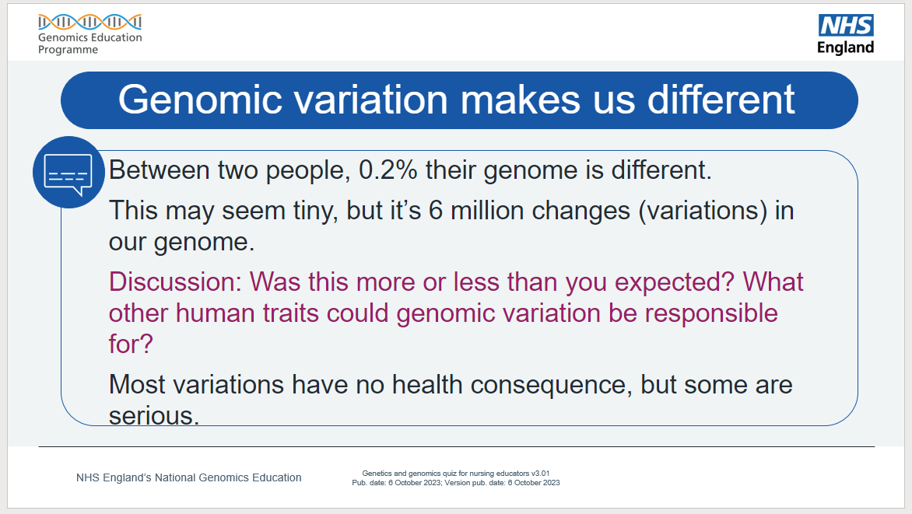
Note to educator: For this discussion, get the learners to think about everyday natural human differences like eye colour, hair colour and curl, how individuals perceive the taste of Brussels sprouts or coriander, and so on. ​
It is also useful to help learners recognise just how similar we are.
Furthermore, stating some fun facts can embed the idea of how important genomic differences in growth and development can help. For example, our genomes are around 98%–99% similar to that of chimpanzees. Also, more than half of our genome shares similarity with less human-like organisms, such as chickens, fruit flies and bananas.
More information:
- Food, glorious food and its bitter aftertaste: www.genomicseducation.hee.nhs.uk/blog/food-glorious-food-and-its-bitter-after-taste/
- Bonobos join chimps as closest human relatives: www.science.org/content/article/bonobos-join-chimps-closest-human-relatives
- Infographic showing “all living things” percentage DNA similarity with humans: www.popsci.com/humans-genetically-linked-to-bananas/

Section: Genomes to proteins
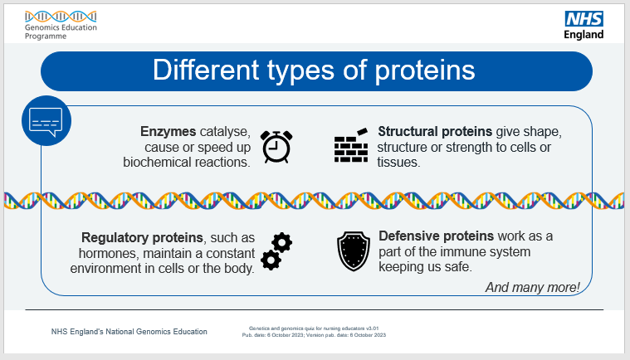
Note to educator: Here are some other types of protein and their function:
- Blood-clotting proteins: part of an organism’s blood clotting response.
- Cell membrane/channel proteins: found in a cell’s membrane.
- DNA- and RNA-associated proteins (nucleoproteins): proteins that attach to nucleotides.
- Contractile proteins: help muscle fibres to contract.
- Motor proteins: ‘molecular machines’ that help move material in a cell.
- Receptor proteins: are bound to by other molecules.
- Toxins: used in predation or defence by some non-human organisms.
- Transport proteins: move material in an organism.
- Storage proteins: store something until needed.

Section: Inheritance and variation
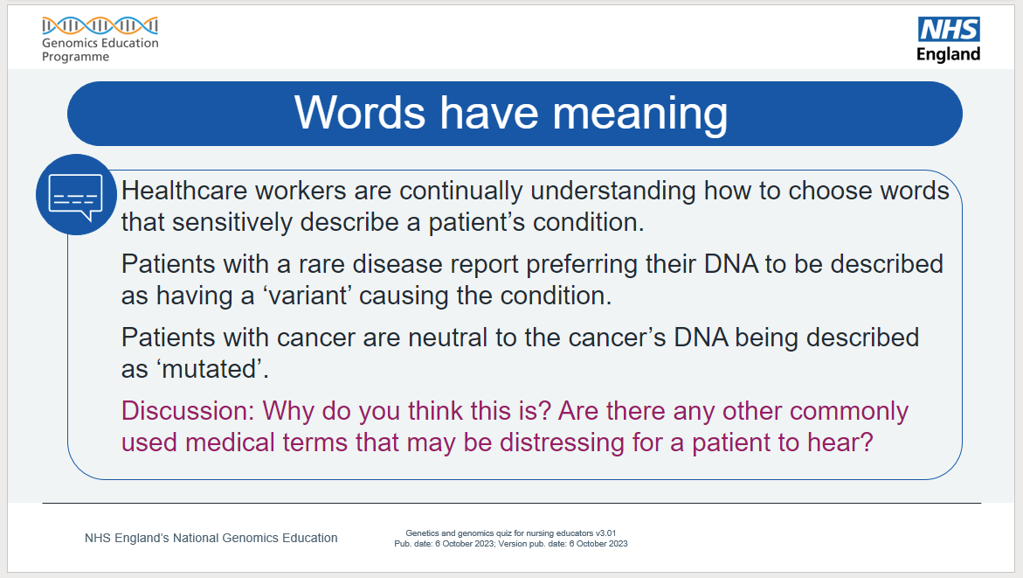
Note to educator: For this discussion, encourage learners to think about how the patient might feel or react to being referred to as “having a mutation”. Explore how complicated or dense medical words and phrases may affect the patient and their understanding of the situation.​

Continued on next page.

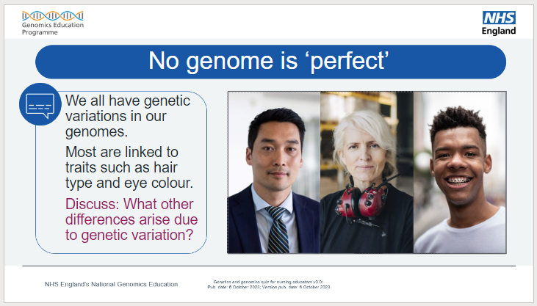
Note to educator: Learners may repeat items from previous discussions where hair colour and curl, eye colour, how we perceive some flavours (and so on) are all differences with a genomic basis.
Consider prompting for unseen differences. Same examples of what genetic variation affects include:
- how we respond to certain medications;
- our predisposition to diseases such as cancer, or illnesses such as schizophrenia; and
- how our immune system responds to communicable diseases and infections.
Be careful to avoid framing differences as only genetic or genomic since a person's environment or personal circumstance will tend to influence them. For example, a person vaccinated will experience a different disease outcome when compared to someone who is not.

Continued on next page.

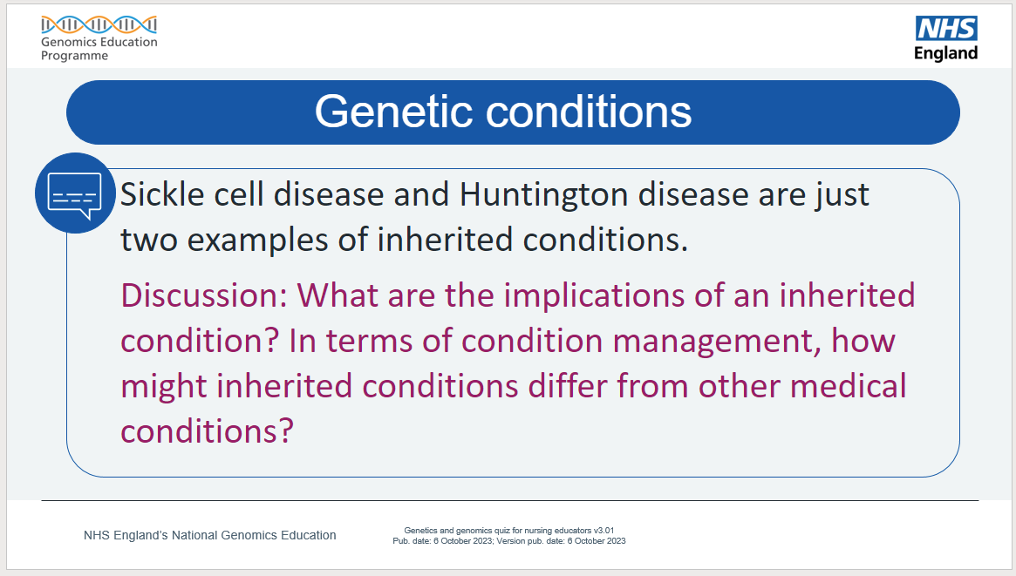
Note to educator: For this discussion, prompt the learners to explore what the future looks like for a patient, who may be a child, and their family. How long will a patient have that condition. Is the condition easy to manage and live with? What lifestyle changes might need to be considered? How favourably does today’s society view people with that condition?
Ask questions to encourage comparisons between treatment and management for a genetic condition to that of non-genetic conditions. For example, sickle cell disease (genetic) vs sepsis (not genetic), or Duchenne muscular dystrophy (genetic) vs broken bones or sprains (not genetic).​
You may also wish to think about the advantages and disadvantages of using genomics to predict the chances of family members developing a condition.

Section: Research and techniques
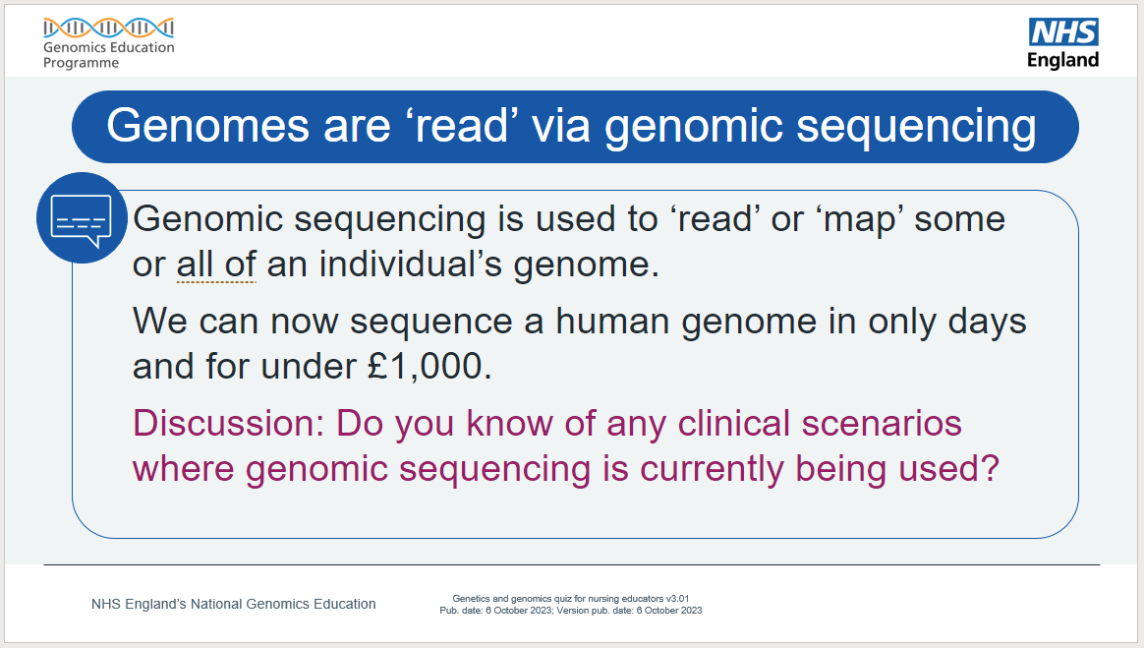
Note to educator: Sickle cell disease and cystic fibrosis are two examples, but many exist. For this discussion, you may wish to note the National Genomic Test Directory, which has a list of all eligible genomic tests commissioned by the NHS in England, the technology by which they are available, and the types of patient who will be eligible.​
More information:
- The National Genomic Test Directory: www.england.nhs.uk/publication/national-genomic-test-directories/ ​

Section: Diagnostics
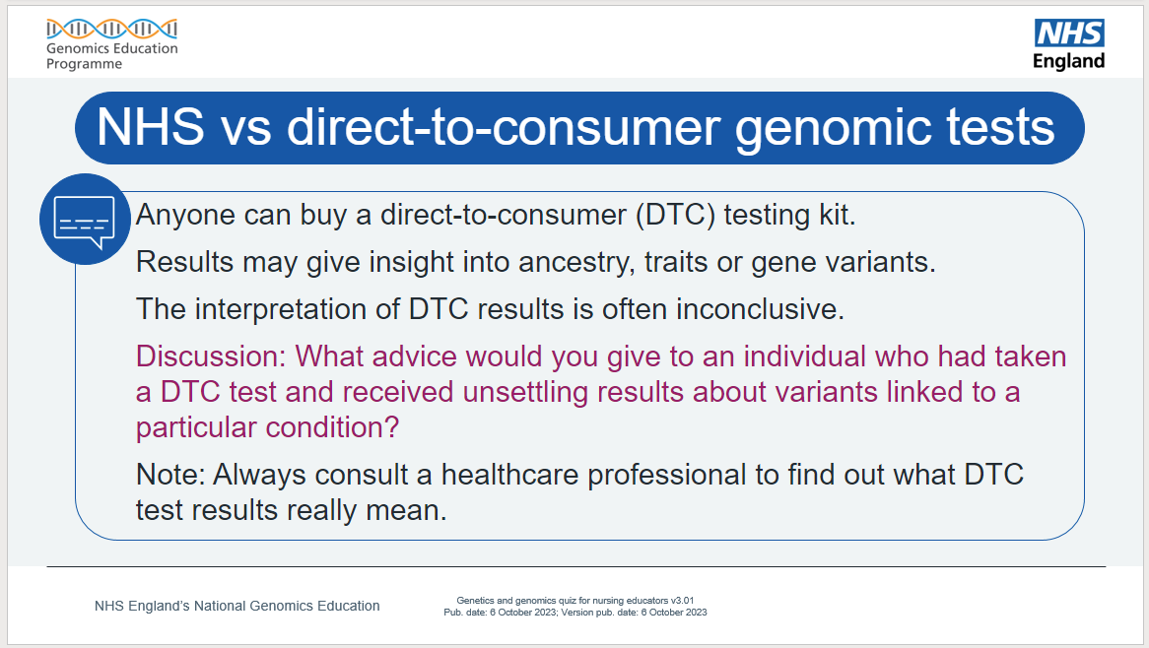
Note to educator: For this discussion, get the learners to think about how a patient seeing their primary care clinician (such as a GP) might be feeling if they have used an off-the-shelf test and received unsettling results. What could the clinician do to reassure the patient?​

Section: Infections and genomics
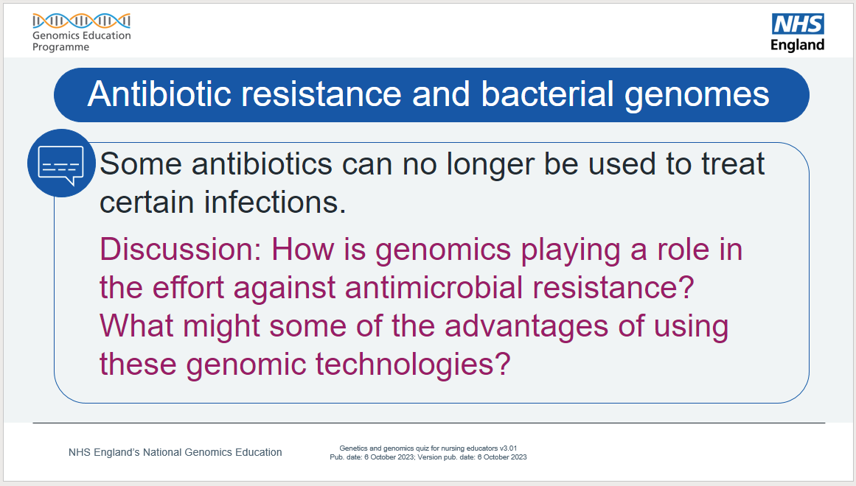
Note to educator: For this discussion, genomics also has a great potential in terms of targeted prescribing of antibiotics. For example, a genomic test can tell if bacteria sampled from a patient are resistant to specific antibiotics. Also, genomic technologies are quicker than culturing microbiology samples and so they may permit bedside testing. Finally, antibiotic resistant bacteria outbreaks can also be better tracked with genomics.​

Section: Family history
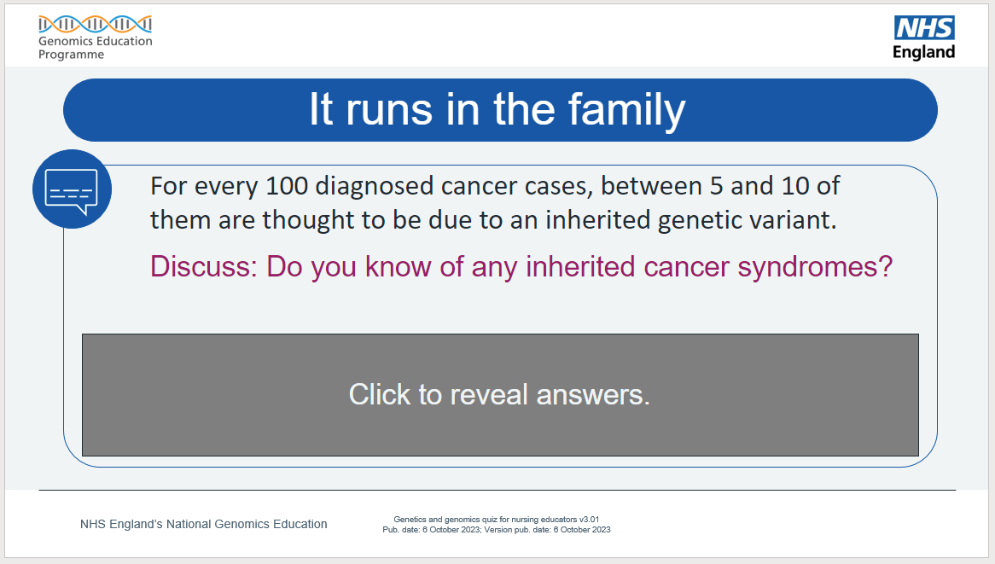
Note to educator: There are many, but some more common ones are listed.​

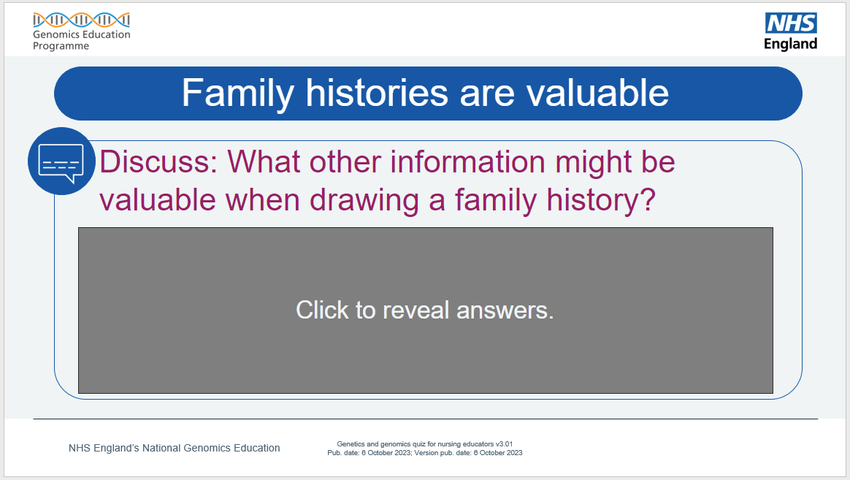
Note to educator: For this discussion, any information that helps a clinician reach a diagnosis is good information to have.​

Section: Results are far reaching
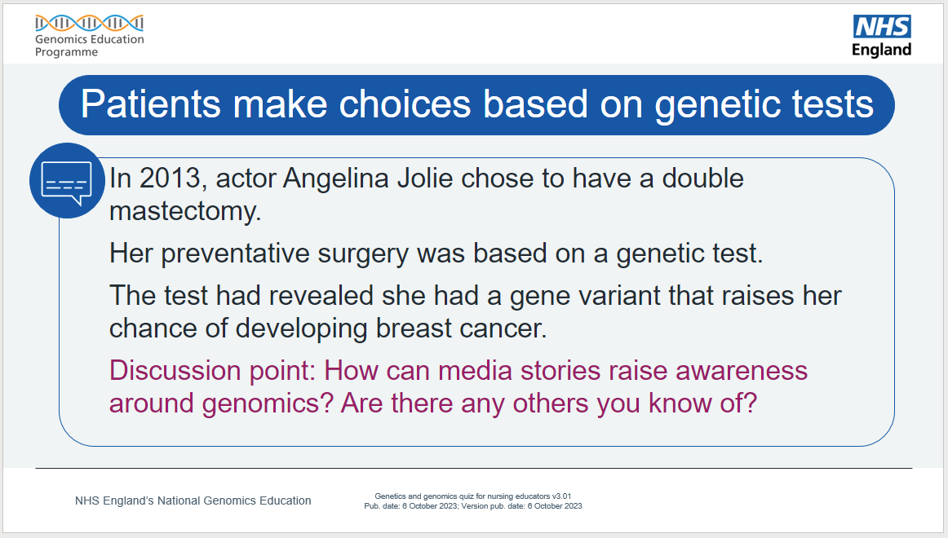
Note to educator: Media stories can get people talking about something, which may remove the taboo and get people seeing clinicians. Chris Hemsworth (Thor in the Marvel movies) discovered he has an APOE4 gene variant which is connected to Alzheimer’s disease. Journalist Krishnan Guru-Murthy has hypertrophic cardiomyopathy which is a genetic heart condition.​
More information:
- Chris Hemsworth’s APOE4 diagnosis: www.genomicseducation.hee.nhs.uk/blog/marvel-star-goes-public-on-his-apoe-genetic-link-to-alzheimers/
- Krishnan Guru-Murthy’s hypertrophic cardiomyopathy diagnosis: https://virginradio.co.uk/entertainment/119068/strictly-2023-krishnan-guru-murthy-doctors-health-concerns

Continued on next page.

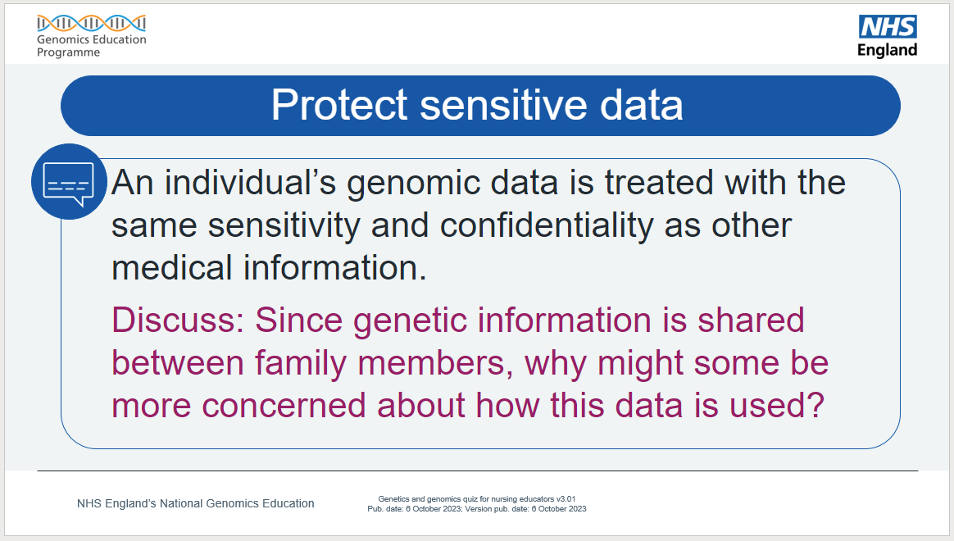
​Note to educator: For this discussion, encourage the learners to think about ramifications of genomic data, how it is stored and who might use or access it. For example, years after it was taken from a crime scene, DNA was eventually matched against some stored data the killer’s family members had sent in for DNA-based ancestry testing. This led to the killer being arrested.​
In terms of health insurance, should a family member discover they have a genetic condition, your own premiums and costs might increase as the company will assume you have something similar.​
Additional information: Since 2018, the Code on Genetic Testing and Insurance, which is an agreement between our government and the Association of British Insurers (ABI), states that predictive genetic test results are not taken into account, unless the life insurance is over £500,000 and the applicant has had a predictive test for Huntington disease. However, the increasing use of genomics as a predictive tool means this agreement is regularly reviewed and may change in the future.
- The Code on Genetic Testing and Insurance can be found at: www.abi.org.uk/data-and-resources/tools-and-resources/genetics/code-on-genetic-testing-and-insurance/

Section: Precision medicine
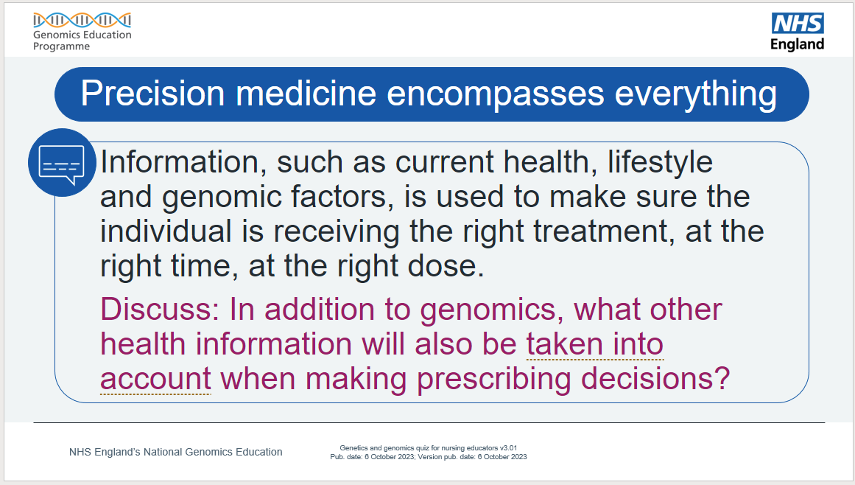
Note to educator: For this discussion, think about the patient as a whole (holistically), from genomics to lifestyle to the environment they live in.​ For most clinical situations genomics is only one part of the puzzle. More often there is an interplay between the variation in our genome and other non-genetic factors.

