‘Knowledge Hub’ (Tier 2) template document
Expert adviser: _________________

SMN1-related spinal muscular atrophy
Spinal muscular atrophy (SMA) is a genetic disorder where loss of anterior horn cells in the spinal cord (lower motor neurons) and the brain stem nuclei causes muscle weakness and hypotonia in the context of normal cognition.
Title and summary: The title should specify the topic, in this case the genetic condition. The summary below should provide a one-sentence outline of the topic.
If possible, please identify an expert adviser who is happy to review the completed article. (Where appropriate, this may be done by the working group’s senior reviewer.)

Clinical features
Clinical features – Brief summary of the clinical features, ideally in bullet points
- Progressive muscle weakness: proximal muscles are usually more severely affected than distal muscles.
- Hypotonia.
- Areflexia/hyporeflexia.
- Tongue fasciculations.
There are different types of SMA, which are characterised by the age of onset and severity of symptoms shown in the table below:
Increasing severity | SMA type | Age of onset | Presentation and prognosis
 | Type 0 | Prenatal | Often there will have been reduced fetal movements. Postnatally there is respiratory failure at birth, severe weakness, absent reflexes and arthrogryposis.  Most babies will not live beyond 6 months
 | Type 1 (also known as Werdnig-Hoffman disease) | < 6 months  (Mean 2.5 months) | Babies may manage to develop some head control but have a progressive muscular weakness and so are unlikely to sit unsupported. May have suck/swallowing difficulties.  Median survival is 8-10 months
 | SMA 2 | 6-18 months | Proximal muscle weakness. Delayed developmental milestones with loss of some skills. Reduced or absent reflexes.  Most survive into adulthood
 | SMA 3 | Childhood: >18 months | Achieve normal ambulation but progressive difficulties running/climbing. Loss of motor skills and fatigue are common.  Normal life expectancy.
 | SMA 4 | Adulthood | Fatigue and proximal muscle weakness  Normal life expectancy

The genetics of SMA
The genetics of: Explain underlying genetics of the condition and causative genes. Emphasise any clinically relevant points that affect genetic testing/variant interpretation.
SMA is caused by loss of both copies (in trans) of the SMN1 gene (most frequently deletions of both gene copies).
There are two important genetic testing points to remember:
- The variability of severity of the disease is affected by the number of copies of another gene that is able to produce small quantities of functional SMN protein: the SMN2 gene. Individuals can have between one and eight copies of SMN2. A baby with SMA type 0 is likely to have only one copy of SMN2, whereas an individual with SMA IV is more likely to have four or more copies.
- Around 5-8% individuals who are carriers for SMA have two copies of SMN1 in cis with each other and a deletion in trans (see figure*), known as the 2+0 configuration. This would lead to a false negative result; that is, they wouldn’t be reported as being a carrier but they are.

Inheritance and genetic counselling
SMA is an autosomal recessive condition. The parents of most affected individuals are carriers for the condition and therefore have a 25% (or 1-in-4) chance of another child being affected (see figure*).
Note: There are Knowledge Hub (Tier 2) documents available on the different inheritance patterns that you should put in links to where appropriate.
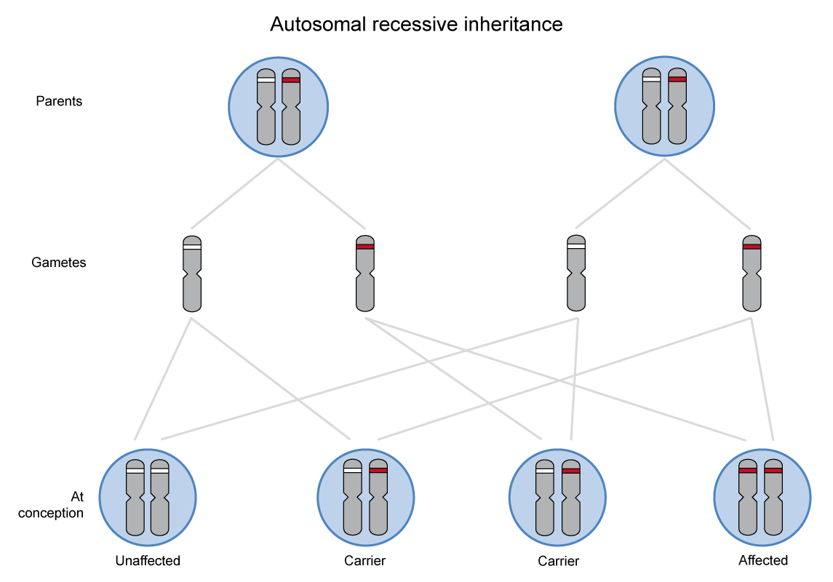
*Diagrams and figures are welcome and we can re-draw if required.
Management implications
Management: Note this is a genomics resource. It is not intended to provide clinical management of individual conditions. As such, a very brief overview of management should be given as here, highlighting any genetic therapies if relevant.
Management of children with SMA is complex and should be delivered via a multi-disciplinary team with detailed suggested approaches published by several authors.
Management – Consider linking here to any useful published guidelines
Gene-directed therapies/trials:
Gene-directed therapies in SMA is a research active area. Two options are shown below:
- Nusinersen (Spinraza): This is an antisense oligonucleotide that allows the body to produce more and better quality (longer length) SMN from the SMN2 gene.
- Onasemnogene abeparvovec-xioi (Zolgensma): Using a vector, the faulty SMN1 gene is replaced with a working copy.
Resources for clinicians:
Resources for clinicians – Please link to any resources you think would be helpful. This could be review papers, NICE guidelines, criteria for diagnosis and so on. Please also include the NGTD link as standard.
Also link to relevant Tier 1_Presentation documents for genetic testing info e.g. in this SMA example link back to Tier 1_Hypotonic infant.
- National Genomic Test Directory and eligibility criteria
Resources for patients and families:
Resources for patients and families: Link to any recommended patient information leaflets, support groups and so on.
Also link to relevant Tier 1_Presentation documents for genetic testing info e.g. in this SMA example link back to Tier 1_Hypotonic infant.

