The Framework Project Initiative
Quick jump to:
Introduction
Developing a framework project (flowchart)
Illustration of how to develop a framework
Framework projects and the national transformation projects
Developing the education to support the framework delivery
Governance
Any queries?
Appendix 1: GeNotes
The GeNotes development process
GeNotes templates

Introduction
Thank you for contributing to the Framework Project Initiative. This is a collaboration between NHS England and NHS Improvement (NHSE/I), Health Education England (HEE) and the Academy of Medical Royal Colleges (AoMRC) to facilitate the integration of genomic medicine through the alignment of patient pathways, workforce development and education/training requirements.
The aims of the initiative are to:
- introduce a unified approach to the integration of genomic medicine across the different specialties;
- identify the workforce development and education/needs;
- harness and share expertise from around the country;
- avoid duplication of effort and resource development; and
- provide a ‘bite-sized’ clinically relevant approach to genomic medicine.
Each framework project is built around a patient pathway and is the approved NHS Genomic Medicine Service (GMS) resource. The patient pathway should be a high-level pathway and we are prioritising those clinical areas where genomic medicine will be initially adopted. Each pathway is linear, and many are likely to be smaller sections of larger pathways or networks.
A flow diagram representing the steps to developing a framework is shown overleaf.

Developing a framework project

* For instance, a larger pathway to investigate an intellectual disability might be divided into one pathway to request genomic and testing and several pathways to return results, namely: 1) for a clearly causative result, 2) where no genomic change is identified; 3) for a variant of uncertain significance and 4) an incidental finding is identified.
** Consult with the HEE Genomics Education Programme’s competency frameworks.

Illustration of how to develop a framework
An exemplar of the framework is shown here. (Please note, this is not a completed framework but is shown for illustration.)
- Clinical pathway: Identify a clinical pathway where genomic medicine will be required for delivery (either for testing or management).
In this example, you identify a clinical pathway for genomic testing to investigate a child with an intellectual disability.
- Component pathways: Reduce a larger pathway to its shorter component pathways.
For instance, a pathway undertaking testing to investigate an intellectual disability might be divided into smaller pathways: a) requesting genomic testing and b) interpreting and feeding back results, the latter of which could be broken down further, to the following component pathways:
- Requesting testing
- Feeding back results: causative result is identified
- Feeding back results: no genomic cause is identified
- Feeding back results: uncertain result is identified
- Feeding back results: incidental finding is identified
The step we will focus on in this exemplar is a) Requesting testing.
- Component steps: Break down each pathway into its component steps; likely to be between three and five steps.
It is helpful to use a spreadsheet to start the mapping process, and you may find our spreadsheet template helpful for this. You will see that we have divided the component pathway into five steps:

- Competency alignment: Align the steps to the competency required to deliver each of these steps.
Determine which competencies your workforce will require to deliver each of the steps. You may find it helpful to refer to the competency frameworks developed by the HEE Genomics Education Programme (GEP) and the genomic syllabus developed by the Academy of Medical Royal Colleges. Number each learning need.

- Education and training: Identify the education and training that is required to develop the competencies to deliver each of the steps.
Map each of the steps to the education and training resources that are required to develop those competencies. Note in brackets which numbered learning need(s) each resource addresses. If you know that a resource exists that would meet this need, please provide a link or the resource itself.

- Workforce group: Align the pathway to the workforce group(s) who will be delivering each step of the pathway.
Identify the workforce groups who, in your region, are likely to be delivering each of the steps. You can colour-code the icons to easily differentiate between different professional groups. In this example, a single professional group has been identified.

Once your framework pathway is complete, please email the spreadsheet to the GEP. You can also email us with your questions or suggestions to improve the template or process.

Framework projects and the national transformation projects
In the first instance, we are prioritising five of the national transformation projects (Lynch syndrome, monogenic diabetes, FH, sudden cardiac death and DPYD) to formulate into a framework structure. We hope that, by piloting this approach with these five projects, we will be able to develop a sustainable infrastructure going forward.
Once the framework structures for the five projects have been created, we will upload these to the HEE GEP website so that they can be nationally accessed, modified for local / regional needs and used in clinical practice. We also plan to include a table of completed and ongoing projects so that, if you are inspired to move on to subsequent projects, you can see which have been developed and which need developing.

Developing the education to support the framework delivery
A considerable education and training package will be required to deliver each of the framework structures that are developed. Ideally, these resources would be 1) developed in line with a template/guide and 2) hosted/signposted on the GEP website so that they can be easily accessed and nationally shared.
We are developing a new resource called GeNotes (Genomic Notes for clinicians), which would be the ideal platform to develop and disseminate many of these resources. If you are interested in finding out more about, generally contributing to, or using the GeNotes platform as the repository for your framework educational tools, please see Appendix 1, which includes the resource development process and templates.

Governance
All framework projects will be ratified by the HEE and NHSE/I joint workforce steering group and AoMRC’s Genomics Professional Partnerships Group (GPPG) before being uploaded to the GEP website and nationally disseminated.
You can choose either to submit your completed project to the GEP or present the project yourself at either the joint workforce steering group or AoMRC’s GPPG meetings.

Any queries?
If you are interested in developing a framework structure but have questions, please contact the GEP.

Appendix 1: GeNotes

GeNotes is an online ‘just in time’ educational resource being developed by subject matter experts in collaboration with HEE’s GEP.
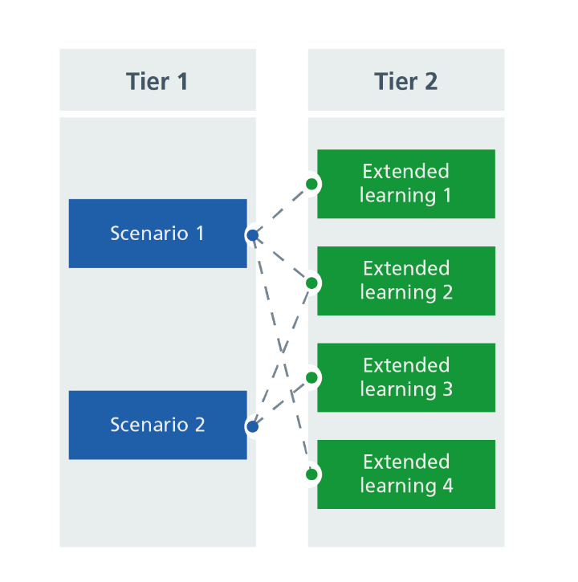
It has been designed for healthcare specialists working within the NHS and aims to provide the education and training at the point of need, with ‘hooks for learning’ into an extended learning opportunity. This is achieved through a tiered structure.

Tier 1: In the Clinic
Tier 1 resources are based around the point of patient care and are centred around a clinical scenario. They are organised in a section titled ‘In the Clinic’ comprising two types of resources: one for the presentation/testing stage, and another for the results stage.
The testing resources are aligned to the National Genomic Test Directory and are designed to a template where the clinician can first ‘locate’ themselves through a generic clinical scenario, then check whether their patient is eligible for testing, and then access information on how to request testing. The results-focused resources educate a clinician about the different types of results that may be returned and how these should or could be actioned: clinically actionable; variants of uncertain significance; and no clinically actionable variant identified.

Tier 2: Knowledge Hub
Tier 2, or the Knowledge Hub, acts as an encyclopaedia of resources that can be accessed either via a link embedded in tier 1 or independently. The resources are organised into different themes, including conditions, genes, inheritance patterns, genomic technologies, communication resources, and the GMSA/GLH structure.
These resources can feature a range of different media including articles, narrated slide decks, infographics, filmed interviews and animations. For those who have previously undertaken a MOOC (massive open online course) on FutureLearn, the Knowledge Hub can be seen as a ‘muddled-up MOOC’, where the individual learner can chart a bespoke learning journey reflecting their educational requirements and interests.
GeNotes is also designed to link to external resources. It will signpost to management guidelines (including NICE), external educational resources and curricula, as well as resources for clinicians to share with their patients.

GeNotes development process
If you are interested in developing a resource for GeNotes that can be shared nationally, please follow the flow diagram on the next page.

Developing GeNotes resources to support a framework project
1. Identify resources to support pathway competencies
Please develop the resource as per the templates and ensure your name and the names of any other contributors are included so that you can be acknowledged. As part of the editorial process, you may be contacted with queries or asked to check the final article before publication. Please also indicate whether you would be happy to be contacted in the future to review and update the resource(s).
4. Develop resource(s) for upload and dissemination
You can contact the specialty working group via the GEP to outline your proposed resources. This is important to ensure that:
1) you have the appropriate support developing the resource to template;
2) the resource(s) haven't already been developed; and
3) the resource enters the GeNotes editorial process.
* If a working group hasn’t yet been established for the specialty area for which you want to develop a resource, please contact the GEP and we can still progress your resource through the editorial process.

3. Contact the specialty working group
2. Is this a Tier 1 (In the Clinic) or a Tier 2 (Knowledge Hub) resource?
List the types of resource(s) you will need to create. Are they Tier 1 (at the point of patient care and centred on a clinical scenario)? Or are they Tier 2 (foundation knowledge)? In some cases, you may develop Tier 1 resource(s) and accompanying linked Tier 2 resource(s).
What educational resources do you need to support the development of your framework?

GeNotes templates
We have developed template documents for GeNotes, which are shown on the following pages. If you are developing a resource that you feel would be suitable for Tier 1 or Tier 2, then please develop it according to these templates.
Instructions are provided in the grey text boxes. Please note, these instructions should be removed from the final document.

‘In the Clinic’ (Tier 1) template document

Presentation: A child with an intellectual disability
For some children presenting with an intellectual disability with developmental delay, there will be a genetic cause.
Title and summary: For a presentation/testing-stage article, the title should describe the clinical presentation. (For a results-stage article, the title should describe the results, eg ‘Patient with colorectal cancer (germline DPYD variant)’.)
The one-sentence summary below the title should highlight key point(s) of the article.
(Note the National Genomic Test Directory is organised mainly by condition, but we believe it is more helpful for this resource to be accessed by clinical presentation.)
The title is followed by a one sentence strapline to give context/summarise key points

Example clinical scenario
Example clinical scenario: This should describe a patient scenario that a clinician might encounter with this presentation. Keep it brief: 4-5 lines or 80 word maximum.
A family attend clinic concerned because their six-year-old son’s development is delayed: he sat at one year, was walking at 2.5 years and, at the age of six, has some single words but is not talking in sentences. He has some dysmorphic features and was diagnosed with an atrial septal defect following the detection of a heart murmur at the newborn check.
When to consider genetic testing
When to consider genetic testing: This should help to guide the clinician as to when genetic testing is appropriate for the presentation. The test directory eligibility criteria document has a list of testing criteria. If available, these criteria should be used here.

- Moderate to profound intellectual disability
- An intellectual disability (of any severity) associated with:
  - behavioural problems, including autistic spectrum disorder;
  - other medical problems, such as seizures, congenital heart disease;
  - abnormal growth patterns (growth retardation, overgrowth, asymmetric growth);
  - microcephaly or macrocephaly;
  - dysmorphic facial features; and/or
  - a family history of learning disability (particularly if X-linked pattern) or of multiple miscarriages

What do you need to do?
What do you need to do: This section is not about the diagnostic process or general management, but what you need to do in terms of ordering genomic testing.
- Consult the test directory eligibility criteria to ensure your patient is eligible for testing and to access a spreadsheet of all available tests.
Always include the first bullet point with links to test directory eligibility criteria and spreadsheet.
- Decide which of the panels best suits the needs of your patient/family. For developmental disorders, there are a number of available panels including:
  - R27: if you have already done array CGH and Fragile X testing and would like to investigate single gene causes of a child’s developmental delay/intellectual disability.
  - R29: if no genetic testing has yet been undertaken in a child with developmental delay/intellectual disability. This panel includes microarray, fragile X testing and sequencing.
  - R377: if only a microarray is required.
  - R47: if you think your patient might have a diagnosis of Angelman syndrome.
  - R48: if you think your patient might have a diagnosis of Prader Willi syndrome.
  - R53: if you think your patient might have a diagnosis of Fragile X syndrome.
Conditions highlighted in green: Make a note if any of the conditions you list are not currently included in the Knowledge Hub and need developing. Of note, the GEP’s genetic condition factsheets can be adapted for this purpose (where available).
- A record of discussion (RoD) form is required. If you have not completed a RoD form before or do not have access to one, please find information here.
- Depending on the details you provide and the panel chosen, a range of genomic investigation techniques will be applied to your patient’s and, if appropriate, their family’s DNA. These include (but are not restricted to):
  - Whole genome sequencing
  - Whole exome sequencing
  - Gene panel
  - Single gene testing
  - Methylation studies
  - Southern blotting
  - Common aneuploidy testing
  - Microarray
  - MLPA
Technologies highlighted in green: Please prune as necessary. Each of these will link to a Tier 2 Technologies document, which will be available to link to as necessary.
- For DNA-based tests (all the above listed tests), an EDTA sample is required. For many of the tests (particularly whole genome and exome sequencing), parental samples are also needed/helpful. Please refer to your local GLH for details of test request forms and where to send samples.
Resources for clinicians:
Resources for clinicians: Link to any resources you think would be helpful (such as review papers, NICE guidelines, criteria for diagnosis, management guidelines and so on). Also there will be some printable Patient Communication Aids that might be relevant, such as for explaining AD/AR/XL inheritance. These are listed on the spreadsheet. Please also include the NGTD links as standard.
- National Genomic Test Directory and eligibility criteria

Resources for patients:
Resources for patients: Link to any recommended patient information. leaflets/support groups etc.

‘Knowledge Hub’ (Tier 2) template document
Expert adviser: _________________

SMN1-related spinal muscular atrophy
Spinal muscular atrophy (SMA) is a genetic disorder where loss of anterior horn cells in the spinal cord (lower motor neurons) and the brain stem nuclei causes muscle weakness and hypotonia in the context of normal cognition.
Title and summary: The title should specify the topic, in this case the genetic condition. The summary below should provide a one-sentence outline of the topic.
If possible, please identify an expert adviser who is happy to review the completed article. (Where appropriate, this may be done by the working group’s senior reviewer.)

Clinical features
Clinical features – Brief summary of the clinical features, ideally in bullet points
- Progressive muscle weakness: proximal muscles are usually more severely affected than distal muscles.
- Hypotonia.
- Areflexia/hyporeflexia.
- Tongue fasciculations.
There are different types of SMA, which are characterised by the age of onset and severity of symptoms shown in the table below:
Increasing severity | SMA type | Age of onset | Presentation and prognosis
 | Type 0 | Prenatal | Often there will have been reduced fetal movements. Postnatally there is respiratory failure at birth, severe weakness, absent reflexes and arthrogryposis.  Most babies will not live beyond 6 months
 | Type 1 (also known as Werdnig-Hoffman disease) | < 6 months  (Mean 2.5 months) | Babies may manage to develop some head control but have a progressive muscular weakness and so are unlikely to sit unsupported. May have suck/swallowing difficulties.  Median survival is 8-10 months
 | SMA 2 | 6-18 months | Proximal muscle weakness. Delayed developmental milestones with loss of some skills. Reduced or absent reflexes.  Most survive into adulthood
 | SMA 3 | Childhood: >18 months | Achieve normal ambulation but progressive difficulties running/climbing. Loss of motor skills and fatigue are common.  Normal life expectancy.
 | SMA 4 | Adulthood | Fatigue and proximal muscle weakness  Normal life expectancy

The genetics of SMA
The genetics of: Explain underlying genetics of the condition and causative genes. Emphasise any clinically relevant points that affect genetic testing/variant interpretation.
SMA is caused by loss of both copies (in trans) of the SMN1 gene (most frequently deletions of both gene copies).
There are two important genetic testing points to remember:
- The variability of severity of the disease is affected by the number of copies of another gene that is able to produce small quantities of functional SMN protein: the SMN2 gene. Individuals can have between one and eight copies of SMN2. A baby with SMA type 0 is likely to have only one copy of SMN2, whereas an individual with SMA IV is more likely to have four or more copies.
- Around 5-8% individuals who are carriers for SMA have two copies of SMN1 in cis with each other and a deletion in trans (see figure*), known as the 2+0 configuration. This would lead to a false negative result; that is, they wouldn’t be reported as being a carrier but they are.

Inheritance and genetic counselling
SMA is an autosomal recessive condition. The parents of most affected individuals are carriers for the condition and therefore have a 25% (or 1-in-4) chance of another child being affected (see figure*).
Note: There are Knowledge Hub (Tier 2) documents available on the different inheritance patterns that you should put in links to where appropriate.
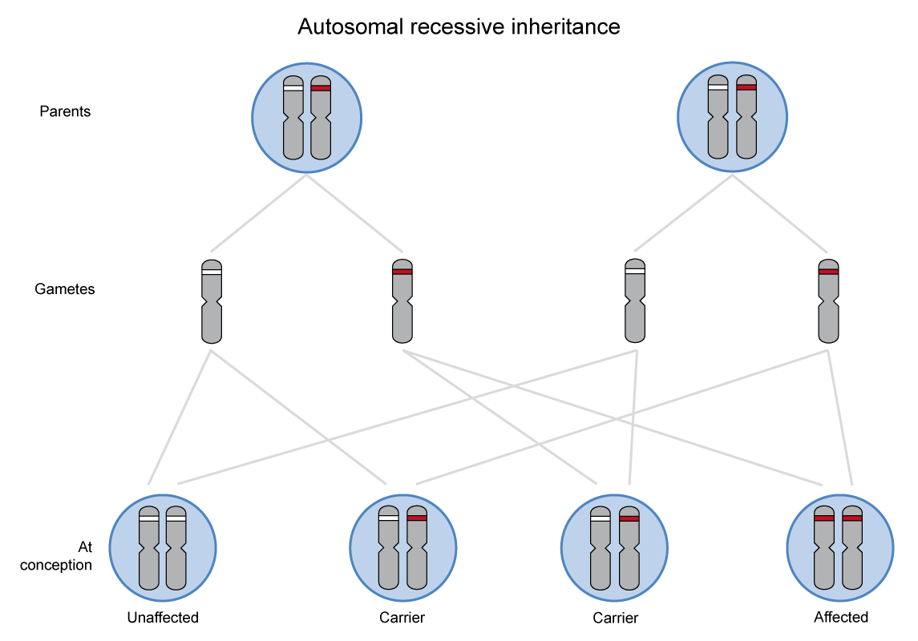
*Diagrams and figures are welcome and we can re-draw if required.
Management implications
Management: Note this is a genomics resource. It is not intended to provide clinical management of individual conditions. As such, a very brief overview of management should be given as here, highlighting any genetic therapies if relevant.
Management of children with SMA is complex and should be delivered via a multi-disciplinary team with detailed suggested approaches published by several authors.
Management – Consider linking here to any useful published guidelines
Gene-directed therapies/trials:
Gene-directed therapies in SMA is a research active area. Two options are shown below:
- Nusinersen (Spinraza): This is an antisense oligonucleotide that allows the body to produce more and better quality (longer length) SMN from the SMN2 gene.
- Onasemnogene abeparvovec-xioi (Zolgensma): Using a vector, the faulty SMN1 gene is replaced with a working copy.
Resources for clinicians:
Resources for clinicians – Please link to any resources you think would be helpful. This could be review papers, NICE guidelines, criteria for diagnosis and so on. Please also include the NGTD link as standard.
Also link to relevant Tier 1_Presentation documents for genetic testing info e.g. in this SMA example link back to Tier 1_Hypotonic infant.
- National Genomic Test Directory and eligibility criteria
Resources for patients and families:
Resources for patients and families: Link to any recommended patient information leaflets, support groups and so on.
Also link to relevant Tier 1_Presentation documents for genetic testing info e.g. in this SMA example link back to Tier 1_Hypotonic infant.

