# The 2023 Genomic Competency Framework for UK Nurses



Contents

1. Genomics within healthcare 3

2. Genomics and nursing 4

3. At a glance: the 2023 Genomic Competency Framework for UK Nurses 5

4. Competency frameworks in genetics/genomics for nurses 6

5. How were the 2023 competencies developed? 7

6. The 2023 Genomic Competency Framework for UK Nurses in full 12

7. Who are the competencies for? 14

8. Next steps 15

9. Project leads 16

10. Acknowledgements 16

11. References 18

**This report describes the updating of an existing competency framework for UK nurses undertaken by NHS England’s National Genomics Education programme (previously Health Education England’s Genomics Education Programme). The purpose of the report is to outline the healthcare context in which these competencies sit, the background to the work and the methodology used to update the framework.**

## Genomics within healthcare

Using genetic information (such as family history, single-gene and chromosomal tests) within healthcare is not a new practice and has been present in the NHS since the 1950s. However, in the past 10 years huge advances have enabled the integration of genetic, and now genomic, testing and information into routine clinical settings, supported by specialist genetic/genomic services.

The landmark 100,000 Genomes Project – launched by the Department of Health and Social Care in 2013 and delivered by the National Health Service, Genomics England and other partners – was established to demonstrate the benefit whole genome sequencing could bring to individuals and their families within the NHS1. Not only did the outcomes demonstrate improvements in diagnosis, treatment selection and management, but the project also helped to define the infrastructure needed to integrate whole genome sequencing technology into mainstream care.

Reconfiguration of services across the NHS in England has seen the establishment of the Genomics Medicine Service (GMS) and the development of a National Genomic Test Directory that includes eligibility criteria for each test available. Genomics healthcare is now a key driver for health service delivery for the UK’s home nations, as evidenced in the policy document Genome UK and related plans for implementation2,3. The vision is to provide equitable access to genomic testing by embedding genomics into routine care across clinical settings, making the NHS the first national health service in the world to do so.

With the move to improve and increase access to genomic testing, more healthcare professionals than ever before are likely to encounter patients and their families who are undergoing or have undergone genomic testing. As such, there is a pressing need to ensure that all healthcare professionals have role-appropriate genomic knowledge, skills and attitudes to support those in their care. The nursing workforce is the largest in the NHS, with more than 730,000 on the Nursing and Midwifery Council (NMC) register in 20234. Therefore, nurses are well placed to support the integration of genomic healthcare across services and will need the correct education and training to feel confident to do so.

## Genomics and nursing

Recognising the increasing value of genomics to patient care, the NMC has made explicit reference to genomics within the current proficiency standards for registered nurses, which set out the skills, knowledge and attributes that all nurses must demonstrate5.

Genomic literacy and confidence to use genomics in clinical practice among registered nurses is typically low and is often only developed by those working in specialist areas. Inclusion of genomics within the standards is a call to action for all the profession. The NMC standards are also used by universities as the basis for curricula design within pre-registration nurse training programmes and are therefore pivotal for both the current and future nursing workforce.

As there is no central guidance on the interpretation of genomics-related NMC proficiencies, there can be uncertainty among the nursing and educator workforce as to their application to clinical care. Guidance and support for education and training to prepare and upskill both the current and future nursing workforce is needed. These competencies are one element of the extensive work being undertaken to help meet that need.

## At a glance: the 2023 Genomic Competency Framework for UK Nurses

Below is a summary of the 2023 framework. A more detailed version can be found on pages 12-14 of this report.

1. Identify individuals who might benefit from genomic services and/or information as part of assessing needs and planning care.

2. Demonstrate effective communication in tailoring genomic information and services to the individual.

3. Advocate for the rights of all individuals to make informed decisions and act voluntarily.

4. Demonstrate a knowledge and understanding of genomics in human development, variation and health to underpin effective practice.

5. Apply knowledge, understanding and context of genomic testing and information to underpin care and support for individuals and families prior to, during and following decision-making.

6. Examine your own competency of practice on a regular basis.

7. Obtain and communicate reliable, current information about genomics, for self, patients, families and colleagues.

8. Provide ongoing nursing care and support to patients, carers, families and communities with genomic healthcare needs.

## Competency frameworks in genetics/genomics for nursing

Competency frameworks are an effective, familiar and measurable method of identifying skills, knowledge and attitudes required for a particular task and can be used to identify education and training needs. A genetic/genomic competency framework for UK nurses already exists6 and is a revision of competencies originally developed by national consensus for nurses, midwives and health visitors in 20037 as part of the activities outlined in the UK Government white paper ‘Our Inheritance, Our Future, Realising the potential of genetics in the NHS’8.

In the years since its publication, the scope, scale and pace of the use of genomics within the NHS has increased dramatically prompting this review and revision of the framework in 2020 led by the National Genomics Education programme9 at NHS England (previously Health Education England’s Genomics Education Programme). The team exists to deliver and advise on learning and development opportunities that prepare current and future NHS professionals to make the best use of genomics in their practice. The 2023 framework reflects the changes in service provision and identifies the competencies required by all nurses to deliver a modern genomics health service.

The original competencies in genetics for all nurses were developed as a result of a large multi-day in-person consensus meeting and consultation. That framework primarily focused on the competencies required to identify and support individuals and families who could benefit from genetic testing and/or information, usually via referral to specialist (genetic) services, and included competencies around informed decision-making, tailored communication and core (scientific) knowledge. The framework was reviewed in 2010. All of the original competencies were found still to be relevant. Wording was updated, including the shift in use to the term genomics, and an additional competency focused on ongoing care added.

The updated competency framework recognised that, for most individuals and families, testing/diagnosis will be a small part of the patient journey and that care throughout a person’s life should be provided by an informed workforce. Both versions were developed using a patient-centred approach with a focus on rare disease (single-gene and chromosomal conditions), as that was the main application of testing at those times.

## How were the 2023 competencies developed?

Scoping work was undertaken at the start of this initiative to explore current nursing roles that incorporate genomics and areas for future practice given the new genomic healthcare applications that have come on-line since 2010. This preliminary work provided detail as to where nurses are encountering genomics and identified that the competencies described in the 2010 framework are still relevant.

There has been a significant shift in testing, however. Samples are not limited to an individual’s genome but can now include tumour material and pathogens. And the approach to testing has grown from predominantly single-gene and chromosomal analysis to include large multi-gene panels, arrays, and whole exome and whole genome sequencing. Results are used to inform risk assessment, diagnosis, prognosis and management, including treatment selection to optimise efficacy and limit adverse responses to medicines.

Looking forward, it is anticipated that there will be more point-of-care testing, greater personal genomic data held within patient records, and the use of individual and population data to inform public health messaging and screening stratification. Taken in combination, it was clear that the 2010 framework should be revised and updated to reflect the core competencies required by nurses working in a healthcare system underpinned by genomic medicine. To achieve this, a consensus approach was adopted, mirroring the methodology used to create the 2010 nursing competencies, and a more recent competency framework developed by National Genomics Education programme10.

A steering group (see Acknowledgements, pages 16-17) was convened with representatives from nursing practice, education and policy to consider the evidence for a revised framework, review and approve the process, provide critical discussion around the value of the competencies to the different end users, and help guide and support dissemination.

We worked with clinical colleagues and recipients of genomic testing (see Acknowledgements) to develop clinical scenarios that reflect current or near-future practice within the NHS, which could be used for the review.

### 5.1 The consensus group

An invitation to take part in the work was distributed to nurses from practice, education and policy, as well as those working in associated roles. Of those invited, n= 18 agreed to participate in the work and included clinical nurse specialists, university lecturers, health visitors and professional leads. The nursing associate profession was also represented (see Acknowledgements).

### 5.2 The consensus method

The consensus work was conducted in three parts, all virtually (figure 1).

**Figure 1: Consensus work steps**

### 5.2.1 Review

#### Review of 2010 competencies: to determine if they are still valid and if anything needed adding or changing

For the first exercise, the consensus group were presented with clinical scenarios and asked first to identify the patient/family need and then determine what the nurse needs to know, think or do (the knowledge, skills and attitudes) to meet those needs. In total, six scenarios were used, with each member of the consensus group reviewing at least three. Each scenario was either a real-life patient experience or based on current or anticipated services, and importantly provided sufficient detail reflecting the breadth and variety of nursing practice (see ‘Overview of scenarios’, page 9).

This primary stage was undertaken individually and participants were given two weeks to complete the exercise. After this, responses where collated and mapped by the team to the eight existing competencies, first to ‘test’ whether these were still relevant and valid and secondly to identify if there appeared to be a need for additions, rewording or omissions (part 2).

#### Overview of scenarios

A child undergoing treatment for secondary lung cancer: the parent’s perspective:

* Tumour profiling to inform the selection of a targeted treatment.
* Identification of a germline change with implications for other family members.

An adult diagnosis of neonatal diabetes:

* A chance learning opportunity for a health professional led to the re-evaluation of the storyteller’s childhood diagnosis.
* Further (DNA-based) tests resulted in a revised diagnosis, a change in how the condition is now managed and the significant (positive) impact on health and wellbeing that has resulted.

An individual describes their experience of having an ‘off-the-shelf’ (direct-to-consumer) DNA test:

* From saliva sample for ancestry information and health traits, to understanding the range of information reported back.
* The person discusses conversations with primary care health professionals and the challenges around understanding the implications of an unanticipated finding indicating an increased risk for a condition.

Rapid point-of-care testing to facilitate tailored (antibiotic) prescribing. Testing from both the health professional and parent perspective:

* Targeted ‘bedside’ test to identify a variant that predisposes individuals to ototoxicity (resulting in hearing loss or total deafness) if treated with an aminoglycoside.

A diagnosis of ovarian cancer and genomic testing within the mainstream service. Patient and clinical nurse specialist’s perspectives:

* Tumour testing as part of the diagnostic pathway to inform treatment selection.
* Consenting to take and store a blood sample and test it if a possible germline change is identified.

Trio exome sequencing of a critically unwell child:

* A parent’s account of testing: the consent process including the option of analysing the parental samples for ‘additional findings’ (conditions that are looked for in addition to the primary reason for testing).

The nursing knowledge, skills and attitudes identified by the expert consensus group members as necessary to meet the needs of the patient and/or family in each of the scenarios were mapped to the 2010 framework and were found to align with the competencies. This further supported the observation that the eight competencies in this framework are still valid and the decision to review and revise rather than ‘starting from scratch’ to establish new competencies.

### 5.2.2 Revision

#### Revision of 2010 competencies based on outputs from Part 1, including use of up-to-date terminology reflecting integration and advances in genomic medicine.

From the responses provided, a number of topics were identified that warranted further clarification or discussion (the context of testing, situational information, such as stage in the diagnosis/patient journey; understanding; managing expectations; and health promotion). These were then taken back to the consensus group during an online meeting where attendees were asked to discuss and, when applicable, use online anonymous voting to make a decision. For each topic discussed, options for voting were: ‘already covered in the existing competencies; merits a new competency; should be more explicit in an existing competency; or should not be included’. For those unable to attend, an opportunity was given to input via an online form.

The project leads met to review the outcomes. No new competencies were required. However, there were topics that the group agreed should be more explicit in an existing competency. Revisions were made, including more general text revisions that reflect the advances in genomic medicine.

### 5.2.3 Agreement and consultation

#### Sharing of final 2023 framework with consensus group to agree and approve. Framework then published as part of a wider consultation with stakeholders.

The revised competencies were shared with the consensus group to ensure that the framework reflected and captured all points covered during the consensus exercise. A final version of the competencies, incorporating the modifications that had been discussed, was shared with and agreed by the consensus group.

The framework was then published as part of a wider consultation piece where stakeholders were given an opportunity to comment and provide feedback. Responses were reviewed and incorporated as appropriate into the final framework.

The 2023 Genomic Competency Framework for UK Nurses is comprised of 8 domains (figure 2), focused on: the ***identification*** of those who could benefit from genomics; the importance of ***effective and tailored communication*** that supports ***informed decision*** making; a requirement for ***core knowledge in genomics*** that can be applied to different clinical situations depending on role and scope of practice, and ensures an understanding of ***genomic testing*** to underpin ***ongoing care***; the use of ***reliable information*** and the recognition that ***competence in genomics*** must be maintained.

The detail for each domain is provided in full below. Numbering is used for convenience and does not indicate an order for achieving competence or hierarchy of importance. To be competent in any one of the domains requires the knowledge, skills and attitudes provided by each of the other domains.

Importantly, there is nothing in the competencies that extends a nurse’s scope of practice beyond what is already set out by the NMC. This framework articulates the expectations of the NMC ‘through a genomics lens’. Many of the bullet points do not specifically refer to genomics and will be recognisable as part of everyday nursing practice. They have been included within this framework because of their intrinsic importance to providing care that is informed by genomic testing and information. Furthermore, they help to demonstrate that although perceived as a ‘new’ discipline, healthcare professionals will already possess many of the competencies needed to support patients and their families with regard to genomic medicine.

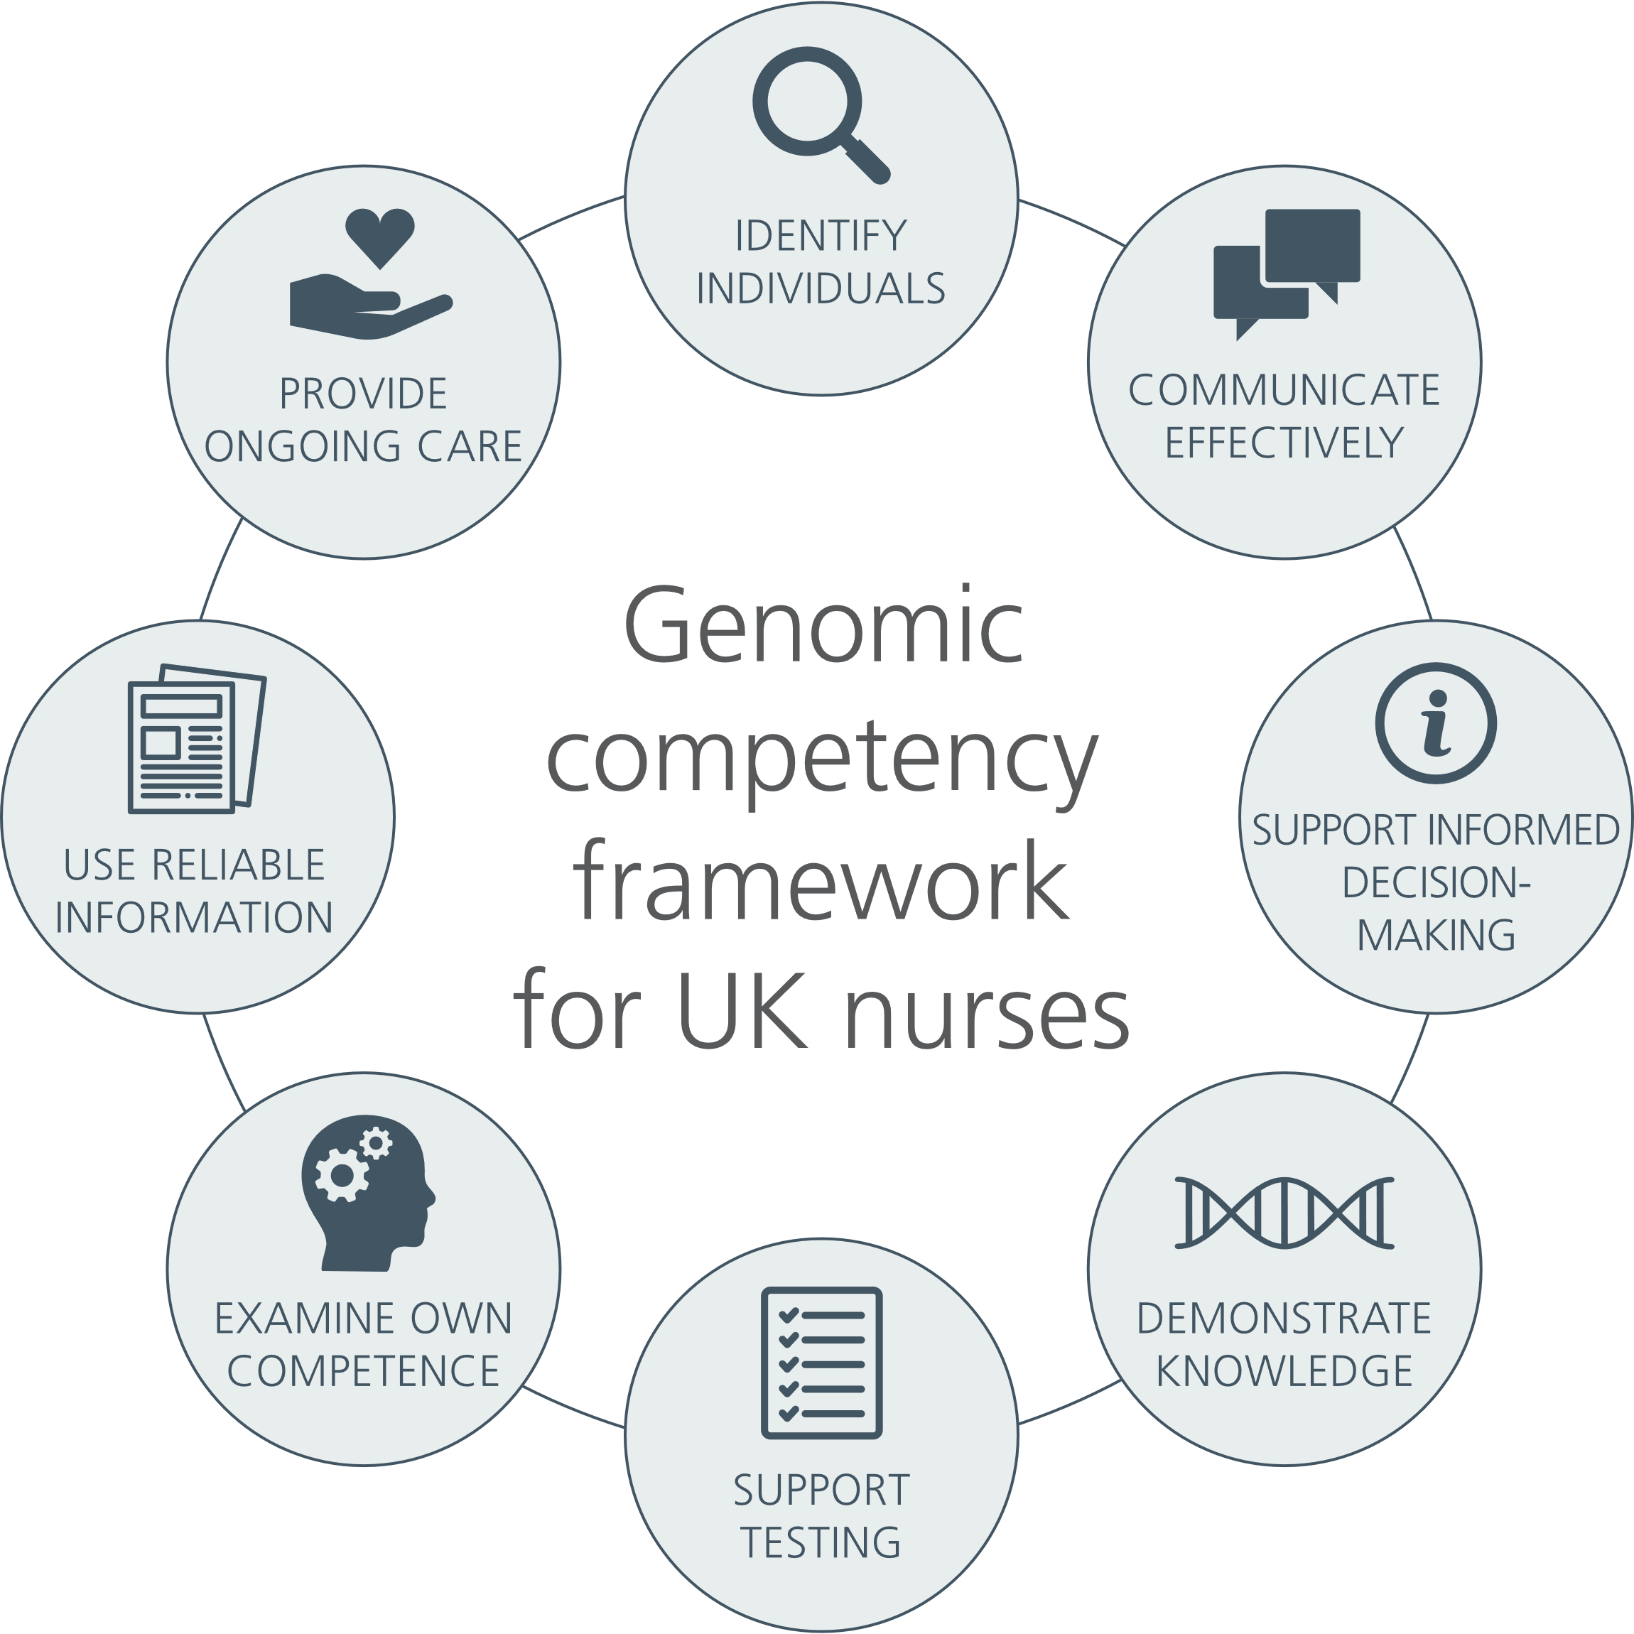

**Figure 2 Domains of competency**

## The 2023 Genomic Competency Framework for UK Nurses in full

**1. Identify individuals who might benefit from genomic services and/or information as part of assessing needs and planning care:**

* recognising the key indicators of a potential genetic condition, or clinical situation where genomics-informed healthcare would be appropriate;
* recognising the importance of family history in assessing predisposition to a genetic condition;
* based on an awareness of the care pathways relevant to your role that incorporate genomics services and information; and
* taking appropriate and timely action to seek assistance from and refer individuals to genomics specialists, other specialists and peer support resources.

**2. Demonstrate effective communication in tailoring genomic information and services to the individual:**

* recognising factors (such as ethnicity, culture, religion, ethical values, developmental stage or language) that may influence the individual’s ability to use information and services;
* listening to and acknowledging an individual’s prior experience or stage in their diagnosis/treatment journey; and
* demonstrating the use of appropriate communication skills in relation to the individual’s level of understanding of genomic issues.

**3. Advocate for the rights of all individuals to make informed decisions and act voluntarily:**

* understanding the importance of delivering genomic information and counselling fairly, accurately and without coercion or personal bias, to facilitate decision-making and manage expectations;
* recognising that your values and the values of others may influence the care and support provided during decision-making, and that choices and actions may change over time;
* ensuring that the consent process is person centred; and
* promoting and supporting equitable access to genomic services.

**4. Demonstrate a knowledge and understanding of genomics in human development, variation and health to underpin effective practice:**

* relating it to the maintenance of health and manifestation of conditions;
* relating it to the prevention and management of a genomic condition or response to treatment; and
* underpinned by core genomic concepts that form a sufficient knowledge base for understanding the implications of different conditions and clinical situations that may be encountered.

**5. Apply knowledge, understanding and context of genomic testing and information to underpin care and support for individuals and families prior to, during and following decision-making:**

* including types, uses and limitations of genomic tests to prevent, predict or treat a health condition, and an awareness of the processes for testing and return of results;
* recognising that decision-making and testing in some situations may be time-critical;
* incorporating awareness of the ethical, legal and social issues related to testing, recording, sharing and storage of genomic information and data; and
* incorporating awareness of the potential physical, emotional, psychological and social consequences of genomic information for individuals, family members and communities.

**6. Examine your own competency of practice on a regular basis:**

* recognising areas where professional development related to genomics would be beneficial;
* maintaining awareness of clinical developments in genomics that are likely to be of most relevance to your area of practice, seeking further information on a case-by-case basis; and
* based on an understanding of the boundaries of your professional role in delivering genomic healthcare including the referral, provision or follow-up to genomic services.

**7. Obtain and communicate reliable, current information about genomics, for self, patients, families and colleagues:**

* using information technologies and other information sources effectively to do so;
* applying critical appraisal skills to assess the quality of information accessed; and
* ensuring the information is appropriate for the intended audience.

**8. Provide ongoing nursing care and support to patients, carers, families and communities with genomic healthcare needs:**

* being responsive to changing needs through the life-stages and during periods of uncertainty;
* demonstrating awareness about how a genomic test result can have implications for family members and might impact on family dynamics;
* working in partnership with family members, multidisciplinary teams, and other agencies in the management of conditions;
* recognising the potential expertise of individuals, family members and carers with genomic healthcare needs, that develops over time and with experience; and
* promote healthy behaviours that may be beneficial to alleviate symptoms or, where applicable, implement management strategies or lifestyle changes to help reduce risk.

## Who are the competencies for?

First and foremost, the framework is applicable to all registered nurses, as it outlines the core genomic competencies required, irrespective of role or area of clinical practice.

Specifically, nursing managers could use the framework to guide and identify training needs for their staff, for instance during revalidation or appraisals, in addition to informing role definition and workforce development where competencies can be aligned to scope of nursing practice. Equally, the framework can be used by registered nurses to identify their own competence and identify their own education and training through CPD opportunities.

The framework can also be used as a tool to aid curricula design and facilitate the integration of genomics into teaching. Learning outcomes and practice indicators can be mapped to each of the eight competencies and a second piece of work by the project team is intended to do this. Due to the competencies outlining the core genomic knowledge, skills and attitudes, the framework is not only applicable to the post-registration space, but also the pre-registration space. Lastly, the competencies can be used as a foundation on which to develop frameworks for more specialist roles and pathways where genomics and nurses play a part – work that is already underway.

Complementing other educational initiatives produced by NHS England’s National Genomics Education programme, the competency framework supports a consistent approach to educating the workforce. Where applicable, the framework will align to specific resources to benefit educators and those in practice to embed genomics knowledge. Importantly, the framework has been designed by the profession for the profession to ensure adoption and application.

## Next steps

Despite engagement with key stakeholders, the previous competency framework was under-utilised. Therefore, the dissemination and sharing of this piece of work is paramount to its success. Coupled with this is the provision of supporting information and guidance on how to use the framework, which will further encourage its adoption and use across the profession.

A second piece of work is planned to add learning outcomes and practice indicators mapped to each of the competencies and where available identify supporting educational resources. The addition of this detail will support education, both in curricula design and assessment, and the measurement of competency in practice. A similar document was produced during the 2010 revision and can be found [here](http://www.genomicseducation.hee.nhs.uk/2010-nursing-competency-framework/).

The long-term goal is to ensure the use of the competency framework within nurse education and training across pre- and post-registration settings. We are conscious of the variation in the delivery of education and training for nurses nationally and the variation in nursing roles. As such, we fully expect that the framework may be adapted or modified to suit the situation. This could include developing the competencies to reflect additional knowledge and skills in specialist or advanced practice and the extended nursing family; for instance, nursing associates.

However, the project team hope that by providing a single framework to work from and guidance on how it can be used, there will be unified starting point that will encourage consistency.

## Projects leads

Dr Ed Miller, education specialist, NHS England’s Genomics Education Programme.

Associate Professor Emma Tonkin, Genomics Policy Unit Faculty of Life Sciences and Education, University of South Wales.

## Acknowledgements

This work was funded by the National Genomics Education programme, NHS England (formerly Health Education England).

#### Steering committee

* Michelle Bishop, associate director, learning and training, Wellcome Connecting Science
* Tootie Bueser, director for nursing and midwifery, South East Genomic Medicine Service Alliance
* Kate Davies, associate professor in paediatric prescribing and endocrinology, London South Bank University
* Nigel Harrison, pro vice-chancellor and dean, faculty of health, medicine and social care, Anglia Ruskin University
* Myles Harris, associate lecturer (teaching) in risk, disasters and humanitarianism, University College London
* Charlotte Hitchcock, associate director of nursing and midwifery, Central and South Genomic Medicine Service Alliance
* Tracie Miles, associate director of nursing and midwifery, NHS South West Genomics Medicine Service Alliance
* Alison Pope, deputy director, National Genomics Education programme, NHS England

#### Consensus panel

* Annette Breen, lead nurse, East of England Genomic Medicine Service Alliance
* Victoria Carr, lead nurse, East of England Genomic Medicine Service Alliance
* Angela Cazeaux, clinical nurse specialist, familial hypercholesterolemia, British Heart Foundation
* Ellie Gordon, senior nurse; learning disability and mental health, Workforce, Training and Education directorate, NHS England
* Bridget Hoad, senior regional clinical lead (nursing), Workforce, Training and Education directorate (Midlands), NHS England
* Lorna Hollowood, senior lecturer, adult nursing, University of Worcester
* Charlotte Jarvis, associate nurse specialist (endocrinology), Alder Hey Children’s NHS Foundation Trust
* Joann Kiernan, senior lecturer / learning disability consultant nurse, Edge Hill University / Alder Hey Children’s NHS Foundation Trust
* Eduardo Lee, renal genomics medicine clinical nurse specialist, Guy’s and St Thomas’ NHS Foundation Trust
* Adele Lewis, inherited cardiac conditions nurse specialist, Aberdeen Royal Infirmary
* Mark Mencias, neurogenetics clinical nurse specialist, St George’s University Hospitals NHS Foundation Trust
* Laura Monje-Garcia, national lead nurse for the Lynch Syndrome Project, St Mark’s Centre for Familial Intestinal Cancer (London)
* Sally Shillaker, practice development lead, genomics, Institute of Health Visiting
* Samantha Simpson, nursing associate external clinical educator, Abbey Medical Practice (NHS), Lincoln
* Jagraj Thandi, pharmacist, Barts Genomics
* Daniella Spiteri Cornish, lecturer in clinical education, University of Leeds
* Nicki Taverner, clinical lead for genomics, Health Education and Improvement Wales
* Lucy Tomlins, professional lead, learning and development, Royal College of Nursing

## References

1. Genomics England (2023). 100,000 Genomes Project https://www.genomicsengland.co.uk/initiatives/100000-genomes-project.

2. UK government (2020). Genome UK: The future of healthcare. https://www.gov.uk/government/publications/genome-uk-the-future-of-healthcare

3. UK goverment (2022). Genome UK: shared commitments for UK-wide implementation 2022 to 2025. https://www.gov.uk/government/publications/genome-uk-2022-to-2025-implementation-plan-for-england

4. Nursing and Midwifery Council Data report (2023) https://www.nmc.org.uk/globalassets/sitedocuments/data-reports/may-2023/isl114-23-er-data-report_final_web-acc.pdf

5. Nursing and Midwifery Council (2018). Future nurse: Standards of proficiency for registered nurses.https://www.nmc.org.uk/globalassets/sitedocuments/standards-of-proficiency/nurses/future-nurse-proficiencies.pdf

6. Kirk M, Tonkin E and Skirton H (2014). An iterative consensus-building approach to revising a genetics/genomics competency framework for nurse education in the UK. J Adv Nurs. 70(2):405-20. doi: 10.1111/jan.12207

7. Kirk KM, McDonald K, Longley M and Anstey S (2003). Fit for Practice in the Genetics Era: a Competence Based Education Framework for Nurses, Midwives and Health Visitors. Competent, capable, caring. Report to the Department of Health NHS Genetics Team Extended Summary. University of Glamorgan, UK. ISBN 1-84054-107-5

8. UK government (2003). Our Inheritance, Our Future: Realising the potential of genetics in the NHS. https://data.parliament.uk/DepositedPapers/Files/DEP2008-1084/DEP2008-1084.pdf

9. NHS England’s National Genomics Education programme (2023). https://www.genomicseducation.hee.nhs.uk/

10. Pichini A and Bishop M (2022). A nationally agreed cross-professional competency framework to facilitate genomic testing. Genetics in Medicine. 24(8):1743-1752. doi: 10.10116/j.gim.2022.04.2023.