Process evaluation of the familial hypercholesterolaemia CPI pathway: Summary of results

Introduction
The Clinical Pathway Initiative (CPI), led by NHS England’s National Genomics Education, aims to facilitate the integration of genomic competencies into mainstream clinical pathways, and to enable the wider healthcare workforce to support patients through genomic testing and management via a national and consistent approach.
The initiative maps clinical or patient pathways that involve genomic practice. At each step along a pathway the knowledge, skills and attitudes required by healthcare professionals interacting with the pathway are identified, and educational resources aligned that can be used to meet these requirements. Each pathway is typically designed to be profession agnostic and applicable throughout the country, allowing expertise and resources to be shared between professions and locations. The CPI is designed for service leaders and educators to identify and address workforce development needs. It can also be used by individuals to identify and address their own development needs.
As the primary evaluation, the National Genomics Education team conducted a process evaluation of one of the first CPI projects to be developed: familial hypercholesterolaemia. Using a mixed-methods approach, this process evaluation aimed to evaluate the usability and acceptability of the CPI by both authors and end users, and to provide insight into the innovation to make recommendations for optimal success. The protocol for this process evaluation can be found here. All interviews and surveys were conducted between April and May 2023.
Results from this process evaluation will help to inform a longer-term real-world evaluation of individual CPI projects, and their impact on workforce education, training, and patient care.

Key findings
- 92% of survey respondents, and 100% of end users, were either receptive or highly receptive to the CPI method and found the initiative essential or highly essential to meet the needs of the workforce.
- 100% of survey respondents rated the CPI as essential or highly essential to meeting the needs of their organisation’s goals and objectives. End users could not rate the CPI as essential at present due to the lack of incentivisation in their area but did view the CPI as a valuable and beneficial tool for professional development and mainstreaming genomic medicine.
- The CPI was commended by all interviewees for its simplicity and transferability to deliver consistent, high quality genomic standards for optimal service development and patient care. 100% of participants (survey and interviewees) thought that the CPI would be effective or highly effective if used in their setting.
- The familiarity of a competency-based tool to non-medical health professionals shows promise for integration into the wider healthcare workforce, with flexibility to be adapted to need.
- Incentives are key to the CPI success. Parallel development of CPI projects with service or job planning may assist with application for commissioning and other types of incentives.
- Incentivisation will also help to break down some challenges to CPI writing and implementation. These challenges included the availability of time, capacity, sustainability, and perceived role relevance in mainstreaming.
- Insights of how to improve usability of the CPI and thus improve success, are highlighted, leading to recommendations as written in the next section.

Recommendations
- Incentives should be used to successfully implement the CPI.
This has partially been addressed, as writing CPI projects is a named action of the Genome UK 2022-2025 implementation plan and Genomic Medicine Service Alliance (GMSA) deliverables. Further possibilities for incentivisation of the CPI would be endorsement from Royal Colleges or other professional bodies.

- Awareness of the CPI needs to be increased.
This has been addressed through improvements to the CPI webpage and presentations at national conferences. Further engagement with Royal Colleges/training bodies should be considered, alongside reporting of success stories of CPI pathways that have been written and/or implemented.

- The role of the lead author should be clear.
The role of a passionate and enthusiastic lead author with the ability to engage a working group comprising of members from a variety of backgrounds is essential to writing a CPI project. Working group members may include educationalists, multi-speciality, multi-professional healthcare staff and non-medical representatives including charities. The National Genomics Education team have accordingly written the CPI document: “CPI author role description”, which outlines expected roles and responsibilities of CPI project authors and is available via the National Genomics Education website.

- Visualisation of CPI projects should be easy.
Ease of visualisation of CPI projects should be improved. The new CPI webpage for completed CPI projects accommodates this, by presenting the step-wise competencies, the educational resources, and the workforce for each CPI project, as drop-down menus. An excel document for the FH CPI is also available to download for those that prefer spreadsheets. At present, an excel form seems most appropriate for authors, but can be adapted to local need. The National Genomics Education team will continue to review this.

- A generic template is required that includes pre-written common pathway steps and competencies.
Many competencies are repeated across multiple steps of the CPI or can be used in different genomic pathways. A new CPI template now accommodates pre-written common pathway steps and competencies, such that much of the generic writing is pre-filled for authors to then tailor to their chosen pathway.

6. Support should be provided to authors.
The National Genomics Education team have provided several documents to support authors in writing a CPI project. Workshops and drop-in sessions are also being held to trouble shoot and help to provide further support.

7. An evaluation toolbox should be developed for real-world evaluation. Validated resources for real-world CPI evaluation should be signposted to, or new resources developed where needed, for end users to apply in their own setting, such as pre-made patient surveys.

Results in detail

The respondents
Survey: 15 authors were invited to the FH CPI process evaluation survey.12 authors responded to survey, consisting of a range of professionals with roles related to the subject area of familial hypercholesterolaemia, some with multiple roles, and from widespread geographical areas.
- four had educational roles: GMSA education and training lead, assistant professor or professor;
- five were GMSA leads for the national transformation FH project;
- five were health professionals: consultant genetic counsellor, pharmacist, nurse or GP; and
- four had advisory roles: AHSN NENC CVD programme lead, AHSN NENC specialist advisor, co-director of PRISM or clinical lead.
Notably, 42% of participants who responded to survey had a role in leading the National Transformation FH Project.
Geographical locations/organisations of survey respondents included the following (some multiple):
South East England GMSA (two respondents);
North East Yorkshire GMSA (two respondents);
North Thames GMSA (three respondents);
East of England NHS Trust;
Guy's and St Thomas Hospitals;
Universities: Northumbria University, UCL; and
National: Academic Health Science Network (two respondents) and HEI.

Interview: four of the 12 authors were invited to interview. Their roles included:
- GP/primary care lead and co-lead for the National Education and Training Workstream for FH;
- FH lead nurse
- Assistant professor (previous nurse and GC); and
- GMSA pharmacy lead (genomic specialist pharmacist) working in collaboration with NHSE National Genomics Education.
Geographical locations/organisations of interviewed authors included:
- North Thames and South East GMSA;
- North East Yorkshire GMSA (two respondents); and
- Northumbria University/Academic Health Science Unit.

The FH CPI was not published on the GEP website at the time of evaluation, therefore only two end users were known. Both end users - a pharmacist in secondary care, and a pharmacist working in interface between primary and secondary care from North East Yorkshire GMSA and North Thames GMSA - kindly agreed to interview. Surveys were not collected from end users to avoid duplication of data in this small cohort. All survey responses are therefore collected from the authoring group.

Motivations for developing the FH CPI
Survey respondents were asked to choose from select options their motivations for developing the FH CPI. Respondents could choose any number of listed motivations, and free text was provided for any other motivations not listed.
Motivations ‘Represents a local pathway in need of genomic input’ and ‘Genomic knowledge required for national pathway guideline’ were each selected in nine responses.
The motivation ‘Awareness of local need amongst colleagues’ was selected in seven responses.
The motivation ‘Requirement of the GMSA’ was selected in six responses.
Motivations ‘Requirement of the National GMS Transformation Service, and ‘Pathway reflecting the national test directory’, were each selected in five responses.
The motivation ‘To anticipate/represent a pathway in your area’ was selected in four responses.
The motivation ‘Personal interest’ was selected in two responses.
One response was left in the free text box for ‘other’ motivations: ‘Used CPI as a framework to underpin the development of an FH module previously in collaboration with AHSN. Interested in sharing this experience and widening the applicability of this approach’.
National policy and incentives were remarked upon by both authors and end users as a reason for writing or implementing the FH CPI.
Author: ‘The NHS long term plan (seeking to identify 25% of people with FH by 2024)’
End user interview: ‘indirectly it [impacts] on [priorities of work] and what's being commissioned’.
This is reflected by an author survey response, who also supported the authoring process of the CPI through their commissioned role in the FH proactive care framework.
Survey Response: ‘the DES (Directed Enhanced Service) had a little bit of an influence’.
DES’s are nationally agreed enhanced services that are commissioned, and which are offered to all GP practices in England. Whilst ‘service pressures and capacity’ (Author), and ‘local need’ (end user) also acted as drivers for CPI creation, goals beyond the initial scope of the CPI also acted as personal ambitions and development for CPI authors and end users:
Author: ‘more widely in the NHS long-term plan, the drive to deliver care closer to home to patients when possible… so the idea to be able to counsel and test them within their GP practice without them having to wait a certain number of months and then travel in order to go and see a specialist service’
End user- ‘from my point, I think a little bit beyond the CPI, which is very focused on actually case-finding, it's about opportunistic finding that I do quite a lot of while I'm optimising patients’.

Usefulness of the CPI
Qualitative analysis of the usefulness of the CPI – themes and key findings:
- Meeting the needs of the mainstream workforce: authors view the CPI as essential. End users see value in the CPI, but do not yet view it as essential due to the lack of incentivisation.
- CPI content: authors considered the CPI competencies to sufficiently cover complex issues associated with genomics. End users disagreed.
- Role optimisations: need to correctly target appropriate workforce, considering the balance between natural role extension and cost of target workforce.
- Clinical governance and service planning: authors and end users appreciate the ability to set standards. This was also felt to be helpful for job planning and service development.
- Integration of the CPI: Author and end users can visualise the CPI being embedded into professional frameworks and processes of the wider workforce.
Meeting the needs of the mainstream workforce:
Reflecting one of the main aims of the CPI, recognition of the impact of the CPI for mainstreaming was highlighted.
Author: ‘It’s all around trying to…mainstream genomics’.
End user: ‘the CPIs are really relevant to the rollout of genetic testing and getting that into mainstream practice’
Building on this, authors commented on the essential need for the CPI.
Figure 3: Bar Chart to show the views of survey respondents on whether the CPI is essential to meet the needs of the workforce and organisation.
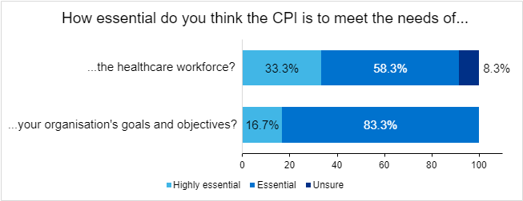

91.6% of survey respondents rated the CPI as essential or highly essential to meeting the needs of the workforce.
100% of survey respondents rated the CPI as essential or highly essential to meeting the needs of the organisation.
Author: ‘I think it's essential to have a competency framework for any mainstream genomic test… you're essentially asking them to do something, which has been the remit of the clinical genetic specialty for a number of years’
Although end users recognised the potential of the CPI to enable professionalism in genomics;
End user: ‘Its existence is crucial and its value. I think it's making sure that there are appropriate resources in place to allow the implementation’.
They also recognised that without incentivisation, the CPI will not be used to its optimal capacity in implementation.
End user: ‘at the moment it's not a commissioned service, so it's not essential’.
CPI Content
Regarding the content of the CPI to meet the needs of the workforce, there was a difference of opinion between authors and end users regarding genomic consent, counselling and complex issues.
Author: ‘the framework really helps with understanding those complex issues (ethical issues and you know, particularly families not getting along) and helps with providing some sort of answers… issues that you might never have had to deal with before.’
End users disagreed on the basis that this was a very new skill for them, and that more supporting competencies and resources were required.
End user: ‘But for pharmacists…We don't consent anybody for anything. It's all already done by another profession. So the genetic counselling and gaining consent [is] a very new skill for pharmacists.’
End user: ‘[we need] that awareness of what that means when having those consultations with individuals that they're longer than 10 minutes’
End user: ‘basically more complex conversations or shared decision making needs to be in there as well’.

Practicalities surrounding consenting and counselling competencies were also considered as a potential obstacle even with the attainment of these skills.
End user: ‘So depending on which area of pharmacy you're working in, you may or may not have access to patient notes…
And so, so there's the first thing about actually recording your conversation of consent. But then the second thing is being able to go back to that conversation.’

Role optimisation:
Furthering thoughts toward mainstreaming, correct targeting of training was also considered, as one end user described as:
End user: ‘getting the right buck for your money’.
A variety of factors need to be considered to ensure this, including a firm baseline of training to build upon at pace, and the costs involved.
Author: ‘pharmacists already had a considerable role in managing lipids …it seemed a natural extension of their role’,
End user: ‘we are expensive in comparison to nurses…pharmacists do have a role, but it's (about) making sure …the use of your whole workforce is done appropriately for that vehicle of mission and service’,
Costs also include personal implications, for example indemnity for consenting and diagnosis in the wider workforce.
End user: ‘giving someone a diagnosis…is something some pharmacists do with extra insurance…there might be something around insurance and diagnosis or misdiagnosis’
Author: ‘…would you be covered if you made a mistake or something?... if you've aligned to the national framework, is that enough?’.

Clinical Governance:
Regarding current practice in mainstreaming genomic medicine, it was commented:
Author: ‘I feel there’s quite a lot of variation in practice’.
Authors and end users commended the CPI for its ability to set consistent standards in genomic competencies.
Author: ‘one of the key benefits of CPIs is to provide a standardization across different multidisciplinary workforce groups so that there's almost a standard of high-quality care no matter what your professional occupational role that you meet the same standards as another colleague’.
End user: ‘I think the CPI definitely provides assurance for service…commissioners to know…that there's consistency in what's being provided’.
Author: ‘it was very necessary having a competency framework of sorts… in order for people to be able to benchmark their competency against it and show that they would be able to deliver this… it's really key for governance reasons’.
Clarity of the scope is recommended by end users to encompass clinical governance in CPI content.
End user: ‘there needs to be some kind of safety and clinical governance incorporated into it as well... I think it does mention it in the CPI that within your professional boundaries.’
Service Planning
Standardisation of competencies, and clinical governance, was felt to be an important use of the CPI in role specification, job planning and service development.
Author: ‘I see it as a support document. So if you're involved in these types of services, you could reflect and see whether your practice aligns to the recommendations on the CPI’.
End user: ‘the CPI definitely provides assurance for service commissioners to know exactly what's being provided, but also to know that there's consistency in what's being provided.’
Integration of the CPI
The end users of this process evaluation had not yet implemented the FH CPI themselves but were looking at how the CPI could be integrated into pharmacy training.
End user: ‘we are looking at the educational training infrastructure for the pharmacy workforce that complement the CPI… for qualified pharmacists from foundation level to advanced practice.’
End user: ‘We have identified key stakeholders that are part of the educational training workforce for pharmacists that we will be engaging with through questionnaire in order for us to just see their appetite, where they're at, their faults and opinions and any recommendations.’
End user: ‘We need to speak to service commissioners to understand what they want pharmacists to be able to demonstrate, to show that the service is safe and consistent.’
This complements one of the aims of the CPI; to be a workforce agnostic approach to the integration of genomic competencies across pathways. Moving forward, an author considered an ambition of the CPI to ‘(look) at how we can take it as a professional agnostic tool and embed it within profession specific frameworks and processes’.
Other future goals mentioned by authors of the CPI included service expansion, engagement from recognised educational bodies, further mainstreaming of genomic practice, and achieving ‘that wider audience and awareness’ for FH, the CPI, and National Genomics Education as a whole.
Author: ‘I know [what the] CPI [is]. Oh, now I know who the Genomics Education Program are, and it'll kind of join the dots’.

Acceptability of the Clinical Pathway Initiative
Qualitative analysis of the acceptability of the CPI – themes and key findings
- Receptivity: both authors and end users were open to using the CPI tool but acknowledged that some in the wider workforce may still consider genomics as outside of their role.
- Acceptability as an educational tool: Authors and end users reflected on the familiarity and transferability to the delivery of both genomics and other educations initiatives and fitted in with norms and values in their area.
Receptivity:
91.7% of survey respondents felt that their organisation was receptive or highly receptive to implementing the CPI, the remaining 8.3% were unsure.
Both authors and end-users at interview valued the potential of the CPI as a useful framework. Individually, all interviewees were open to utilising the CPI, but end users emphasised the need for a supportive team to fully achieve the benefits offered by the CPI.
End user: ‘we're quite receptive, we're quite driven... [we would] probably take it [using the CPI] in [our] stride’
Author: ‘I think they all see the value in it and really want to actually promote this and make it a widely known resource…people definitely see the value using the CPI and the potential it has’.
End user: ‘I'm very fortunate to be part of a team that is into innovation and testing…So if given the right forums, they'll be more than happy to test and make this part the normal programs that exist’.
However, concern remains that for many members of the wider workforce, genomics is still niche.
End user: ‘in my opinion, I don't think my local colleagues are aware of genomic medicine’
Author: ‘I just still think that anyone working in mainstream medicine still doesn't think of genomics as part of their role’.
Acceptability as an educational tool
End users and authors reflected on the familiarity, and thus transferability, of the CPI as an educational framework to apply in their setting.
End user- ‘We have competency frameworks, which are similar in that they list… skills that you would need to demonstrate in order to achieve a certain level. And so I can see that the CP. is similar to a pharmacist education framework, however, nothing exists at the moment for genomics or clinical testing or FH’.
Author- ‘essentially you have the different activities similar to the CPI with the education resources, and…you would tick to say you'd done these various education[al activities] and then… self-declared competence in order to provide a service. The difference is for those there's often a service spec…’
The CPI was thought to be helpful to demonstrate qualities of the workforce needed when delivering a service, or be used to build up a business plan for service development. Due to its workforce agnostic approach, an appreciation of the method for adaptability to suit local or workforce requirements was also acknowledged by authors and end users. Outside of genomics, an appreciation for application of the CPI as an educational framework in other areas was observed.
End user: ‘this is broader (than other frameworks) for the workforce and any commissioner or provider can look at it and then decide which specialists or areas in their workforce may be able more suitable’
Survey response: ‘CPI can be used to underpin the development and delivery of education initiatives. Also, to allow for assessment purposes if required. The CPI could also be applied to direct or influence professional and service development in FH’.

The CPI’s constructivist approach to learning in the CPI was also discussed as a preferential approach to changing attitudes toward genomics.
Author: ‘We've got a lot of behaviourists …they like to be passive learners, but I think with this it, it stretches them out of that comfort zone and gets them to look.... You're not here just to learn about something. You are here to understand why that's important and who it's important to. So, I think to be able to change your attitude towards genomics and genetics, it would be a good motivator’.
Fitting into norms and values:
Naturally fitting with routine roles and practice is key in successful implementation of new interventions. The CPI was developed to mirror this, both in methodology, and in role relevance.
Author: ‘it was develop[ed] to reflect the existing clinical pathway’
Author: ‘Of any educational, approach that you want to use, making the patient journey in the clinical pathway and to see when touchpoints are, it makes it a little bit more understandable’.
Author: ‘and certainly the allied healthcare professionals… it very much fits with their working practices that they would… need… a protocol, a competency, education resources that meet that, and then a process for… essentially signing off their competency’.
For end users, the CPI method fitted with, and built on, their previous experience with educational frameworks.
End user: ‘I think it's acceptable, the way that it's set out... I liked it as a pharmacist with the pharmacist's brain, that that was how I liked lists of things and I liked the way that it was set out’.
The authoring group proposed an ambition of the CPI being accepted into routine practice.
Author: ‘I hope that they would welcome it as any sort of updates to NICE guidance. This is just a sort of an adaptation to their normal practice and, and improvement on it’.

Usability of the CPI
Adapted questions of the validated ‘System Usability Scale’ (SUS) provided a quantitative figure of usability. In the SUS, a score of 68 or above is considered as above average.
10 of the 12 survey responders, and 2 end users, completed the System Usability Scale.
In this process evaluation, the median SUS score for authoring was 65, and 72.5 for implementation.
Some authors commented that, in acting as reviewers, that they could not accurately comment on the writing process of the CPI, which may have influenced some scores.
Additional themes needing to be addressed to aid improvement emerged from survey free text and interviews as follows:
Usability of the CPI – themes and key findings
- Practicality associated with visualisation: presenting the CPI as an excel spreadsheet is suboptimal to reviewers and to end users.
- Overarching concepts: numerous competencies can be applicable to multiple CPI steps or pathways
- Authoring group support: further clarity and direction may be helpful for future CPI pathways.
- Awareness of the CPI/NHSE National Genomics Education: authors and end users highlighted the need for further advertisement of the Cpi/GEP through endorsement and sharing of success stories.
- Adaptations of the CPI: the CPI can be adapted toned. In the case of the FH CPI, a ‘digital solutions’ column was added. Other considerations include role/grade separation, and inclusion of a self-declaration of competencies.
Practicality associated with visualisation
Whilst the excel preference worked well for active CPI writers:
Author: ‘I like… the Excel spreadsheet representation because you can get quite a representation of a stepwise project with several components’,
Excel visualisation was largely considered to be suboptimal to both reviewers and end users.
Author: ‘I think the biggest challenge with developing CPIs is how to visualize them…if it was linear [vertical], I would flick through and have a read. But because the CPI goes horizontal, It's really difficult to view on an Excel spreadsheet’.
End user: ‘Simplifying the CPI content format and design for practical use will simplify it and make it more attractive for the user’s eye to process. This has influenced some of the scores’.
Overarching concepts
Authors noted numerous competencies that could be common to many or all steps of a CPI pathway, or indeed applicable to other CPI projects..
Author: ‘we recognized that there were overarching competencies that would apply to the whole of the CPI and started to think about how they could be represented within the CPI’.
Author: ‘there's probably quite a lot of overlap, isn't there with just general genomics’.
Support in writing/reviewing
Being the first CPI project, the FH authoring CPI group acknowledged the need for improved clarity and direction from the genomics education team for the development of future CPI projects.
Author: ‘We were writing this tool as a national transformation project team and therefore had the relevant participants/capacity working together to enable this to happen- support may be required from the GEP team in other scenarios.’
Author: ‘A “quick guide” including how to word learning objectives/educational needs would be helpful.’
In consideration of the reviewing process, one author reflected that a “shared forms” system may also be useful.
Awareness of the CPI / NHSE National Genomics Education
Knowledge of the FH CPI to end users was limited due to its lack of website publication at the time of evaluation. Further promotion of the CPI method was desired by both authors and end users.
Author: ‘I think perhaps we need to make it more explicit that this is the approach to education and training that we're using and how it can be actually used to develop services.’
Author: ‘unless you're involved in it, I don't think anyone knows about it.’
End user: ‘it feels for me that genomics is still a very specialist service and perhaps only specialists would look for it or know where to look for it.’
Speciality and professional college/societal endorsement and advertisement was suggested as one way to overcome this.
End user: ‘I'm a member of the RPS (Royal Pharmaceutical Society) and I've just joined the UK CPA (UK Clinical Pharmacy Association) genomics and I do get random emails from other areas…’
Other possibilities for advertisement of the CPI included an introductory video of the intentions of the CPI to be uploaded to the website, more examples of CPI projects ‘to see what’s kind of worked and what hasn’t worked’ (author), and the use of success stories:
End user: ‘NICE have got an example of that, haven't they… I think it really helps people to understand a service, or how to use the training when, when you can actually visualize a service and understand somebody's already done this work’.
Adaptations of the CPI
The authoring group took it upon themselves to adapt the CPI to contribute to digital usability, which was felt to be important in the primary care setting.
Author: ‘We did also identify that it would be useful to have a further step, which was around supporting data and digital solutions for each step as well.’
Other consideration for CPI adaptations included a self-assessment/self-declaration of competencies;
Author: ‘So if you've been doing FH gene testing for many years professionally, You could tick that box without doing the education that's recommended via GEP, because you could meet that via a different route’.
and consideration of role/grade separation
End user: ‘I would just add a standard, I guess part of regulation…is which parts should be mandatory for people that are doing certain elements’.

CPI success:
Confidence of success:
100% of survey respondents felt that the CPI would be very effective or somewhat effective in their setting.
Potential challenges to success:
Interviewed authors gave insight into some reservations toward effectiveness.
Author: ‘I think there's gonna be maybe a bit of a time lag”… it'll be an evolution with time where we see more and more mainstreaming and I don't know, larger pilots or commission services’.
The need for commissioning and incentives were repeatedly stated by both authors and end users as key to successful implementation and sustainability of the CPI on a national basis.

Author: ‘I think it will be the same as if things are currently, it'll be in isolated areas. It won't necessarily be nationally as it. As it should be. And there'll still be pockets of different practice. Unless there is that sort of national sort of hammer throw’.
End user: ‘if the incentives continue, it'll actually be well used because there is a demand for it and there is a service that will exist nationally where people would want that guidance to make sure that they are providing optimal pathways for their local communities. I think if the incentives do not exist, that will be one of the biggest boundaries’.
Suggested incentives from interviewees included commissioning, formal recognition in competency achievement, and mandating competencies.

Figure 6: Diagram to display interplay and co-dependence of CPI development, role specifications and commissioning.
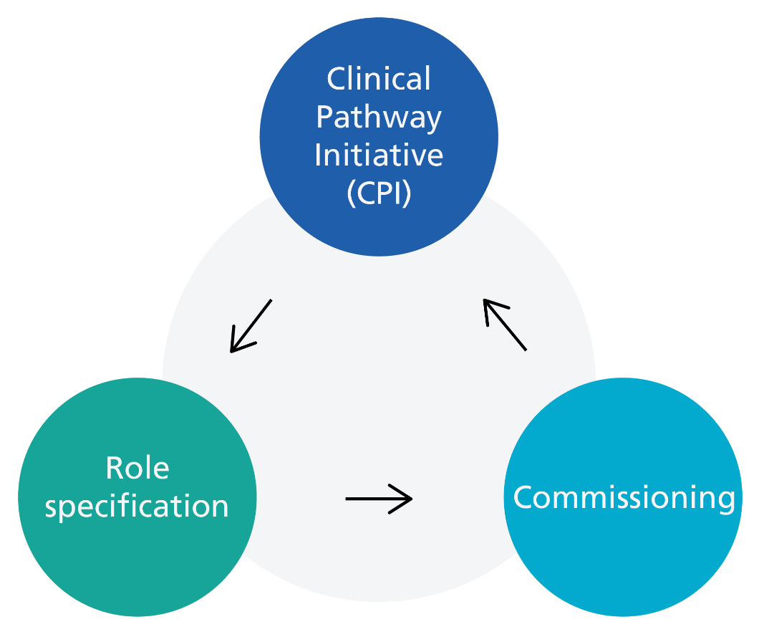
The interplay between commissioning and service/role specification was specifically mentioned for sustainable success.
Author: ‘you can't have a service without having some kind of role specification. But on the other hand, if you have a role specification in no service, then it's not gonna be sustainable. So, it's just thinking about that in the wider context and developing both in parallel’.
Incentives were also valued to gain “buy in” from employers and provide protected time from employers to increase their capacity to write and implement a CPI project.
Author: ‘the time element is a factor I think’

Survey Responder: ‘I believe CPI can be affective, however will need support and incentives to allow clinicians to have the time to upskill and adopt the pathway in practice. Otherwise there is a risk of continued varying practice across the UK and unequitable access to genomic testing’.

With incentives, end users stated that they would be ‘a hundred percent confident’ in successful implementation of the CPI.
Whilst ‘Lots of resistance to change’ was perceived by one survey responder as a potential barrier, another survey responder offered that ‘there remains a reluctance to teach genomics and genetics but this approach could make it easier to understand the principles behind the science’.

Resources:
Alignment of educational resources was considered to be a benefit of the CPI above other educational tools that are available.
End user: ‘I don't think there's a particular forum that exists at the moment that you have the composite of all the resources that are available.’
However, this may make the CPI vulnerable if educational resources are not available to all who use that CPI project.
Author: ‘how do you meet that competency without that resource, and also, where education is provided by a university or locally. So for example, Northumbria University do a course on FH gene testing, but how does that (become) readily available nationally so everyone can access it?’
This demonstrates that there may be smaller pockets of quality education, which may be in high demand, but may not be shared in a high-level CPI project due to limitations in access or being of high cost to the delivering institution or subsequent learner.
Author: ‘the training courses which meet the education means of the competency framework (are) vastly oversubscribed”’
Capacity of the workforce may also be a limiting factor to success, as one author commented: ‘resources are difficult in terms of people availability’.
This statement was made with respect to those who may be available to run courses but can also reflect the workforce in general. Capacity of the workforce is influenced by role responsibilities in the time that is available to them. A CPI author who had delivered a course covering some of the FH CPI competencies reflected that even after implementation, previous working demands had not changed sufficiently for the new skills to be practiced. In speaking of effective counselling:
Author: ‘what came off the back of our pilot (was) that they didn't have time to do the screening really properly’ .
Finally, ensuring quality of the educational resources to be aligned, including highlighting any training courses, was also considered to be challenging for authors.
Author: ‘And if they're up to standard as well, because you can't be responsible for reviewing their content’.

Figure 7: Diagram to demonstrate perceived barriers to successful implementation, inputs to overcome them, and outputs of successful implementation for future targeted evaluation.
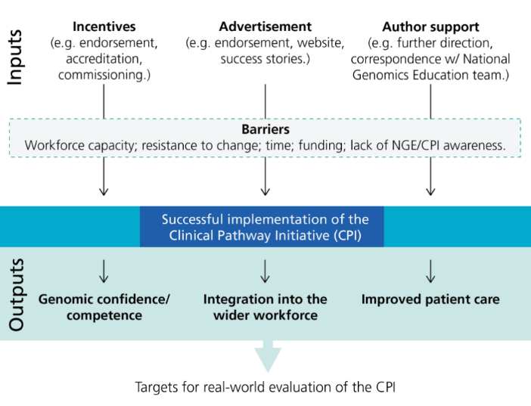

Practicality in writing a CPI: the FH experience
The process of writing the FH CPI was described as “very interesting and enjoyable” by authors. Authors described their first draft as being formed by a smaller cohort of individuals.
Author: ‘we did think carefully in the group as to who was needed.’
Expertise from different specialities, professions, and areas of medical education, formed part of that core group.
Author: ‘I think this is key for (the) CPI… to work. I think you have to work as a team and have within that team experts in different areas, and that really helps it to become robust.’
The first draft was ‘extensively modified’, and the core group met virtually every 6-8 weeks, although this ‘changed with need’. Email correspondence was also exchanged between those meetings.
Author: ‘I always knew that if I needed to get in touch with anyone outside of those meetings I could do’.
Once the core group were satisfied with their draft, wider feedback was sought from special interest groups, charities, and other GMSA areas.
Author: ‘Once we had the initial, reasonably firm draft, we then circulated it much more widely… to other groups that had a national interest really in the project. We circulated it to the National Oversight Group for the FH GMSA project…(and) more in depth to Heart UK. We circulated it to the primary care special interest group in genomic medicine as well because they comprised GP’s and pharmacists, obviously from primary care who've got additional expertise (and) also to the North East and Yorkshire and North Thames GMSA steering groups for the project. So we did seek feedback really quite broadly’.
Feedback from the wider group was obtained via email, and as an agenda item on the steering group meeting for the FH transformation project.
Authors acknowledged the need for an enthusiastic leader to drive a CPI project through to completion.
Author: ‘the output would've maybe been different if you didn't have that leadership person taken responsibility for the development and delivery of it’.
One challenge to writing reflected thoughts around best practice.
Author: ‘I think it's about what best practice looks like. And the challenge is sometimes this isn't fully embedded, so you don't quite know what best practice is.’
This can be supported by the National Genomics Education team.
Author: ‘I think the Genomics Education Programme are really the trailblazers here and within genomics and workforce. They are the sole point of training and education, so I almost think they can set their own standards and values’.The National Genomics Education Team have informed insight of core values and competencies to be recognised by all professionals when mainstreaming genomic medicine and can assist in the recognition of these across all CPI projects.

Figure 8: The CPI authoring and reviewing process.
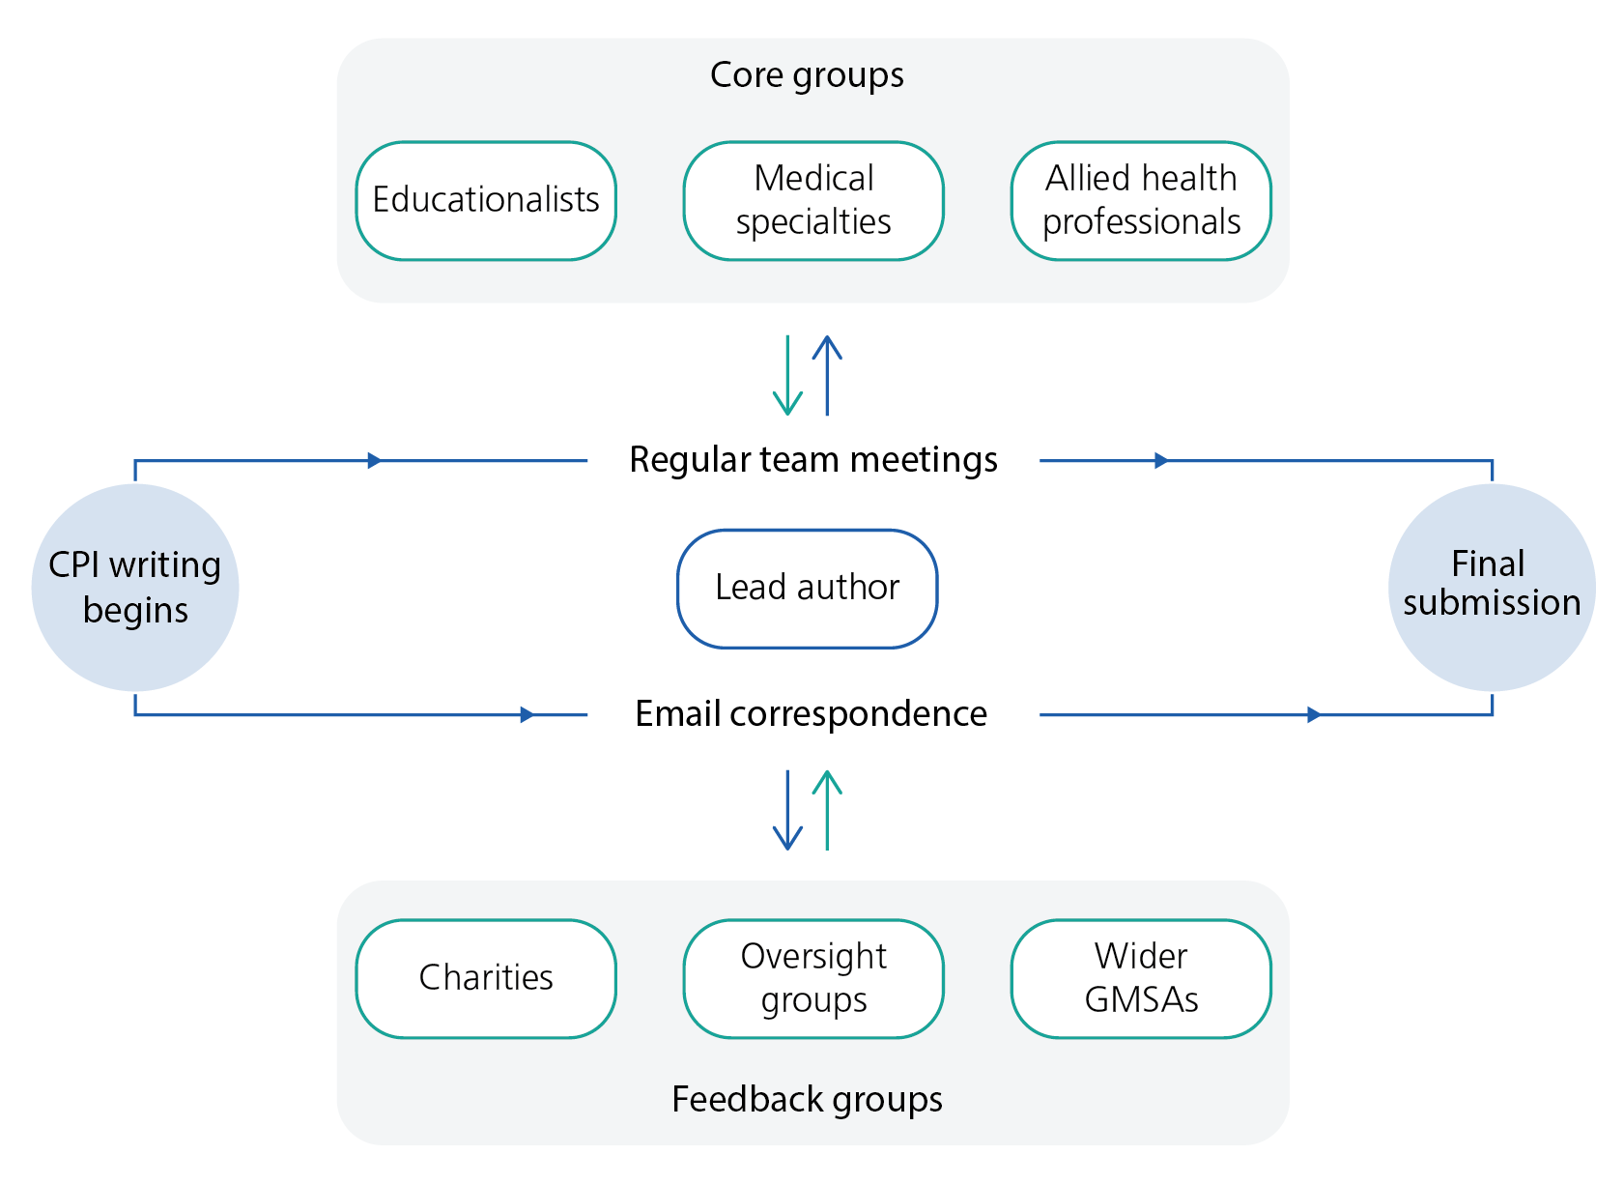

Future evaluation of the CPI
Authors recommended the option for viewers of individual CPI projects to provide informal feedback on the website.
More formal parameters for CPI evaluation included a national survey, and to measure, to quote one author; ‘…how successful this could be in clinical practice to develop services’, in addition to patient feedback, particularly around counselling. One author had piloted a project around FH counselling with rating scales, describing their evaluation as
Author: ‘a patient feedback form of the experience. So whether or not they knew they had FH and…[what they] felt that had been well explained, [whether] they knew the implications for themselves and their family and basically, how good the counselling was and if they thought it was a good idea to have this process in primary care.’
It was felt that this type of approach could be used in evaluation of the CPI. The use of patient feedback regarding the service that they have been involved in, and counselling received, was mentioned by two authors in interview. This has consequently informed the final recommendation of this process evaluation to contribute to future evaluation of the CPI in practice.

