Familial hypercholesterolaemia pathway mapping
Briefing paper

Clinical pathway initiative and digital solutions

Dr Judith Hayward, Dr Dermot Neely, Lindsay O’Dair, Andrew Michaelson and Dr Michael Wright (on behalf of North East and Yorkshire Genomics Medicine Service Alliance and in collaboration with Academic Health Science Network North East and North Cumbria)

1.0 Purpose
To present the range of existing and imminent digital technologies that could support clinical pathway and service development in identifying people affected with familial hypercholesterolaemia (FH). Maximising the potential of digital infrastructure is embedded within the NHS Long Term Plan, Accelerating genomics medicine in the NHS strategy and current primary care practice, including electronic health records (EHRs).
To scope digital solutions for all stages of the FH identification and testing pathway and is relevant to those involved in delivery and development of services for patients including: commissioners, clinical leads, informatics healthcare professionals, primary care and secondary care.
2.0 Background
FH is an inherited condition that predisposes affected individuals to extremely high cholesterol levels and premature cardiovascular disease. It is currently under-diagnosed, with only 10%–15% of those affected believed to have been identified. The NHS Long Term Plan has set an ambition to identify 25% of the predicted FH patients in the next five years. A national transformation project was funded to support this ambition, delivered through seven Genomic Medicine Service Alliances (GMSAs), with an aim to identify effective strategies to increase detection of patients with FH, mainstreaming of FH testing and pathway transformation. Existing services and pathways show variability in models, maturation, resources and access between geographies.
End-to-end clinical pathways deliver patient care as well as being a mechanism for provision of education and workforce development, with enormous potential for supporting digital technologies. Within primary care, GPs access information at the point-of-care; developing and embedding point-of-care resources, information and expert advice within clinical pathways and IT systems is crucial. Digital transformation has been identified as a key priority within the NHS Long Term Plan; the Covid-19 pandemic was a significant driver in progressing development and embedding digital technologies.

NHSE's National Genomics Education (NGE) programme recognises the importance of high-level clinical pathway development, sharing learning and promoting consistency through development of its Clinical Pathway Initiative (CPI). The CPI comprises a library of template clinical pathways for use across the NHS that map episodes of clinical activity, educational resources, healthcare professionals and digital technologies. North East and Yorkshire (NEY) GMSA and North Thames GMSA jointly led, in collaboration with the NGE, the development of the episodes of clinical activity and competencies components specific to delivering FH diagnostic testing to adults.

This briefing paper summarises the broad categories of digital technologies, illustrated with specific examples, and then maps these technologies to the episodes of clinical activity identified within the FH CPI. This package is led by NEY GMSA with expert input from members of the NEY GMSA FH Project Steering Group, GMSA FH National Oversight Group, Primary Care Special Interest Group for Genomics, Academic Health Sciences Network North East and North Cumbria (AHSN NENC), Heart UK and NGE.

3.0 Digital technologies and solutions
These are summarised within the following categories:
- Integrated within primary care records and IT systems.
- Facilitating direct patient contact.
- Provision of expert advice.
- Requesting FH testing.
- Web-based technologies and apps.
Please note that there is overlap across these categories.
3.1 Integrated within primary care records and IT systems
Searches which mine primary care records for specific Read / SNOMED-CT codes have been developed by PRIMIS (based on the FAMCAT tool for FH identification) and CDRC. Both platforms integrate with the two main primary care IT providers in the UK: SystmOne and EMIS Web.
In primary care there is widespread use of pathway repositories, which may be embedded directly within IT systems or within local intranets (for example, CSU or Trust). Templates supporting clinical pathways embedded within primary care IT systems are accessed within a couple of clicks and have the potential to support a wide functionality, for example:
- Summarising relevant Read or SNOMED-CT codes (for example, for Dutch Lipid Clinic Criteria).
- Presenting relevant results (for example, total cholesterol (TC) or low-density lipoprotein cholesterol (LDL-C) results over time).
- Referral criteria.
- Referral forms which are auto generated and integrate patient details, consultations and results.
- Consent forms.
- Direct requesting of advice from secondary care.
- Hyperlinks to guidance and other information for both healthcare professionals and patients.
- Key points for clinical management.
Educational resources: the NGE-led GeNotes workstream.
Appendix 1 contains screenshots from Familial Breast Cancer Pathway (based on NICE CG164 Familial Breast Cancer) embedded within SystmOne, demonstrating integration of decision support, key points for clinical management for those at near-population risk of developing breast cancer, links to guidance and patient information and functionality to incorporate into SMS or email to the patient.
Templates may be developed locally or developed nationally and enabled locally: an example of one provider of the latter is Ardens.
There is potential for automation of processes and machine learning within primary care systems.
3.2 Facilitating direct patient contact
Several platforms now support direct text messaging of patients: from SMS to platforms such as Airmid or PATCHS. The non-SMS platforms have the potential to include the option for patient replies, utilise embedded text templates, add hyperlinks to NHS or other online information, hyperlink directly to a form within the patient record or contain a proforma for the patient to complete electronically. These platforms can be used to contact patients or seek information such as family history.
Online appointments via platforms such as eConsult or Medilink are protocol-based and, following patient choice of category or keyword, will require the patient to answer a pre-determined list of questions with the option to attach photos.
There are also platforms for video consulting, alongside telephone and face-to-face consultation, to support a variety of patient interactions depending on clinical scenario.
3.3 Seeking remote expert advice
Advice and guidance is a service that allows one clinician to seek advice from another via the NHS e-Referral Service (e-RS). Requests and responses are in the form of text messages to the clinicians through the service, either via a dedicated portal or electronic integration of their clinical system within the e-RS. Advice and guidance messages may include patient details but not access to primary care EHR.
Consultant Connect provides a platform for direct specialist advice and guidance by phone outside the primary care EHR.
Electronic advice service allows a practitioner to request specialist advice directly from the primary care EHR. An electronic referral is made to request advice from a secondary care service and to allow temporary access (with patient consent) to the full primary care EHR. An entry is then made directly by the secondary care service in the primary care EHR, giving a full audit trail, and the date the episode of care ended.
Appendix 2 contains screenshots from SystmOne demonstrating the how key information and clinical queries are captured and presented to the secondary care service for response.
3.4 Requesting tests
Order Comms systems allow pathology requests and can embed alerts or information which the requester is required to submit before the request can be processed. Returned results and relevant Read / SNOMED-CT codes are automatically entered into the primary care EHR.
Returned results can also include information to support interpretation and explanation, recommendations for further management and embed links to guidance and resources.
3.5 Web-based technologies and apps
There are a variety available and in development; these have potential to provide education and information, facilitate recording of patient or family history, referral guidelines, decision-support tools and integrate with NHS IT systems.
One such example is GeNotes, developed by NGE, a ‘just-in-time’ online educational resource for frontline clinicians providing concise and specialty-specific information at point-of-care which links to opportunities for extended learning. GeNotes directly aligns to the National Genomic Test Directory and national priorities.
Another example is the St George’s Family History Questionnaire Service (FHQS): a cloud-hosted patient-facing questionnaire application developed by St George’s University Hospitals NHS Foundation Trust to enable efficient online collection of personal and family history information directly from a patient. FHQS automatically generates family tree diagrams (pedigree charts) and tabulated forms to aid clinical review. Interfacing options with local systems are available to enable seamless transfer of collected data into local clinical systems.
4.0 Mapping of digital technologies to CPI steps and competencies
CPI step | Competency | Educational resources | Supporting digital technologies
Case-finding search in primary care IT system | Describes available informatics tools to support case-finding.  Demonstrates ability to access, upload, run and generate output from case-finding tool within primary care IT system. | Demo videos and guides within relevant websites (for example, UCL-Partners). | Integrated searches:  - CDRC search repository.  - PRIMIS (FAMCAT).  - UCL-Partners.  Creation of supporting SNOMED-CT codes.
Identifying relevant information to facilitate clinical diagnosis and eligibility for testing: EHR review | Demonstrates up-to-date knowledge of FH, including inheritance and clinical presentation.  Demonstrates up-to-date knowledge of criteria for diagnosis of FH:  - Clinical diagnostic criteria: Simon Broome and Dutch Lipid Clinic Network (DLCN) criteria (including relevant modifications, for example, Welsh).  - Genomic Test Directory: FH testing criteria.  Demonstrates knowledge of secondary causes of hypercholesterolemia and alternative diagnoses.  Identifies relevant clinical information from the EHR including: family history, previous blood and lipid results and other co-morbidities.  Understands the limitations of the EHR (for example, coding). | GeNotes.  RCGP modules.  Heart UK: Identifying FH in primary care.  University of Northumbria course.  Guidelines:  - NICE.  - NHS AAC. | Primary care IT template:  incorporating required investigations, hyperlinked guidelines, embedded test request form  Electronic test request form containing GTD testing criteria, embedded / interfacing into Order Comms systems (ICE, NGIS).  Guidelines: hyperlinked to primary care systems.  GeNotes: interfacing with primary care systems.  Decision support tools: either integrated or interfacing within primary care IT system.
Identifying relevant information to facilitate clinical diagnosis and eligibility for testing: direct patient contact | Interprets diagnostic criteria to identify further information needed (for example, family history, repeat lipid profile, tests to confirm or exclude secondary causes).  Elicits relevant family history information (up to second-degree relative and ages affected with symptoms or signs).  Records relevant information within the primary care record. | As above | Direct patient messaging.  Link to automated questionnaire within or interfacing with primary care IT systems.  App with patient-facing functionality.  Online, phone, video or face-to-face consultation (for example, NHS Attend Anywhere).
Determine eligibility for testing | Applies knowledge of diagnostic criteria and utilises relevant resources and patient information to enable decision-making.  Assesses where FH genomic testing is appropriate in the patient’s clinical pathway with reference to relevant pathways and guidelines (local / regional / national pathway).  Demonstrates awareness of and applies guidance and clinical pathways to on-going management of those non-eligible.  Seeks further assistance, where relevant, based on scope of practice:  - Seeks advice appropriately, identifying appropriate route of expert advice within local / regional clinical pathways.  - Summarises and presents relevant information concisely.  - Recognises professional boundaries and competencies. |  | Local clinical pathway within pathway repository (for example, intranet, template embedded within IT systems).  Electronic test request form containing GTD testing criteria, embedded / interfacing into Order Comms systems.  Digital Routes to expert advice (for example, e-RS Advice and Guidance, EAS, Virtual MDT, Consultant Connect).

Counsel and consent for FH testing | Demonstrates the ability to explain the implications and limitations of a genomic test for FH and establishes patients understanding and ability to consent.  Ability to consent patients for FH genomic testing, adhering to national and local consent processes.  Conveys to the patient the purpose and process of the clinical testing being offered:  - Outlines the condition to the patient.  - Explains the test is to aid diagnosis, risk of cardiovascular disease (CVD) and to optimise lipid management.  - Explains possible results (including incidental findings), and describes potential uncertainty of genomic information.  - Explains sampling process and turnaround time for test.  - Explains process for feedback of results and clinical actions that may or may not be taken, applying local clinical pathways.  - Explains implications of results for family members, including clinical actions, applying local clinical pathways.  - Explains implications for insurance.  - Explains storage and usage of samples and data.  Ensures process of recording consent follows national and local processes and governance arrangements.  Identifies when the patient needs additional support from another healthcare practitioner (for example, GP, FH nurse) and facilitates contact or onward referral.  Applies core clinical skills and effective communication skills to the genomic test conversation:  - Establishes the patients understanding of and ability to consent to genomic testing for FH.  - Utilises appropriate language and tailors provision of information to ensure understanding.  - Supports patient decision making without coercion respecting their decision to accept or decline a genomic test for FH.  - As per NGE competency frameworks. |  | Consultation: phone, video or face-to-face.  Template text messages.  Consent forms: attached within secure text, embedded into primary care systems with functionality for patients to complete or sign remotely.  Hyperlinks to patient information leaflets.  GeNotes: interfacing with primary care systems.
Record and request test | Ensures the process of recording consent for a genomic test follows national and local processes and governance arrangements and is appropriate for the test being requested.  Is able to record consent through completion of agreed consent documentation.  Communicates appropriately with other healthcare professional in pathway.  Adheres to sample requirements and local requesting pathways.  Understands the processes for changes to consent and provides patient with details of whom to contact in this situation. |  | OrderComms system interfacing with primary care records for example, ICE.  Primary care IT-system agnostic interfacing: for example, Quest App.  Consent forms embedded into primary care systems with functionality for patients to complete or sign remotely.

Feedback of FH testing results to patient | Arranges feedback of results ensuring appropriate mechanism, environment and appointment time.  Applies knowledge to understand the genomic test result and its implications:  - Recognises variant classification terms and that a genetic cause is not ruled out if no variants are found (such as in a diagnostic test context).  - Understands the implications of the result for clinical care, understands guidelines within area of specialty but seeks further advice where relevant).  Communicates effectively so that patients understand their test results and the implications of these results:  - Explains the result and explains implications for clinical care, adhering to local / regional / national clinical pathways.  - Explains that FH follows an autosomal dominant pattern of inheritance, and family implications for first-degree relatives initially, including outline of cascade testing.  - Conveys that knowledge about result may change (for example, variant of unknown significance).  - Identifies relevant patient resources and support groups.  - Communicates clear plan for follow-up and on-going clinical management.  - Facilitates appropriate onward referrals to other specialists and services as required, for clinical management, out of scope of practice or for support uncertainty and psychosocial issues.  - Provides a copy of the report if requested by the patient.  Documents clinical contact about the genomic result appropriately, including:  - Recording the patient’s diagnosis and result appropriately in relevant patient record systems, including use of the appropriate SNOMED codes.  - Communicating to relevant professionals involved in the wider care of the patient.  Understands and facilitates onward referral as required.  Supports the patient in adapting to the result:  recognises when further support may be required for onward referral to specialist colleagues. | Guidance.  Patient-facing resources (Heart UK). | Results sent to primary care EHR electronically via Order Comms or direct system-to-system integration: reports include relevant guidelines and recommendations for clinical management.  SNOMED-CT codes automatically added to patient record when results saved.  Local clinical pathway within pathway repository (for example, intranet, embedded within IT systems):  including hyperlinks to patient resources and guidelines.  GeNotes: embedded within primary care systems.  Hyperlinks to guidelines including those for lipid optimisation.  Hyperlinks to patient resources.  Secure text messaging systems.

Common to all pathway steps | Recognise and act within professional boundaries and competencies.  Understands all relevant clinical pathways (FH, lipid disorders and CVD) including routes for accessing advice and support.  Works collaboratively with colleagues and specialties, applying and adhering pathways and protocols.  Demonstrates knowledge of all avenues of patient support, including resources and onward referral, communicating these to patients.  Knows how to access and apply all relevant educational resources and guidance (FH, lipid disorders and CVD).  Demonstrations effective communication skills and professionalism in patient care.

Acknowledgements:
- NEY GMSA FH Project Steering Group
- GMSA FH National Oversight Group
- GMSA FH National Education and Training Leadership Board
- NHSE and NGE Workforce Steering Group: Primary Care Special Interest Group in Genomics
- NHSE National Genomics Education Programme
- AHSN NENC: Kate Mackay, CVD Programme Lead, Prof Julia Newton, Medical Director and Sarah Rendall, Digital Transformation Programme Manager Heart UK: Jules Payne, CEO
5.0 Appendices
Appendix 1: Screenshots of Familial Breast Cancer Template embedded in SystmOne.
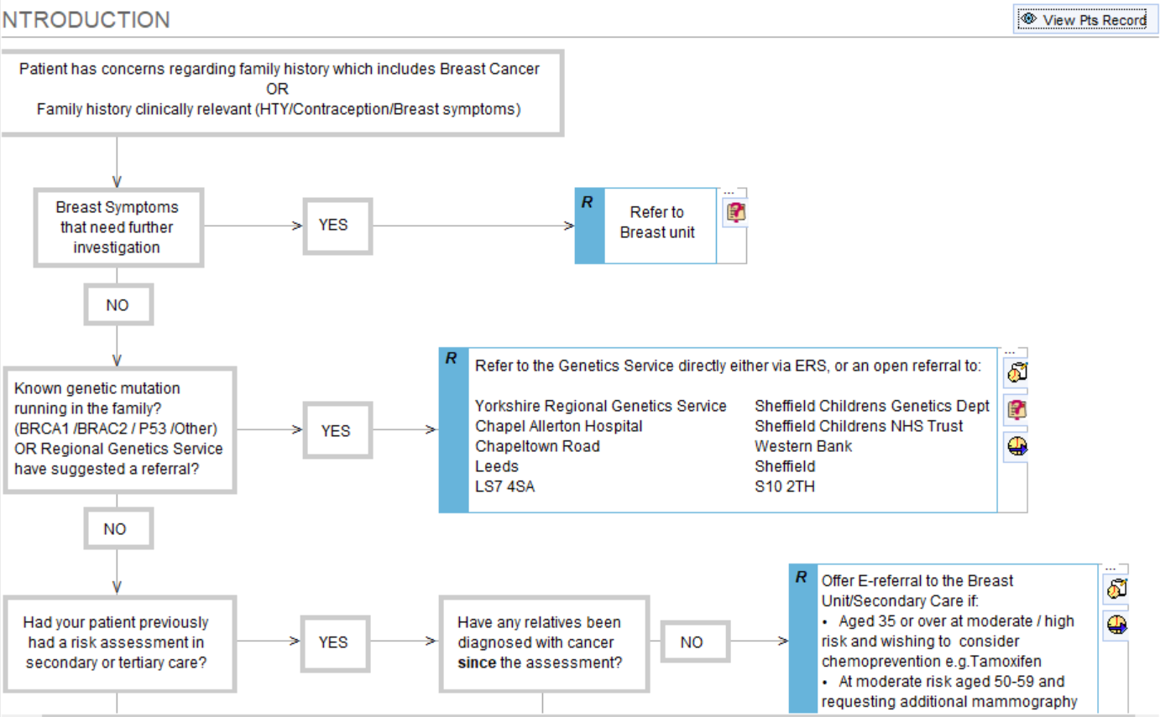
Figure 1: Introduction and first stages of decision-making within clinical pathway.

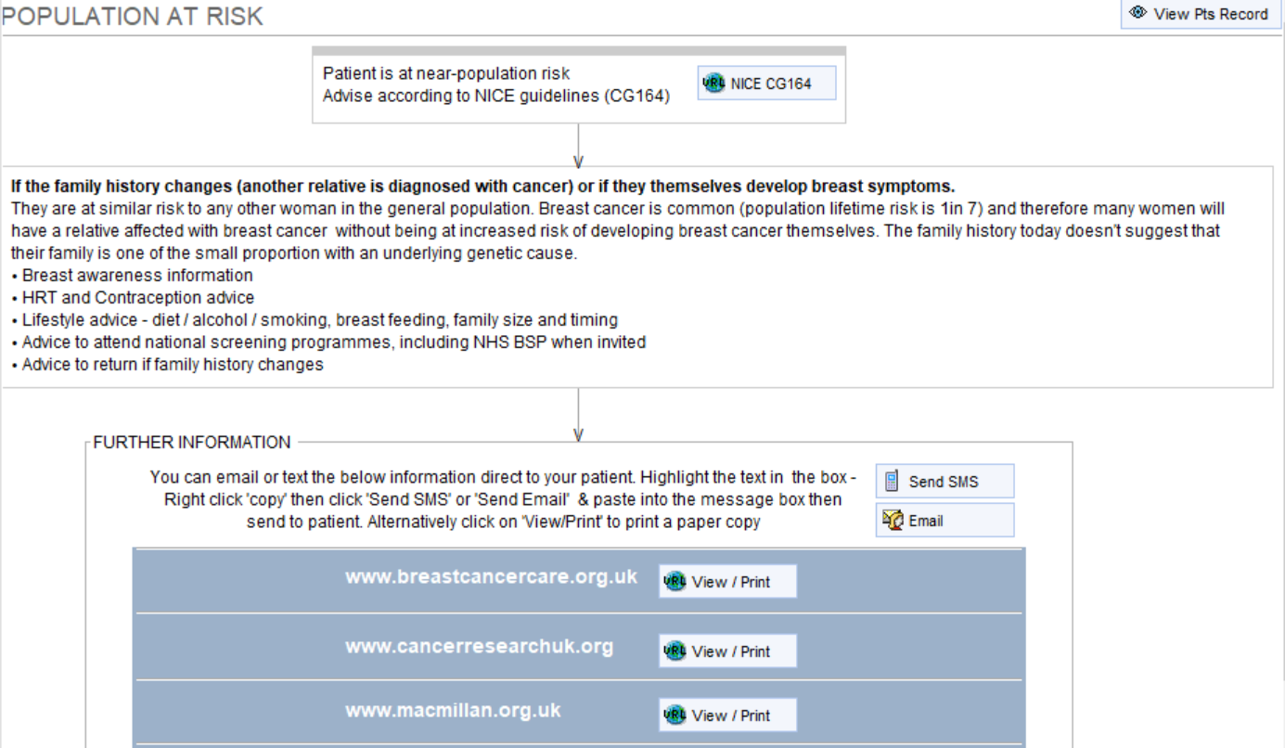
Figure 2: Management of women at near-population risk. Key clinical management points – links to guidance and patient resources with functionality to send via SMS or email.
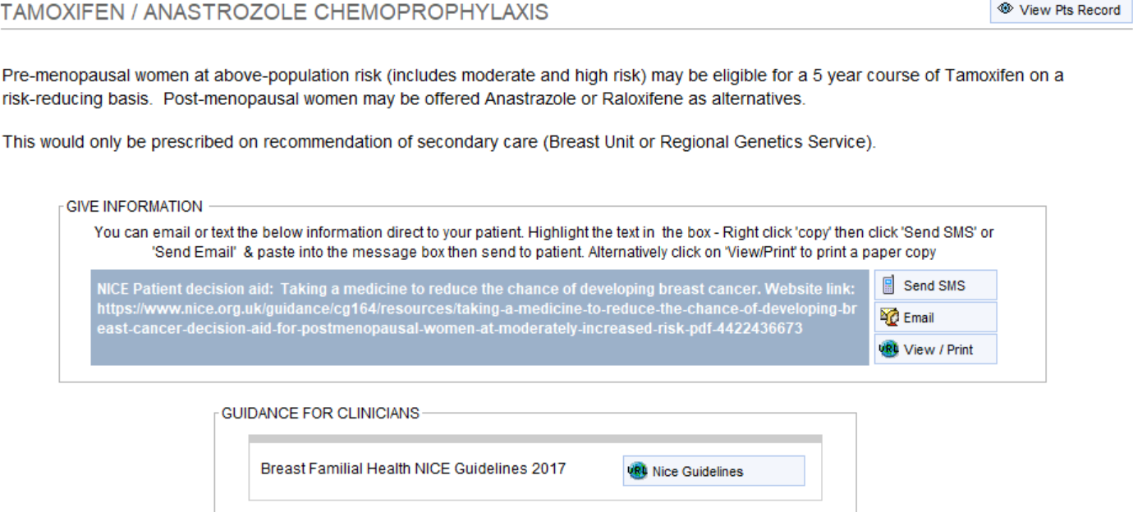
Figure 3: Information regarding tamoxifen/anastrozole chemoprophylaxis.

Appendix 2: Screenshots: Seeking specialist advice via Electronic Advice Service directly from primary care EHR in SystmOne.
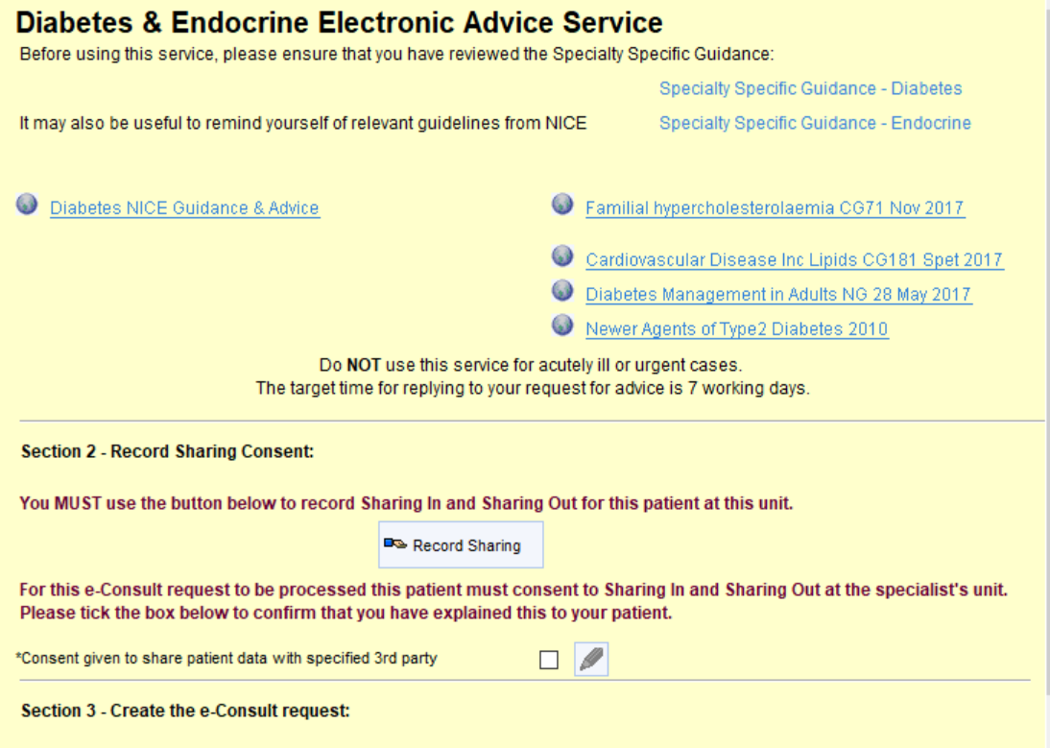
Figure 4: Front page of Diabetes and Endocrine Electronic Advice Service, demonstrating hyperlinks to relevant guidance and mandatory recording of patient consent to view.
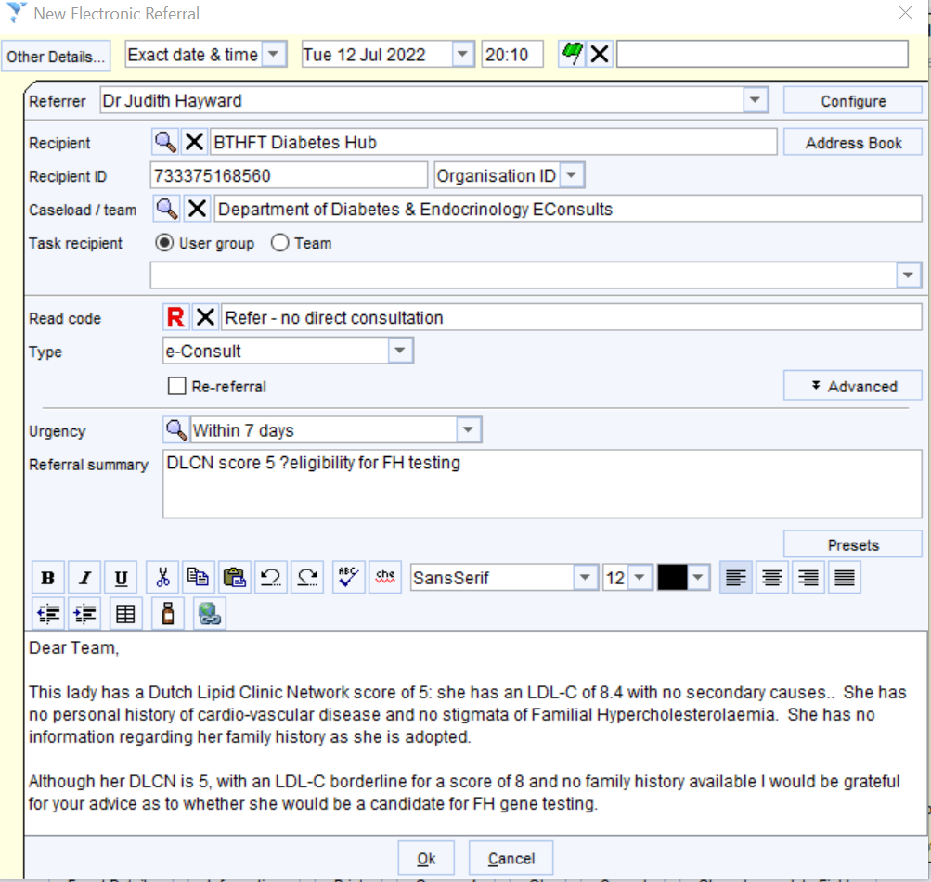

Figure 5: Electronic referral form for electronic advice service embedded within primary care EHR, containing key clinical query.

