Genomics in your practice

A health and social care survey to help us support you
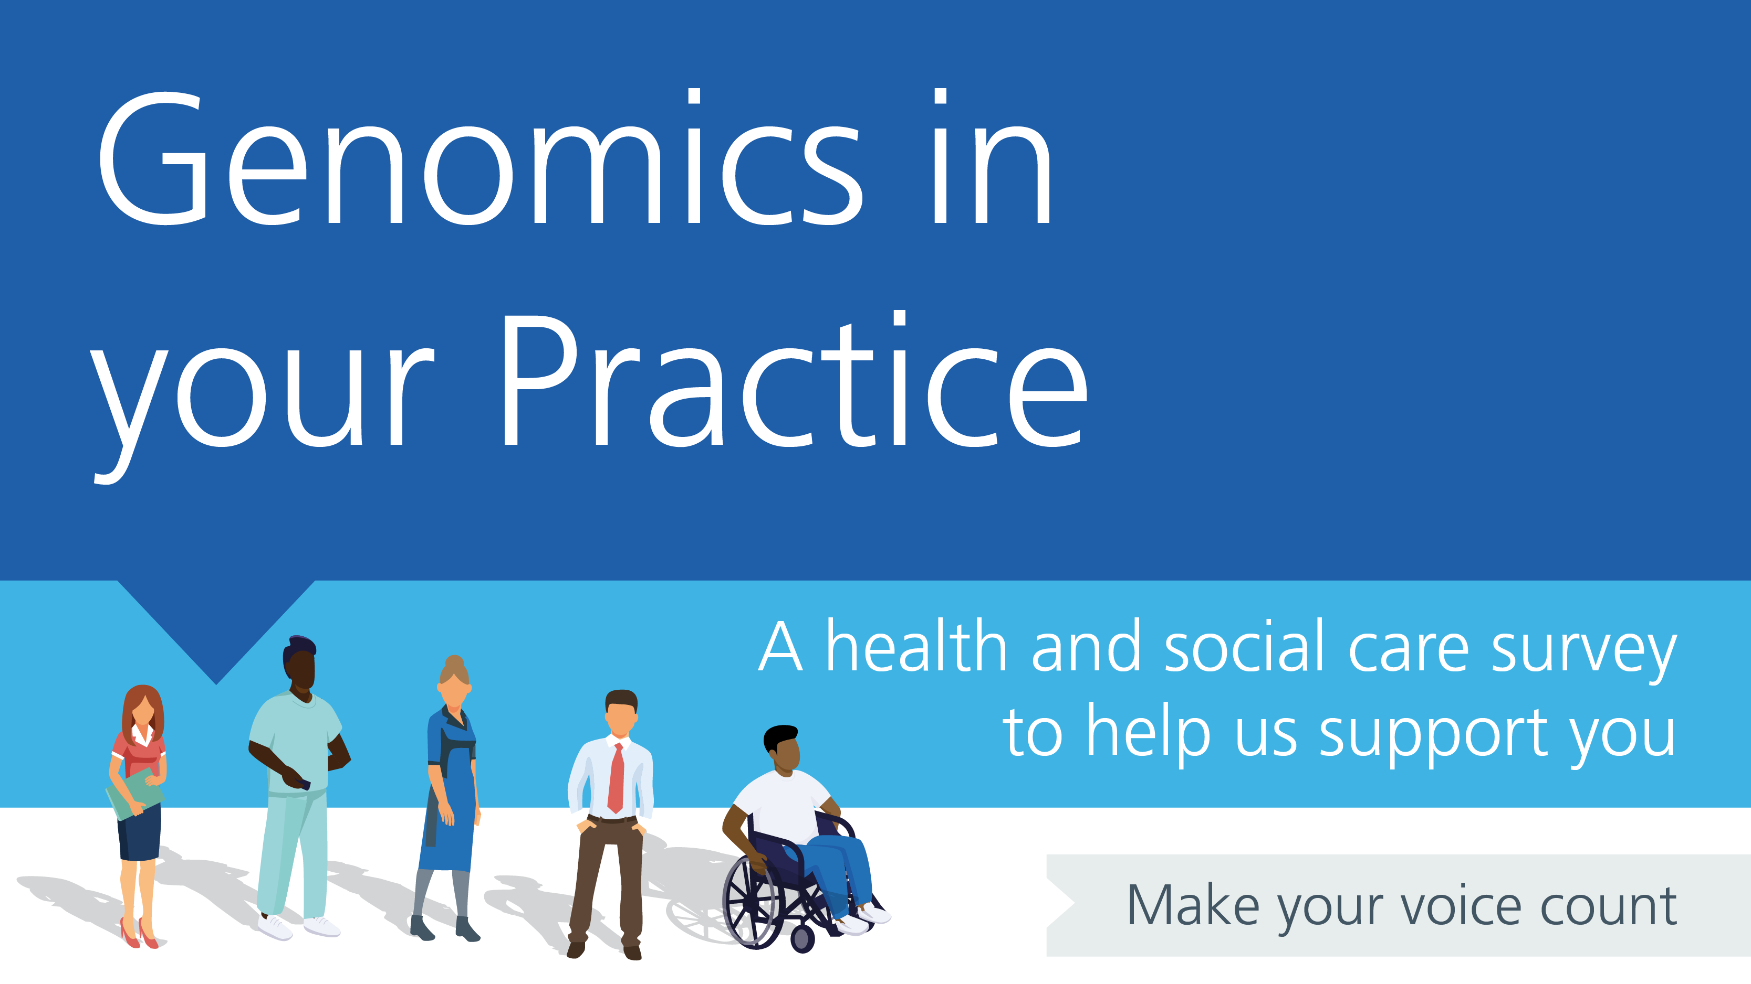
Contents
Introduction 3
Survey development 4
Rationale 4
Development 4
Information governance approval 4
Platform choice 4
Survey deployment 5
Dates of deployment 5
Covid-19 impact 5
Branding and messaging 5
Communications channels 6
Responses 8
Results 9
Demographics 9
Theme 1: Use of genomics in clinical practice 10
Current clinical practice 10
Those who reported currently ordering genomic tests 11
Future clinical practice (in the next five years) 11
Theme 2: Preparedness for a genomic-based healthcare system 12
Preparedness: Fundamentals of genomics 14
Preparedness: Genomic counselling 14
Preparedness: Genomic testing 15
Preparedness: The National Genomic Test Directory 16
Theme 3: Genomics education and training 18
Theme 4: Delivering a genomic medicine service 18
Reflections and recommendations 19
Response rate 19
Recommendations 19
For future surveys 19
For education 19
Acknowledgements 21
Task-and-finish group 21
Consensus group 21
Additional reviewers 22
Appendix: Full results 23

Introduction
This report summarises the results of ‘Genomics in your practice’, a health and social care survey that was open between 24 August 2021 and 31 December 2021. The survey was designed to identify the learning needs and preferences of the UK medical workforce around genomics.

Survey development

Rationale
The ‘Genomics in your practice’ survey was developed as one of Health Education England (HEE) Genomics Education Programme (GEP)’s commitments to the government paper Genome UK. The commitment was to ‘implement a workforce survey to identify learning needs and preferences which will identify gaps and priorities for education and training'.

Development
The survey, including content, branching logic and delivery, was developed by a task-and-finish group. The task-and-finish group primarily consisted of medical professionals, with a small number of genetic counsellors, nurses and educators. The survey was based on a survey of the Australian medical workforce conducted by the Australian Genomics Health Alliance (AGHA). Aligning to the AGHA survey allowed for international comparisons to be made.
To develop the survey, the task-and-finish group met virtually five times between 5 February 2021 and 18 June 2021 to refine the AGHA survey questions and adapt them to the UK workforce. The core of the AGHA survey was retained, but where possible questions were removed or shortened to reduce their length. It was estimated that the final survey would take 15–25 minutes to complete, depending on the respondent’s current involvement in genomics. More questions were asked of people currently involved in genomic testing than those not yet involved.
Once developed, the survey was sent to a consensus group and then to additional reviewers to ensure it was appropriate for all medical professionals in the UK.
The survey was also translated into Welsh for deployment in Wales.

Types of questions
The survey included three types of questions:
- Categorical-type questions – for example, ‘Which stage of your medical career are you in?’ with multiple-answer options available, plus ‘other (please specify)’ where appropriate.
- Likert scale questions asking about confidence from ‘1 – Not at all confident’, to ‘10 – very confident’, plus where appropriate the option of ‘Unsure how confident I am’ or ‘N/A’.
- Free-text answers – for example, ‘Why do you think genomics will not impact your practice in the next five years? Please clarify.’.

Information governance approval
This project was assessed by the NHS Health Research Authority as not requiring their approval to be carried out. It was approved by HEE Information Governance.

Platform choice
The survey was hosted on the SmartSurvey platform, chosen because of its availability within Health Education England and for its suitable functionality.

Survey deployment

Dates of deployment
The survey was intended for deployment in the spring of 2020, but the Covid-19 pandemic halted progress while those involved in the development were deployed elsewhere.
The survey was launched on 24 August 2021 and remained open until 31 December 2021. The survey in Welsh was available from 2 October 2021 until 31 December 2021.

Covid-19 impact
While the initial wave of the Covid-19 pandemic was over when the survey launched in August 2021, the pressures on the NHS resulting from it had not significantly eased. Waiting lists had lengthened and, towards the end of the survey period, the Omicron variant was increasing and spreading rapidly. There was also the roll-out of a third (booster) vaccine dose during this time, adding more pressure on an already overstretched NHS workforce.

Branding and messaging
To facilitate a consistent message and support brand recognition, the GEP developed a series of images to promote the survey (Figures 1–3). A dedicated webpage about the survey, including FAQs, was also published on the GEP website.

There were 1,807 views of the GEP survey webpage and the news item on the website had 292 views.

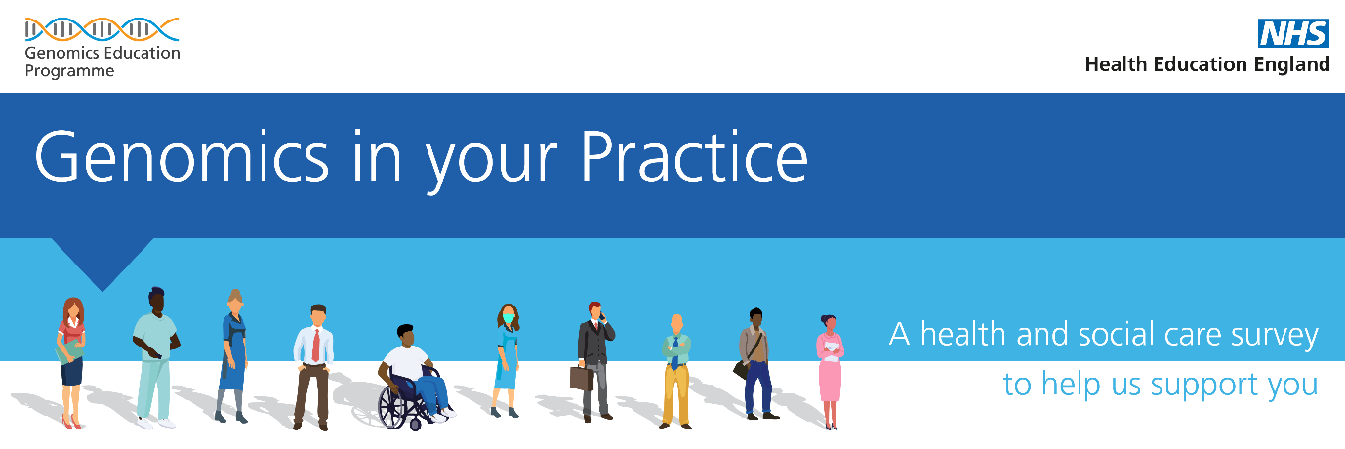
Figure 1. Survey image used in communications about the survey.

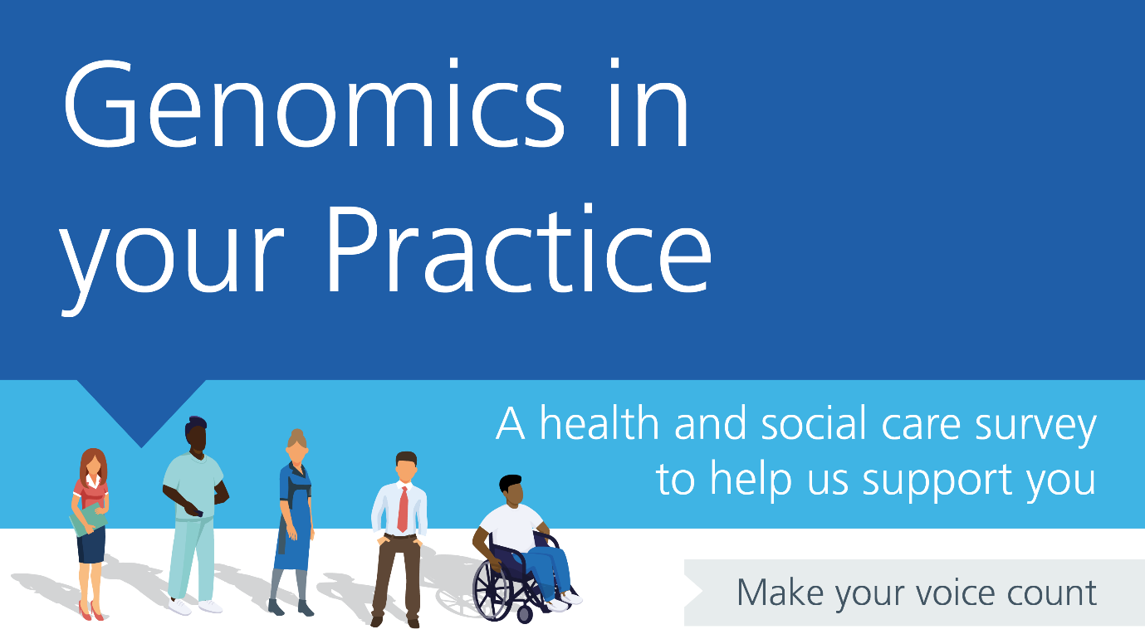
Figure 2. Survey image used within the survey and on the GEP website.

Figure 3. Survey banner used in communications about the survey and as an email banner.

Communications channels
The survey was deployed to the target medical workforce audience through the channels listed below.
- Direct emails to education and training leads within the NHS Genomic Laboratory Hubs on three separate occasions.
- A news item on the GEP website.
- An email on two occasions to network contacts, including:
  - HEE deaneries;
  - royal college networks;
  - specialty advisor committee chairs;
  - professional groups including the Clinical Genetics Society and the British Society for Genetic Medicine;
  - the primary care special interest group; and
  - Macmillan Cancer Support.
- A direct email on two occasions (in August and September) to the medical workforce segment of the GEP mailing list.
- Placement as the top story in the GEP’s September newsletter and as a small article in the November newsletter.
- Appearance in the NHS Genomic Medicine Service (GMS) bi-weekly update on four occasions, and a specific mention from Professor Dame Sue Hill in her introduction to the 10 September update.
- A short article shared with relevant HEE stakeholder engagement managers in September, with a request that they disseminate it to their networks.
- Social media posts on Facebook, LinkedIn and Twitter (retweeted and shared by various others, including the NHS GMS and education and training leads). A post also appeared on the HEE Twitter feed on 16 September.

Responses
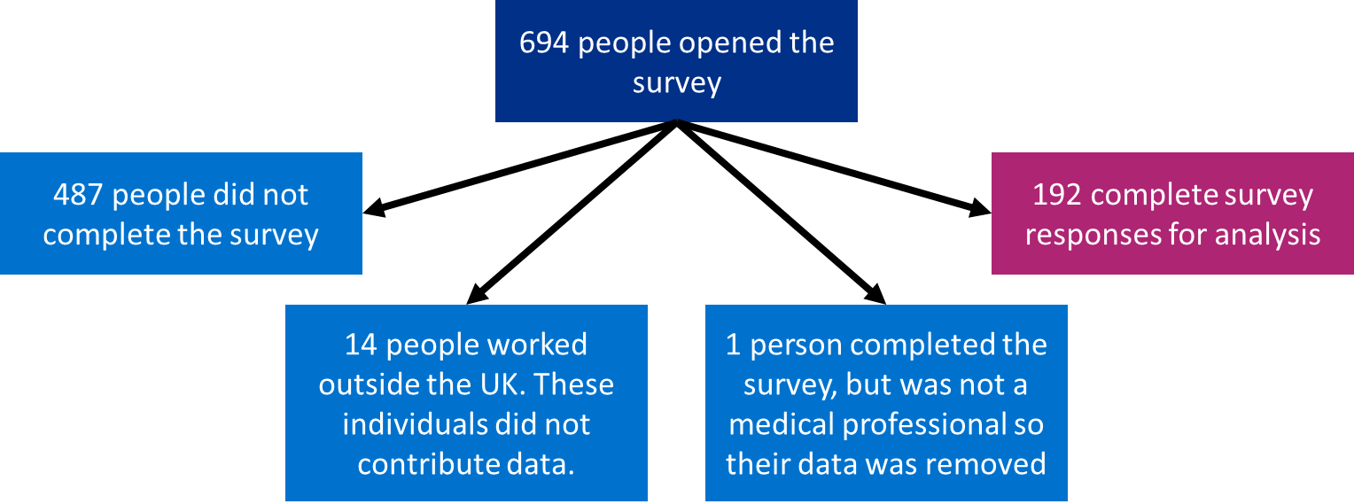

Figure 4. An overview of how many people opened the survey, how many responded fully but were not included in the data analysis, and how many responded fully and were included in the analysis.
A total of 694 people opened the survey, of which 487 did not complete it (Figure 4). The data from the incomplete surveys were not available for analysis because we stated that respondents could withdraw from the survey at any time by closing the browser window.
Of the 487 incomplete responses, the majority (348/487, 71.5%) of respondents did not get past the first two questions:
- ‘Which country do you work in?’ (210/487, 43.1%)
- ‘What is your GMC number?’ (138/487, 28.3%)
The next largest stopping point was at the start of section two, where questions asked how respondents use genomics in practice. At this point, 6.4% (31/487) of incomplete respondents stopped.
The survey provided the option to save and continue later. There were 20 respondents who saved their progress but did not complete the survey.
Of those who did complete the survey, 14 worked outside the UK (Figure 4). The first question asked where they worked and ended the survey if they were outside the UK. These individuals did not contribute data. Additionally, one person who completed the whole survey was not a medical professional, so their data was excluded from the analysis (Figure 4).
The total number of complete responses from medical professionals in the UK was 192. This is split into:
- England: 157
- Scotland: 7
- Wales: 29
- Northern Ireland: 0

Results
Full results are provided in the appendix. Summarised results are presented below.

Demographics
The 192 respondents who completed the survey had a variety of personal and professional characteristics. Absolute numbers of responses were low, however, so it was not possible to analyse by speciality or draw wide-ranging conclusions.
Of those who indicated, there was an even split of male (93/192, 48.4%) and female (94/192, 49.0%) respondents. The majority of respondents were consultants (105/192, 54.7%, Figure 5) and general practice was the best-represented specialty (Figure 6).

Figure 5. The career stages of survey respondents.

Figure 6. The specialities that survey respondents worked in.
*In the ‘Others’ group there were 20 specialities, each with a single respondent. This does not include FY1/2s as they do not have specialities.
For the purpose of this report, the remaining survey results are framed around four themes: use of genomics; preparedness for genomics; access to genomics education and training and delivering a genomic medicine service.

Theme 1: Use of genomics in clinical practice
Respondents were asked about their current and future (in the next five years) use of genomics in their practice.

Current clinical practice
- 120/192 (62.5%) respondents reported currently accessing genetic or genomic testing and/or genomic information for patients within their care.
  - 104/192 (54.2%) respondents had ordered a genetic or genomic test in the last 12 months.
- Clinical genetics teams were contacted for a range of reasons by 98/192 (54.4%) of respondents.
Those who ordered tests made the below requests.
- Testing for a familial variant, testing for common variants, and/or Sanger sequencing of single genes based upon clinical evaluation and the suspicion of a specific genetic condition: 64/104 (61.5%).
- Chromosomal microarray (microarray/array-CGH) tests: 46/104 (44.2%).
- Germline/constitutional gene panel tests: 43/104 (41.3%).
- Germline/constitutional whole exome or whole genome sequencing tests: 32/104 (30.8%).
- Tumour (somatic) tests: 29/104 (27.9%).
- Pharmacogenomic tests: 17/104 (16.3%).
In contrast, 88/192 (45.8%) respondents had not ordered a genetic or genomic test in the last 12 months. Respondents reported that this was because:
- “I referred patients who required genetic or genomic testing to a clinical genetics team or other specialist service.” 47/88 (53.4%)
- “I am unable to order a genetic or genomic test in my current role/department (for example, due to lack of access to testing).”: 19/88 (21.6%)
- “I’m not sure how to order a genetic or genomic test.”: 24/88 (27.3%)
- “I’m not sure of the relevance of genetic or genomic testing to my practice.”: 21/88 (23.9%)
- “The clinical indications for genetic or genomic tests are not seen in my area of practice.”: 22/88 (25.0%)
- “I only rarely see cases/have not seen cases requiring genomic testing in the past 12 months.”: 5/88 (5.7%)

Those who reported currently ordering genomic tests
In general, those who reported ordering genetic/genomic tests (104 respondents) were confident with most aspects of the test they were ordering. This included:
- understanding indications for testing;
- discussing testing with families;
- facilitating patient-informed consent for testing;
- understanding test reports;
- verifying reports by checking literature and databases;
- discussing results with patients/families; and
- participating in a multidisciplinary team meeting at which test results are discussed, and drawing conclusions about ongoing clinical management.
For each of the above aspects of each test, the median response (from ‘1 – not at all confident’ to ‘10 – very confident’) was eight or more. However, for every test and question there were respondents who were less confident (1–5).

Future clinical practice (in the next five years)
Of the 72 clinicians who did not report accessing genomic testing and/or genomic information for patients within their care, 44/72 (61.1%) thought that it would impact their practice in the next five years. Half of these (22/44) thought that it would increase their workload.
The main areas of clinical practice that respondents thought genomics was likely to impact were diagnosis (38/44, 84.4%) and treatment (34/44, 77.3%). Fewer respondents thought that genomics was likely to impact the number of referrals they would receive (6/44, 13.6%) or the type of work they would do (8/44, 18.2%).

Theme 2: Preparedness for a genomic-based healthcare system
Respondents were asked if they felt prepared for a future clinical practice that integrated genomic medicine.
Overall, 88/192 (45.8%) felt they were prepared, 75/192 (39.1%) did not feel prepared and 29/192 (15.1%) were unsure if they were prepared. A chi-squared test showed that there was a significant difference in feelings of preparedness between the individuals who reported currently using genomic data and those who reported not currently using it (chi-square=65.5, df=2, p<0.001). Given this result, we separately evaluated responses about preparedness for a future clinical practice that integrated genomic medicine from those who had reported currently accessing genetic or genomic testing and/or genomic information for patients within their care (120 respondents) and those who did not (72 respondents).
Of the 120 respondents who reported accessing genetic or genomic testing and/or genomic information for patients within their care:
- 80/120 (66.7%) felt prepared to use genomics in practice
- 22/120 (18.3%) did not feel prepared
- 18/120 (15%) were unsure
Among those who either felt prepared or were unsure, there were 18 individuals who stated in the free text box that they were prepared in some areas but not others.
Conversely, of the 72 respondents who reported not accessing genetic or genomic testing and/or genomic information for patients within their care:
- Only 8/72 (11.1%) felt prepared to use genomics in practice;
- 53/72 (73.6%) did not feel prepared; and
- 11/72 (15,3%) were unsure, including two individuals who stated in the free text box that they were prepared in some areas but not others.
Of note and as discussed above, 44 of the 72 respondents thought that genomic medicine was likely to impact on their practice within five years. 31 of these 44 (70.5%) did not feel prepared for this.
Respondents were then asked a series of additional questions to further gauge their preparedness for a genomics-based healthcare system. These questions focused on self-reported confidence of 1) fundamental genomic concepts; 2) genomic counselling; 3) genomic testing; and 4) use of the National Genomic Test Directory, measured using Likert scales.
The results varied, ranging from 1 (not at all confident) to 10 (very confident) for all questions (Figures 7–15). While it is likely that self-reported confidence may vary between specialties, there were insufficient data to evaluate by specialty. We tested the hypothesis that individuals who reported accessing genetic or genomic testing and/or genomic information for patients within their care were more likely to be confident in each aspect than those who did not. The data was not normally distributed, so Wilcoxon rank sum tests with continuity correction were used to test for a difference between the two groups. For each question, there was a significant difference between the two groups (Table 1).

Table 1. Differences in confidence between two groups: those currently accessing genetic or genomic testing (n=120) and those not currently accessing genetic or genomic testing (n=72). The mean and median responses for each group are presented, along with the Wilcoxon rank sum test of a difference between the groups with continuity correction and its p value.
 | Currently accessing genetic or genomic testing (n=120) |  | Not currently accessing genetic or genomic testing (n=72)
How confident are you in your… | Mean | Median | Mean | Median | Wilcoxon rank sum test | p value
Fundamentals of genomics:

…knowledge about genomics? | 6.5 | 7 | 3.7 | 3.5 | 6976.5 | <0.001
Genomic counselling:

…ability to elicit information about genetic conditions as part of a family or medical history? | 7.2 | 8 | 4.7 | 5 | 6182 | <0.001
…knowledge about the requirements for patient consent to genomic testing? | 6.5 | 7 | 3.4 | 3 | 6858.5 | <0.001
…ability to explain genomic concepts to patients? | 6.8 | 7 | 4 | 3.5 | 6412.5 | <0.001
…ability to access information about genomic testing? | 6.7 | 7 | 3.5 | 3 | 7175 | <0.001
…ability to select the right genomic tests for patients? | 6.1 | 7 | 2.5 | 2 | 6901.5 | <0.001
…ability to make decisions based on genomic information? | 6.6 | 7 | 3.3 | 3 | 7118 | <0.001

Preparedness: Fundamentals of genomics

Figure 7. Self-reported confidence in knowledge about genomics ranges from 1, not at all confident, to 10, very confident.

Preparedness: Genomic counselling

Figure 8. Self-reported confidence in ability to elicit information about genetic conditions as part of a family or medical history ranges from 1, not at all confident, to 10, very confident. There were also some who were unsure how confident they were.

Figure 9. Self-reported confidence in knowledge about the requirements for patient consent to genomic testing ranges from 1, not at all confident, to 10, very confident. There were also some who were unsure how confident they were.

Figure 10. Self-reported confidence in ability to explain genomic concepts to patients ranges from 1, not at all confident, to 10, very confident. There were also some who were unsure how confident they were.

Preparedness: Genomic testing

Figure 11. Self-reported confidence in ability to access information about genomic testing ranges from 1, not at all confident, to 10, very confident.

Figure 12. Self-reported confidence in ability to select the right genomic tests for patients ranges from 1, not at all confident, to 10, very confident. There were also some who were unsure how confident they were.

Figure 13. Self-reported confidence in ability to make decisions based on genomic information ranges from 1, not at all confident, to 10, very confident. There were also some who were unsure how confident they were.

Preparedness: The National Genomic Test Directory
The National Genomic Test Directory had been accessed by 59 (30.7%) of respondents. 53/59 (90%) of these respondents reported currently accessing genetic or genomic testing and/or genomic information for patients within their care. Due to the low number of people who had accessed the test directory but were not using genomics in practice, it was not possible to test for a difference between the groups.
The 59 respondents who had accessed the National Genomic Test Directory were asked about confidence in navigating the test directory and selecting the appropriate test. Responses ranged from 1 (not at all confident) to 10 (very confident). The median for confidence navigating the test directory and for selecting the appropriate test were both 7 (Figures 14 and 15). This is the same as most of the general confidence questions detailed above for those who are using genomics in practice, but less than the specific confidence questions related to ordering particular tests. This likely reflects that those accessing the test directory are generally confident with most things around genomic testing in their practice, but are slightly less confident using the test directory than other aspects of genomic testing. A probable explanation for this is that they are familiar with aspects of genomic testing relevant to their practice, but as the test directory is new they do not have as much experience with it. In the free text comments section, seven people had negative things to say about the test directory, and none had positive comments. Three people wrote that, in their experience, even though the test directory states that tests are available this is not always the case locally.
“The NTD is a bit of a dog’s dinner from a clinical perspective – it is not set out in the way that many clinicians think about investigating disease. The excel spreadsheet is a mess, it is clunky and even using it on a day-to-day basis, I am never sure that I have identified all relevant tests for my patients. The labs seem to believe that clinicians will memorise the NTD and select tests by R or M number, that’s just unrealistic. As more tests transition to WGS the ToF will become unfit for purpose, the drop-down box will just look like the excel NTD.”
“It doesn't matter what the directory says, Cambridge isn't doing the work and arranging to get tests done elsewhere is a huge faff. Also, some things in the directory are not an option in the real world at all.”

Figure 14. Self-reported confidence in navigating the National Genomic Test Directory ranges from 1, not at all confident, to 10, very confident. The median response is 7. This question was only asked of those who have accessed the test directory.

Figure 15. Self-reported confidence in selecting the appropriate test from the National Genomic Test Directory ranges from 2, less confident, to 10, very confident. The median response is 7. This question was only asked of those who have accessed the test directory.

Theme 3: Genomics education and training
Respondents were asked about their previous education and training in genomics, and to consider their future education and training needs, including mode of delivery.
In the previous three years, 95/192 (49.5%) of respondents had attended professional development education or training around genomics. Online training was the most common (60/95 (63.2%)), with less in-person training (in-house (internal) programmes 33/95 (34.7%); external programmes 44/95 (46.5%)). This predominance of online training likely (at least partially) reflects the Covid-19 pandemic, although it may also reflect the flexibility that online training affords.
In response to the question “Would improving your knowledge of genomic medicine alter your practice?”, 116/192 (60.4%) said yes, 23/192 (12.0%) said no, and 53/192 (27.6%) were unsure.
In terms of improving confidence in delivering genomic medicine, there was a reported need for more training, education and support. The details of this varied, ranging from generic to specific.
No topic was much more in demand than the others in terms of learning. It might be expected that popular topics for learning would be those that few respondents had already undertaken education in; this was not the case, however, and the number of respondents who had already undertaken education in a topic did not appear to influence that topic's popularity.
A range of training methods were preferred, with consulting colleagues and peers and CPD/CME activities the most favoured.

Theme 4: Delivering a genomic medicine service
Finally, respondents were asked how they think a genomic medicine service should and/or could be delivered.
The results indicate that there is no clear preferred model of delivering genomic testing in practice, although few respondents (9/192, 4.7%) specified that they would like to initiate testing and discuss results with patients/families without support from a clinical genetics team. Factors influencing these choices included respondents’ knowledge, skills and experience, the system they work in, the impact of test results, clinical indications or patient-specific considerations, and time pressures or workload.

Reflections and recommendations

Response rate
The response rate to the survey was low. This is likely due to a number of factors.
Covid-19 impacted the development and deployment of the survey, initially delaying it for approximately 18 months. It was eventually deployed into a particularly overstretched NHS that was dealing with the impacts of the pandemic beyond treating the virus itself, while simultaneously rolling out third-dose booster vaccinations. This will have left many staff unable to engage with the survey.
In addition to the impacts of Covid-19, we were made aware that there were other surveys ongoing. We tried to avoid clashing with other major surveys, but survey fatigue is highly likely to have affected the response rate.
As part of the NHS, we did not have the ability to provide incentives to complete the survey. Being able to provide incentives such as a prize draw may have increased the response rate.
A low response rate may have skewed the data towards the parts of the workforce that are already engaged with and using genomics in their practice. It is therefore suspected that these respondents are more likely to have genomic knowledge and be more confident in using genomics in practice than the wider medical workforce, although it is not possible to confirm this.

Recommendations

For future surveys

Shorter surveys
While aligning the UK survey with that of the AGHA allows for international comparisons, the survey is long. More responses may have been obtained if the survey were shorter. During development, the length of the survey was discussed and it was made shorter where possible, but it remained a long survey (estimated 15–25 minutes). In future, it may be beneficial to give more consideration to what is absolutely necessary and what could perhaps be left out.

Engage with professional bodies and senior leaders
Additional engagement with professional bodies and senior leaders in practice may have helped to increase the response rate. Some engagement took place, but professional bodies and senior leaders were stretched due to the environment in which the survey was deployed.

For education

Deliver additional education in a wide range of formats
There is a general appetite for more education from the survey respondents. Educational needs and delivery preferences are varied. In an ideal situation everyone would be catered for, but in practice targeting education where it is most in demand and in the formats most preferred would be a sensible strategy – though other educational needs and formats should not be neglected.

‘Just-in-time’ resources are needed to support individuals delivering genomic testing in practice
In general, those who are ordering tests and interacting with genomic test results are confident with most aspects of the tests they are ordering. Not all individuals are confident in all aspects, however, and these less confident individuals require appropriate support. Because they need education and training now, as they are already ordering tests and interacting with genomic test results, ‘just-in-time’ educational resources would be appropriate.

Targeted information is required to upskill the workforce in preparation for delivering genomic testing
Some respondents stated that they do not currently order tests but may do so in the near future, or may otherwise interact with genomic test results, and feel their skills and knowledge are lacking. These people identified a need for training, but many indicated that they do not have the time to learn; they therefore need small amounts of information specifically targeted to what they need to know, with additional supporting information available to enable them to learn more about the subject if time allows.

Acknowledgements
We acknowledge the input and advice of the AGHA while adapting their survey for a UK audience.
The development of the UK survey has been supported by professionals from across the health service and beyond.

Task-and-finish group
- Dr Michelle Bishop (co-chair), education development lead, Genomics Education Programme, Health Education England.
- Professor Kate Tatton-Brown (co-chair), consultant in clinical genetics, South West Thames Regional Genetics Service; professor of clinical genetics and genomic education, St George’s University; clinical lead for genomic education, Academy of Medical Royal Colleges.
- Dr Gemma Chandratillake, education and training lead, East NHS Genomic Laboratory Hub.
- Emma Clark, education and training lead, North East and Yorkshire NHS Genomic Laboratory Hub.
- Amanda Clarkson, genomics laboratory operations director, Cambridge University Hospitals Genomic Laboratory, East NHS Genomic Laboratory Hub.
- Sarah Clinton, education and training lead, Central and South NHS Genomics Laboratory Hub, Birmingham Women’s and Children’s NHS Foundation Trust.
- Dr Carrie Furnell, consultant paediatric neurodisability, Virgin Care Ltd.
- Dr Jude Hayward, GPwSI in genetics: Yorkshire Regional Genetics Service; primary care adviser to Health Education England’s Genomics Education Programme; Royal College of General Practitioners joint clinical champion for genomics with Dr Imran Rafi; Shipley Medical Practice: Affinity Care.
- Dr Dahlia Hopmeier, genomics clinical fellow, Great Ormond Street Hospital.
- Dr Fiona Lalloo, consultant clinical geneticist, Clinical Genetics Service, Manchester Centre for Genomic Medicine.
- Dr Catherine Mercer, consultant clinical geneticist, University Hospital Southampton NHS Foundation Trust.
- Dr Siobhan Simpson, senior education and development officer, Genomics Education Programme, Health Education England.
- Victoria Stinton, consultant clinical scientist, North West NHS Genomic Laboratory Hub, Manchester Centre for Genomic Medicine, Liverpool Women’s Hospital NHS Foundation Trust.
- Dr Nicki Taverner, genetic counsellor, All Wales Medical Genomics Service; senior lecturer, Cardiff University; chair, Association of Genetic Nurses and Counsellors.
- Melanie Watson, education and training lead, South West NHS Genomic Laboratory Hub.

Consensus group
- Dr Catherine Breen, general practice specialty trainee, Dumfries and Galloway, Scotland.
- Dr Steven Bunce, GP, Clevedon Medical Centre.
- Dr Will Evans, GP Leeds; honorary (clinical) assistant professor, University of Nottingham; clinical lead, Mendelian; chairman, Niemann-Pick UK.
- Dr Amy Glossop, medical author, NHS Digital.
- Dr Zsuzsanna Iyizoba-Ebozue, Royal College of Radiologists Dr Karol Sicher cancer research fellow; speciality registrar in clinical oncology, St James University Hospital, Leeds.
- Dr Pooja Jain, consultant clinical oncologist, Leeds Cancer Centre; honorary lecturer, the University of Leeds.
- Dr Hannah Walsh, speciality registrar in oral and maxillofacial pathology, Sheffield Teaching Hospitals NHS Foundation Trust.
- Gemma Whitehead, Macmillan clinical nurse specialist in haematology, Chesterfield Royal Hospital.

Additional reviewers
- Dr Tracey Davis, BAPA representative to the Royal College of Paediatrics and Child Health.
- Professor James Hill, consultant general and colorectal surgeon, Manchester Royal Infirmary.
- Dr Anne Marsden, chair of the British Association of Paediatricians in Audiology.
- Catherine Tait, consultant breast surgeon, Bradford Teaching Hospitals NHS Foundation Trust.

Appendix: Full results

GMC number
Provided by 185 respondents.

Gender
- Male: 93 (48.4%)
- Female: 94 (49.0%)
- Prefer not to say: 3 (1.6%)
- Other: 2 (1.0%)

Age
- 25–34: 29 (15.1%)
- 35–44: 54 (28.1%)
- 45–54: 53 (27.6%)
- 55–64: 48 (25%)
- 65 or over: 8 (4.2%)

Location
- Central and South GLH: 31
- East GLH: 9
- North East and Yorkshire GLH: 33
- North Thames GLH: 7
- North West GLH: 47
- South East GLH: 9
- South West GLH: 14
- Wales: 29
- Scotland: 7
- Northern Ireland: 0
- Unknown: 6 (1 London, but could be either North Thames GLH or South East GLH)

Year medical degree completed
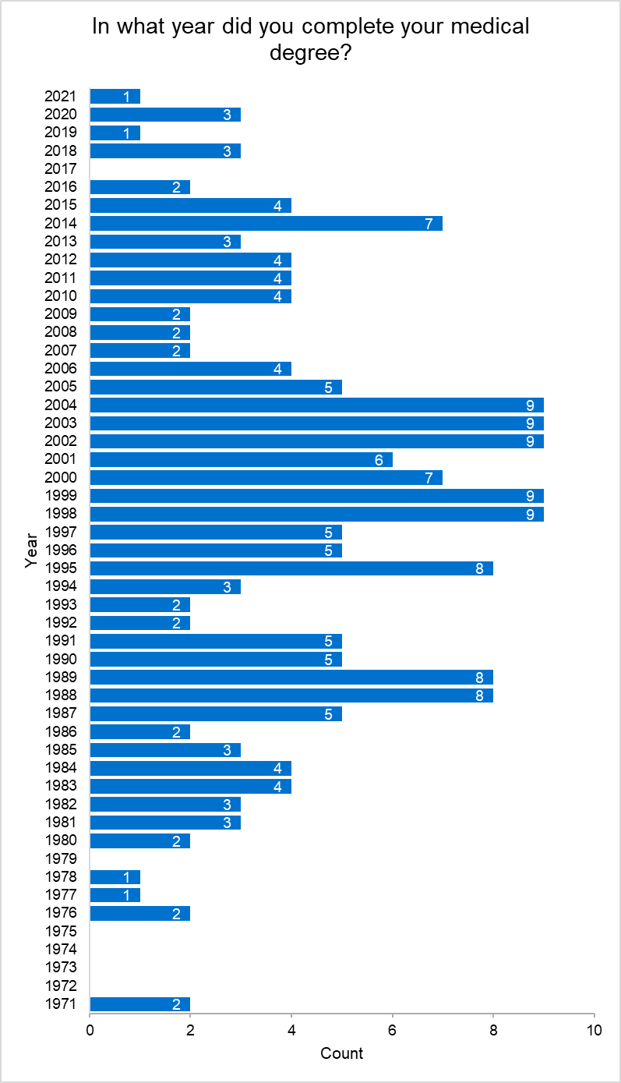

Career stage
- FY1/FY2: 5
- ST2/CT2: 3
- ST3: 5
- ST4: 2
- ST5: 5
- ST6: 2
- ST7: 2
- ST8: 2
- Clinical fellow (pre CCT): 4
- Consultant: 105
- Sessional or locum GP: 3
- GP partner: 31
- Salaried GP: 10
- Speciality or associate specialist: 6
- Other: 7
  - Locum F3
  - Naive medic
  - Primary care dean
  - Portfolio, salaried GP and medical advisor to ERY CCG
  - Clinical specialist working with prescribing decision support provider
  - Retired GP but GP appraiser, Royal College of General Practitioners educational lead and GP training programme director
  - Sessional/locum GP and TTP consultant

Respondents’ specialties
There are responses from a range of specialties (qualified or in training). They are listed in decreasing number of respondents.
- General practice: 50
- Paediatrics: 26
  - Sub-specialties:
    - Community child health: 9
    - Neonatal medicine: 2
    - Paediatric neurodisability: 2
    - Paediatric neurology: 2
    - Paediatric respiratory medicine: 1
- Histopathology: 16
  - Sub-specialties:
    - Hematopathology and soft tissue pathology: 1
- Clinical genetics: 12
- Anaesthetics: 6
  - Sub-specialties:
    - Paediatric palliative medicine: 1
    - Pain medicine: 1
- General surgery: 6
  - Sub-specials:
    - Oncoplastic breast surgery: 1
- Geriatric medicine: 6
  - Sub-specialties:
    - Stroke medicine: 1
    - General internal medicine: 1
    - Working towards CESR in general internal and geriatric medicine: 1
- Clinical oncology: 5
  - Sub-specialties:
    - Colorectal cancer: 1
- General psychiatry: 5
  - Sub-specialties:
    - Eating disorders: 1
    - Addiction medicine: 1
- Obstetrics and gynaecology: 5
  - Sub-specialties:
    - Maternal and fetal medicine: 1
- Dermatology: 4
- Medical microbiology: 4
- Cardiology: 3
- Endocrinology and diabetes mellitus: 3
  - Sub-specialties:
    - General internal medicine: 1
- Paediatric cardiology: 3
- Neurology: 3
- Trauma and orthopaedic surgery: 3
  - Sub-specialties:
    - Paediatric orthopaedics: 1
- Chemical pathology: 2
  - Sub-specialties:
    - Metabolic medicine: 1
- Intensive care medicine: 2
- Palliative medicine: 2
- Renal medicine: 2
- Acute internal medicine: 1
- Audio vestibular medicine: 1
- Child and adolescent psychiatry: 1
- Clinical pharmacology and therapeutics: 1
- Diagnostic neuropathology: 1
- Haematology: 1
- Infectious diseases: 1
  - Sub-specialties:
    - Tropical medicine: 1
- Medical oncology: 1
- Neurosurgery: 1
- Old age psychiatry: 1
- Other: 1
- Paediatric surgery: 1
- Psychiatry of learning disability: 1
- Public health medicine: 1
- Respiratory medicine: 1
- Urology: 1
  - Sub-specialties:
    - Paediatric urology: 1
- Vascular surgery: 1

Specialties by college
- Royal College of General Practitioners: 50
- Royal College of Paediatrics and Child Health: 26
- Royal College of Pathologists: 23
- Royal College of Physicians: 45
- Royal College of Anaesthetists: 6
- Royal College of Surgeons: 13
- Royal College of Radiologists: 5
- Royal College of Psychiatrists: 8
- Royal College of Obstetricians and Gynaecologists: 5
- Faculty of Intensive Care Medicine: 2
- Faculty of Public Health: 1

Special interests
There were a wide range of special interests among respondents – both those with an official recognition pathway and those without. That data is not presented here, because doing so could lead to the identification of individuals who took part in the survey.

Questions on “How confident are you in your…”

What would help you improve your confidence?
There were 140 responses to this question.
- 91 respondents (65.0%) gave a response in relation to training/learning/education. Of these:
  - 11 were requests for specialty-specific training:
    - General practice: 5
    - Dermatology: 2
    - Surgery, cardiology, anaesthetics and respiratory medicine: 1 each
  - 38 were for a specific type of training:
    - Online: 13
    - From local colleagues or specialists: 6
    - Training days: 5
    - Courses: 4
    - Easy-access, introductory or need-to-know information: 5
    - Multi-disciplinary team (MDT) and/or tumour boards: 3
    - Updates: 3
    - Other types: 7
  - 18 were for training on a specific subject or topic:
    - What tests are available: 7
    - When and/or who to test: 4
    - How to test and/or refer: 3
    - How to interpret results: 2
    - Others: 7, including:
      - Specific to speciality: 3
      - Genetic conditions/common applications: 2
      - Consent training: 1
      - Latest developments: 1
- 13 wanted advice, help or support, including from clinical genetics specifically.
- Nine said they needed practice and/or experience.
- 12 said that they were confident or said that they did not need to improve.
  - An additional two said that they see few patients to whom genomics can be applied.
- Three would like decision support tools.
- Three had comments about the test directory.
- Two are confident in one area but not in others.
- Two said they need time to learn.
- 12 gave other responses, some of which were unclear in their meaning.
  - “We don't seem to have much involvement with the geneticists compared to ------ where I worked previously. At that trust there were specialist paediatric neurology specialist geneticists who were an integral part of our MDT but I don't think I really even know any geneticists [here]. Our secondary epilepsy team are also not allowed to send any epilepsy gene panel requests (only tertiary epilepsy are allowed to request) so this lack of integration accompanied by lack of ability to request probably means that I don't put patients forward as much as I should.”

Accessing genetic and/or genomic testing

Do you access genetic and/or genomic testing or use genetic and/or genomic information for any patients within your care? Note that this question refers to all types of genetic or genomic testing of DNA or RNA.
- Yes: 120 (62.5%)
- No: 72 (37.5%)

Genomics in practice in the next five years

Do you think genomics will impact your practice in the next five years?
- Yes: 44 (61.1%)
- No: 10 (13.9%)
- Unsure: 18 (25.0%)

Why do you think genomics will not impact your practice in the next five years?
- Four will have retired.
- Two believe it will impact their practice, but in timeframes longer than five years.
- One can’t see the relevance.
- One only sees limited cases to which genomics could be applied.
- One does not have enough research interest.
- One is a surgeon who focuses on how to deal with the problems rather than why they happened.

Why are you unsure if genomics will impact your practice in the next five years?
- Four don’t think it will directly impact their practice, but do see it impacting on their patients – for example, palliative care.
- Four think it will impact their practice, but it will take longer than five years.
- Two are unsure how it would happen.
- Two are sceptical that it will happen.
- Two answered “Not applicable”.
- Four answered “Other”.

What areas of your clinical practice do you think will be impacted by genomics?
- How I diagnose patients: 38 (86.4%)
- How I treat patients: 34 (77.3%)
- The number of referrals I will receive: 6 (13.6%)
- The type of patient work I am doing (for example, more variant interpretation than face-to-face patient consultations): 8 (18.2%)
- Other (please specify):
  - “To give more clear answers to patient about prognosis and treatment and follow up in genetic conditions.”
  - “Primarily interesting in WGS of microorganisms.”
  - “Impact on my teaching and research activities.”
  - “More referrals to genetic clinics.”
  - “Different patients having surgery.”
  - “Patient support.”
  - “Supporting patients and trainees to understand the information and its usage.”
  - “The development of genomics within high street learning centres.”
  - “My registry responsibilities.”

Please comment if you want to clarify your answer.
- “Probably of greater relevance to oncology rather than GP, but as secondary care specialists are notoriously poor at communication with patients I will probably have to ‘translate’ for the patient.”
- “In psychiatry, I think genetic risk scores will soon be in common use.”
- “I don't know about this, I won't be able to manage the issues, I will have to refer to specialised genetics clinic.”
- “I expect there will be more worried patients coming in with direct-to-consumer results.”
- “Supporting patients about the impact of genomics on treatment pathways including when treatment is not being offered.”
- “I link in with clinical genomics services as I am responsible for the rare disease surveillance registries in Wales. Therefore, the impact for me is population level rather than individual patient level – i.e., data collection to help inform services.”

How do you think your workload will be impacted by genomics?
- My workload will increase: 22 (50%)
  - More patients needing testing: 3
  - More learning needed: 1
  - “Don't really know but most new things increase GP workloads!”
  - “I think workload may initially increase, but in the long term widespread improvements in targeted medicines usage will lead to a decrease/improvement in productivity and patient outcomes.”
- My workload will not be impacted: 21 (47.7%)
  - One respondent said that although the amount of work will not change the type of work will change
- My workload will decrease: 1 (2.3%)

How does genomics impact your work?
- How I diagnose patients: 99 (82.5%)
- How I treat patients: 69 (57.5%)
- The number of referrals I receive: 26 (21.7%)
- The type of patient work I am doing (for example, more variant interpretation than face-to-face patient consultations): 27 (22.5%)
- Other (please specify):
  - Referrals that I make: 4
  - Limited or no impact: 2
  - “Determine likely chemo response and prognosis.”
  - “As applied to tissue diagnostics e.g., MMR testing for potential Lynch syndrome.”
  - “Non-clinical work.”
  - “Covid-19 tests are genetic tests.”
  - “Used with caution due to the frequent psychosocial overlay in paediatric presentations.”
  - “Explain pregnancy loss.”
  - “I am responsible for selecting tissue blocks from gynaecological cancers that I have reported and sending them to the North West Genomics Centre.”
  - “How I characterise disease.”
  - “Discussions with patients about prognosis.”
  - “Increased complexity and volume of work related to genomic testing tissue requirements.”
  - “I have just retired from surgical practice but have a role within my Trust to help the roll-out of genomic testing and to ensure the workforce is aware of what is available, and how to access appropriately. I no longer see patients directly, but do advise MDTs from time to time.”
  - “Awareness helps me advise patients and explain secondary care treatments.”

Do you feel prepared to use genomics in your practice?
Of those respondents who reported accessing genetic/genomic testing and/or genomic information for patients within their care (n=120):
- Prepared: 80 (66.7%)
  - 11 say that they are prepared in some situations, but not all.
  - Three would like more training.
  - One would like clearer guidelines.
  - Others state training that they have had, or that they are prepared, that they use genomics in their practice currently, or that they are clinical geneticists.
- Not prepared: 22 (18.3%)
  - In general (15 respondents: 68.2%) there is a lack of knowledge and a feeling of a need for more training.
    - Specifically, four individuals mention the need to know which tests are available in which clinical situations, and how to order them.
- Unsure if prepared: 18 (15.0%)
  - Most commonly, (seven) respondents say they are confident in some areas but not others. Related to this, one person is OK following guidelines, but they have little understanding of the processes.
  - Time: 3
  - Training is needed: 2
  - Resources/support is required: 1
Of those respondents who reported not accessing genetic/genomic testing and/or genomic information for patients within their care (n=72):
- Prepared: 8 (11.1%)
  - State training that they have had, and that they are prepared.
- Not prepared: 53 (73.6%)
  - In general (42 respondents: 79.2%) there is a lack of knowledge and a feeling of a need for more training.
    - Specifically, five individuals mention the need to know which tests are available in which clinical situations, and how to order them.
  - Others (five) mention that there is limited application in their current practice.
- Unsure if prepared: 11 (15.3%)
  - Two respondents say they are confident in some areas, but not others.
  - Training is needed: 2
  - Resources and/or support is required: 3

Clinical guidelines

Do clinical guidelines (local, national or international) exist for genetic and/or genomic testing in your clinical area?
- Yes: 84 (43.75%)
- No: 32 (16.7%)
- Unsure: 76 (39.6%)

Who provides the guidelines for genetic and/or genomic testing in your clinical area?
- NICE: 29 (34.5%)
- NGTD: 31 (36.9%)
- Local trusts, policies, guidelines, clinical genetics services, et cetera: 27 (32.1%)
- The Genomic Medicine Service Alliances: 2 (2.4%)
- Professional bodies: 18 (21.4%)
- ‘Various’: 2 (2.4%)
- Individuals (named or implied): 6 (7.1%)
- The World Health Organisation: 2 (2.4%)
- Others: 16 (19.0%)
  - “Various consensus guidelines.”
  - “PHE.”
  - “But it is important to note that on NICU indications for WGS are poorly established”.
  - “Not sure but I think there are some for FTD and familial Alzheimer's.”
  - “cIMPACT-NOW”.
  - “Governed by what's available thro' NHS, reviews offer guidance on likely yields for different techniques in different populations.”
  - “KDIGO”.
  - “NHS England.”
  - “CPIC, DWPG (from a decision support solution building perspective).”
  - “Expert centres, analytical service providers.”
  - “Guidelines are for specific gene requests. Isn't this separate from ‘genomics’, and therefore questioned as such??”
  - “From national monogenic diabetes centre at Exeter.”
  - “International consensus guidelines on genetic testing in people with intellectual disability. Clinical genetic services recognise learning disability/intellectual disability as a condition appropriate for testing.”
  - “We have local and national guidelines for pathogen genomic testing e.g. Covid-19, C.difficile infection. The CDI WGS service is ISO accredited through the PHW UK Anaerobic Reference Unit.’”
  - “Literature, gene reviews.”
  - “NIHCE.”

Clinical genetics contact

Have you contacted your clinical genetics team or service in the last 12 months?
- Yes: 98 (54.4%)
- No: 78 (43.3%)
- Unsure: 4 (2.2%)

How frequently did you contact your clinical genetics team or service in the last 12 months?
- Daily: 1 (1.0%)
- Weekly: 12 (12.2%)
- Monthly: 21 (21.4%)
- Quarterly: 16 (16.3%)
- Once or twice: 45 (45.9%)
- Unsure: 3 (3.1%)

Why did you contact your clinical genetics team or service?
- Information about a confirmed genetic condition: 29 (29.6%)
- Information about the interpretation of somatic variants: 22 (22.4%)
- Information about the interpretation of germline/constitutional variants: 17 (17.3%)
- Advice on what type of genetic or genomic test to order: 32 (32.7%)
- Advice on how to refer the patient to the clinical genetics team or service: 28 (28.6%)
- Assistance with genetic counselling before the test: 20 (20.4%)
- Assistance with genetic counselling after the test: 26 (26.5%)
- Advice about referring a patient to the clinical genetics service/team when a genetic condition is suspected (for example, ‘does the clinical genetics service/team need to see this patient?’): 47 (48.0%)
- Other (please specify):
  - To make a referral: 8
  - Service development: 7
  - Regular meetings/contact: 6
  - Testing practicalities (samples etc): 3

Why haven’t you contacted your clinical genetics team or service?
- Genetics and genomics are not relevant to my practice: 10 (12.8%)
- I have not yet needed advice from a clinical genetics team or service in my practice: 65 (83.3%)
- I can manage my patients without advice from a clinical genetics service: 5 (6.4%)
- I’m not sure how to contact my clinical genetics team or service: 15 (19.2%)
- I do not have access to a clinical genetics team or service: 7 (9.0%)
- Other (please specify)
  - “We do not routinely have patients who require clinical genetics input.”
  - “I have tried to engage genetics in the past but due to a lack of interest and/or understanding found them obstructive.”
  - “I do little clinical work now.”
  - “Not in the last 12 months.”
  - “I have in the past, but Covid pandemic has disrupted this at present.”
  - “I usually just refer and they assess the risk and give the patient guidance and advice.”
  - “It has been done via PHW consultants.”
  - “Unsure if there is a clinical genetics team; mainly involved in bacterial/viral genetics rather than human.”
  - “Clinical genetics is not relevant to my practice (medical microbiology).”
  - “I have recently left clinical practice.”

National Genomic Test Directory

Have you accessed the National Genomic Test Directory?
- Yes: 59 (30.7%)
- No: 132 (69.3%)

Please comment if you want to clarify your answer/s.
- Seven had negative things to say about the format of the test directory.
  - “The NTD is a bit of a dog’s dinner from a clinical perspective – it is not set out in the way that many clinicians think about investigating disease. The excel spreadsheet is a mess, it is clunky and even using it on a day-to-day basis, I am never sure that I have identified all relevant tests for my patients. The labs seem to believe that clinicians will memorise the NTD and select tests by R or M number, that’s just unrealistic. As more tests transition to WGS the ToF will become unfit for purpose, the drop-down box will just look like the excel NTD.”
- Three wrote that even though the test directory states that tests are available, this is not always the case locally.
  - “It doesn't matter what the directory says, Cambridge isn't doing the work and arranging to get tests done elsewhere is a huge faff. Also, some things in the directory are not an option in the real world at all.”

Ordering genomic testing

Have you ordered any type of genetic or genomic test in the last 12 months as part of your clinical role?
- Yes: 104 (54.2%)
- No: 88 (45.8%)

Why haven't you ordered any type of genetic or genomic test in the last 12 months?
- I referred patients who required genetic or genomic testing to a clinical genetics team or other specialist service: 47 (53.4%)
- I am unable to order a genetic or genomic test in my current role/department (for example, due to lack of access to testing): 19 (21.6%)
  - Nine stated that they can’t order tests. For example, a response from a GP: “I work in primary care. There seems to be a national blind spot that, in some clinical contexts, some of us have sufficient knowledge to assess patients, pick the right genomic tests, and interpret them.”
  - Two stated that they are unsure what to do, what tests to order.
- I’m not sure how to order a genetic or genomic test: 24 (27.3%)
- I’m not sure of the relevance of genetic or genomic testing to my practice: 21 (23.9%)
- The clinical indications for genetic or genomic tests are not seen in my area of practice: 22 (25.0%)
- Other (please specify):
  - Only rarely see cases or have not seen cases requiring genomic testing in the past 12 months: 5 (5.7%)
  - Have not been required to, or testing is not yet available
  - “I am insignificant.”
  - “I interact with clinical teams mainly around research and they order the tests if needed.”
  - “Do not work in a patient-facing role.”
  - “Minimal clinical workload recently.”

Chromosomal microarrays

Have you ordered chromosomal microarray (microarray/array-CGH) tests in the last 12 months as part of your clinical role?
- Yes: 46 (44.2%)
- No: 58 (55.8%)

How frequently did you order microarray (array-CGH) tests in the last 12 months?
- Daily: 1 (2.2%)
- Weekly: 10 (21.7%)
- Monthly: 17 (37.0%)
- Quarterly: 9 (19.6%)
- Once or twice: 9 (19.6%)
- N/A: 0 (0%)

Why haven't you ordered microarray (array-CGH) tests in the last 12 months?
- I referred patients who required microarray (array-CGH) testing to a clinical genetics team or other specialist service: 6 (10.3%)
- I am unable to order a microarray (array-CGH) test in my current role/department (for example, due to lack of access to testing): 3 (5.2%)
  - “I would refer to a specialist centre for this level of investigation.”
  - “Not available in local labs.”
  - “Primary care.”
- I’m not sure how to order a microarray (array-CGH) test: 6 (10.3%)
- I’m not sure of the relevance of microarray (array-CGH) to my practice: 21 (36.2%)
- The clinical indications for a microarray (array-CGH) test are not seen in my area of practice: 29 (50%)
- Other (please specify):
  - “Also not funded.”
  - “Undertaken on reflex testing if required.”

Testing for a familial variant, testing for common variants, Sanger sequencing of single genes based upon clinical evaluation and the suspicion of a specific genetic condition

Have you ordered any of the following in the last 12 months as part of your clinical role? Testing for a familial variant, testing for common variants, Sanger sequencing of single genes based upon clinical evaluation and the suspicion of a specific genetic condition.
- Yes: 64 (61.5%)
- No: 38 (38.5%)

How frequently did you order testing for any of the following in the last 12 months as part of your clinical role? Testing for a familial variant, testing for common variants, Sanger sequencing of single genes based upon clinical evaluation and the suspicion of a specific genetic condition.
- Daily: 4 (6.3%)
- Weekly: 18 (28.1%)
- Monthly: 12 (18.8%)
- Quarterly: 9 (14.1%)
- Once or twice: 21 (32.8%)
- N/A: 0 (0%)

Why haven't you ordered any of the following in the last 12 months? Testing for a familial variant, Testing for common variants, Sanger sequencing of single genes based upon clinical evaluation and the suspicion of a specific genetic condition.
- I referred patients who required testing for a familial variant, testing for common variants or Sanger sequencing to a clinical genetics team or other specialist service: 11 (27.5%)
- I am unable to order testing for a familial variant, testing for common variants or Sanger sequencing in my current role/department (for example, due to lack of access to testing): 3 (7.5%)
  - “Not available.”
  - “I do not fully understand the question and need more training and refreshing on this subject.”
  - “I would like to do epilepsy gene panel testing and to have much more knowledge about this for my patients, but we aren't allowed to (it has to be neurology, but they often won't see our patients due to their service being overstretched) so often tests just don't happen.”
- I’m not sure how to order testing for a familial variant, testing for common variants or Sanger sequencing: 6 (15.0%)
- I’m not sure of the relevance of testing for a familial variant, testing for common variants or Sanger sequencing to my practice: 11 (27.5%)
- The clinical indications for testing for a familial variant, testing for common variants or Sanger sequencing are not seen in my area of practice: 18 (45.0%)

Germline/constitutional gene panel tests

Have you ordered germline/constitutional gene panel tests in the last 12 months as part of your clinical role?
- Yes: 43 (41.3%)
- No: 61 (58.7%)

How frequently did you order gene panel tests in the last 12 months?
- Daily: 3 (7.0%)
- Weekly: 13 (30.2%)
- Monthly: 9 (20.9%)
- Quarterly: 3 (7.0%)
- Once or twice: 14 (32.6%)
- Unsure: 1 (2.3%)

Please comment if you want to clarify your answer/s.
- Quality of test reports vary. Those from [one GLH] in particular lack detail on how classification was determined.

Why haven't you ordered germline/constitutional gene panel tests in the last 12 months?
- I referred patients who required gene panel testing to a clinical genetics team or other specialist service: 14 (23.0%)
- I am unable to order a gene panel test in my current role/department (for example, due to lack of access to testing): 1 (1.6%)
- I’m not sure how to order a gene panel test: 7 (11.5%)
- I’m not sure of the relevance of gene panel tests to my practice: 18 (29.5%)
- The clinical indications for a gene panel test are not seen in my area of practice: 29 (47.5%)
- Other (please specify):
  - “I only recommend as I am a hematopathologist.”
  - “Panels tend to be requested by our paediatric neurology colleagues for shared patients.”
  - “They would all be handled by the specialist service involved.”

Germline/constitutional whole exome or whole genome sequencing tests

Did you order germline/constitutional whole exome or whole genome sequencing tests in the last 12 months as part of your clinical role?
- Yes: 32 (30.8%)
- No: 72 (69.2%)

How frequently did you order whole exome/genome sequencing tests in the last 12 months?
- Daily: 1 (3.1%)
- Weekly: 7 (21.9%)
- Monthly: 11 (34.4%)
- Quarterly: 0 (0%)
- Once or twice: 8 (25.0%)
- Unsure: 5 (15.6%)

Please comment if you want to clarify your answer/s.
- “Review of variants on gnomAD is by clinical scientists as we medical staff do not have access to the software that facilitates this.”
- “Slightly less confident than other testing as limited experience of WGS at this stage.”

Why haven't you ordered whole exome/genome sequencing tests in the last 12 months?
- I referred patients who required whole exome/genome sequencing testing to a clinical genetics team or other specialist service: 24 (33.3%)
- I am unable to order a whole exome/genome sequencing test in my current role/department (for example, due lack of access to testing): 8 (11.1%)
  - The test isn’t available to order: 6
- I’m not sure how to order a whole exome/genome sequencing test: 7 (9.7%)
- I’m not sure of the relevance of whole exome/genome tests to my practice: 13 (18.1%)
- The clinical indications for whole exome/whole genome sequencing tests are not seen in my area of practice: 27 (37.5%)
- Other (please specify):
  - “I am a pathologist, but do recommend testing in my reports.”
  - “We can do them but the role of this in management of AML patients is not established and remains a research interest at present.”
  - “Potential patient harm??”
  - “You can sequence a whole human genome for an individual?”

Pharmacogenomic tests

Have you ordered pharmacogenomic tests in the last 12 months as part of your clinical role?
- Yes: 17 (16.3%)
- No: 87 (83.7%)

How frequently did you order pharmacogenomic tests in the last 12 months?
- Daily: 0 (0%)
- Weekly: 3 (17.6%)
- Monthly: 3 (17.6%)
- Quarterly: 0 (0%)
- Once or twice: 8 (47.1%)
- Unsure: 3 (17.6%)

Please comment if you want to clarify your answer/s.
- “Limited PGx testing in UK and infrastructure not as well developed as other testing indications.”
- “Have done this once or twice so not very familiar with it.”
- “This involves the R65 gene panel in my clinical practice (permanent childhood hearing loss). I have exchanged emails about the indications for this test with Exeter lab. The genomic register definition for this test is unhelpful I feel. I feel it should include a statement about access to the test for individuals with a family history indicative of possible mitochondrial inheritance, whether or not the patient has had or requires aminoglycosides. Indeed Exeter have tested two of my patients for this reason – neither has had AGs and both were negative. It just needs the criteria to be amended on the database please.”

Why haven't you ordered pharmacogenomic tests in the last 12 months?
- I referred patients who required pharmacogenomic testing to a clinical genetics team or other specialist service: 4 (4.6%)
- I am unable to order a pharmacogenomic test in my current role/department (for example, due to lack of access to testing): 6 (6.9%)
  - “Not relevant to primary care.”
  - “I don’t know what is available.”
  - “Not relevant.”
  - “Not available to my knowledge in my region (e.g. testing for gentamicin sensitivity).”
  - “No access to such testing.”
- I’m not sure how to order a pharmacogenomic test: 6 (6.9%)
- I’m not sure of the relevance of pharmacogenomic tests to my practice: 25 (28.7%)
- The clinical indications for a pharmacogenomic test are not seen in my area of practice: 49 (56.3%)
- Other (please specify):
  - Not indicated in the last year: 3 (3.4%)
  - Other colleagues cover this testing: 3 (3.4%)
  - “Just not been needed.”
  - “I am a big advocate of clinical PGx but other than a limited number not relevant to my area of clinical care these tests are not available.”
  - “Not in clinical practice.”
  - “Limited indication for this in my area of practice.”
  - “N/A I work for public health.”

Tumour (somatic) tests

Have you ordered tumour (somatic) tests in the last 12 months as part of your clinical role?
- Yes: 29 (27.9%)
- No: 75 (72.1%)

How frequently did you order tumour (somatic) tests in the last 12 months?
- Daily: 3 (10.3%)
- Weekly: 14 (48.3%)
- Monthly: 3 (10.3%)
- Quarterly: 5 (17.2%)
- Once or twice: 3 (10.3%)
- Unsure: 1 (3.4%)

Please comment if you want to clarify your answer/s.
- “The actionability we were advised to give a date because other treatments may become available in the future, so e.g. no actional targets on date 26.8.21.”
- “Again, slightly less confident with somatic testing as I do not request it as often as germline testing.”
- “Have only sent one for a cardiac tumour but testing not carried out as histology showed Burkitt lymphoma.”
- “Tumour boards not yet set up. Could do with some more training on how to check literature/databases about variants.”
- “Bad question for haematologists – all aware of importance of looking for clonal evolution where impacting on management of conditions.”

Why haven't you ordered tumour (somatic) tests in the last 12 months?
- I referred patients who required tumour (somatic) testing to a clinical genetics team or other specialist service: 6 (8.0%)
- I am unable to order a tumour (somatic) test in my current role/department (for example, due to lack of access to testing): 3 (4.0%)
  - Not relevant to primary care: 2
- I’m not sure how to order a tumour (somatic) test: 2 (2.7%)
- I’m not sure of the relevance of tumour (somatic) tests to my practice: 10 (13.3%)
- The clinical indications for a tumour (somatic) test are not seen in my area of practice: 58 (77.3%)
- Other (please specify):
  - “I have not seen patients where this was relevant.”
  - “Some of these patients are involved in research studies, rather than having NHS service testing.”
  - “I would defer testing to our oncology team.”
  - “Not in clinical practice.”
  - “Haven't undertaken my cancer training block yet.”
  - “N/A I work for public health.”

In the last 12 months, have you ordered any other types of genetic or genomic tests not mentioned so far in this survey?
- RNA tests (including fusion panels, splicing): 5
- Methylation studies: 4
- Infectious organisms/diseases: 5
- Others:
  - “Research.”
  - “Skin samples.”
  - “Functional assays (research).”
  - “DNA for extraction and storage only”
  - “FISH, next gen seq.”
  - “WGS as part of 100K.”
  - “CF gene probe.”
  - “Genetic risk score (T1Diabetes genetic risk score).”
  - “Karyotype.”
  - “Research WES.”
  - “X-inactivation studies.”
  - “Human leukocyte antigen (HLA) typing.”
  - “Fragile X testing.”
  - “NIPT.”

Preferences for delivering genetic and/or genomic testing

What is or would be your preferred model for delivering a genetic and/or genomic test in your clinical practice, assuming you have appropriate education and training?
- You initiate testing and discuss results with patients/families: 9 (5.0%)
- You initiate testing and discuss results with patients/families, with support from a clinical genetics team as needed: 70 (38.9%)
- You refer to a clinical genetics team to initiate testing and discuss results with patients/families: 58 (32.2%)
- You do not see, and do not expect to see, patients who would benefit from genomic testing: 15 (8.3%)
- Unsure at this stage: 15 (8.3%)
- Other: 13 (7.2%):
  - “Facilitate provision of material for test and issue a combined report.”
  - “I am happy to request and interpret test according to clinical guidelines and clinical need on specimens I receive. I would expect the clinical team to gain consent for these at the time of biopsy.”
  - “I would expect the request to come from the appropriate MDT and the result passed on to the patient's clinician for further action.”
  - “I am happy to initiate testing etc but do not due to pressure and lack of consultant workforce have the time needed/available to me to initiate testing in all the patients need WGS consent etc takes time and currently will delay access to genetic testing for a number of patients. A system similar to the 100,000 Genomes Project where we could fill the initial referral and have a supporting nurse role for consent and blood testing would greatly facilitate.”
  - “As a histopathologist I initiate testing on tumours.”
  - “For inpatients the clinician initiates testing and discusses results with families but for outpatients, unless urgent, the clinician refers to clinical genetics.”
  - “Depends on indication.”
  - “Not applicable – do not see patients.”
  - “Not applicable.”
  - “As things develop, common tests could be undertaken in primary care after suitable training. More complex testing should remain the remit of secondary or tertiary care.”
  - “In-house access to WGS as part of our diagnostic test array.”
  - “I would like to refer people to high street learning centres where well-trained colleagues can offer a reliable service.”
  - “Potentially infectious disease sequencing.”

Comments
- Six state that a mixture of models is preferable, depending on the clinical scenario.
- Six state that there is insufficient time for delivering genetic or genomic tests in their practice.
- Five state that additional support and/or resources are required to enable them to deliver genetic or genomic tests.

What factors influence your preferred model of genomic test delivery?
- 43 respondents mention something to do with knowledge, skills and expertise:
  - Knowledge, skills and/or expertise required: 4
  - More knowledge, skills and/or expertise required: 22
- 29 respondents mention something to do with the system, including:
  - Logistics around testing: 18
  - Accessibility and/or availability of testing for patients: 7
  - Funding: 5
  - Guidelines: 3
- 17 respondents cite the impact of test results.
- 12 respondents cite clinical indications, presentation or other patient-specific considerations.
- 11 respondents cite time or workload.
- Nine mention the need for support and/or access to clinical genetics.
- Nine state that they see few patients.
- Four respondents state that they don’t see patients.
- “In NICU, having the neonatologist (rather than genetics) order the test is key to initiating a rapid turnaround of results. However, genetics’ clinical decision support is ideal once a test result is returned.”

If you were to initiate testing and discuss results with patients/families with support from a clinical genetics team, please indicate which areas of support might be most helpful.
- Advice on whether test is appropriate: 49 (70.0%)
- Pre-test counselling: 35 (50.0%)
- Consent: 30 (42.9%)
- Interpreting results: 56 (80.0%)
- Discussing results with families: 34 (48.6%)
- Follow-up genetic counselling of family: 62 (88.6%)
- Other (please specify):
  - “Depends on the clinical context.”
  - “Fast-track service F2F.”

Please comment if you want to clarify your answer/s. For example, details of support, discussion across disciplines for support.
- “For patients with a balanced translocation, genetic counselling can be helpful in helping them to move forward with future pregnancies. Particularly re PGD.”
- “Initially MDT support to ensure appropriate testing, but as skillset improves, would envisage less support needed.”
- “We have been given some of this in written format.”
- “For some clinical areas I could do it myself, if I had time.”
- “Follow up – particularly for geographically extended families. Some tests may have unexpected cross-condition implications; I don't think we're up to speed with that.”

Initiating and discussing tests with patients

Below is a list of ways in which genomic tests can be initiated and discussed with patients. Please indicate which currently occur in your practice and/or you believe will occur more frequently in the next five years.

 | Currently occurs and will not change | Currently occurs and will occur more frequently in next five years | Does not currently occur but will occur more frequently in next five years | Does not currently occur and will not change | Unsure
Clinicians initiate conversations about germline/constitutional genetic or genomic tests to aid in diagnosis, prognosis, treatment and/or ongoing management | 17 | 64 | 39 | 22 | 38
Clinicians initiate conversations about somatic genetic or genomic tests to aid in diagnosis, prognosis, treatment and/or ongoing management | 14 | 57 | 46 | 23 | 40
Clinicians initiate conversations about pharmacogenomic tests to aid in treatment | 8 | 35 | 64 | 30 | 43
Clinicians initiate conversations about referring to clinical genetics for genetic or genomic tests to aid in diagnosis, prognosis, treatment and/or ongoing management, including pharmacogenomic tests | 27 | 78 | 32 | 10 | 33
Patients/families ask about genetic or genomic tests to aid in diagnosis, prognosis, treatment and/or ongoing management | 20 | 90 | 34 | 6 | 30
Patients/families ask about direct-to-consumer/personal genomic tests and/or online DNA testing, such as SmartDNA or 23&Me | 7 | 55 | 54 | 15 | 49

Would improving your knowledge of genomic medicine alter your practice?
- Yes: 116 (60.4%)
- No: 23 (12.0%)
- Unsure: 53 (27.6%)

Please explain how improving your knowledge of genomic medicine will alter your practice.
- 17 respondents mention something to do with patient management.
- 16 respondents mention the need to stay up to date or to learn more.
- 16 respondents mention conversations with patients and/or families about genomic testing.
- 13 respondents specifically state that their confidence would improve.
- 12 respondents state that they would know when to test.
- 11 respondents would know how to access and/or order testing.
- Six mention diagnosis.
- Five mention understanding, explaining and/or interpreting results of genomic tests.

Please explain why improving your knowledge of genomic medicine will not alter your practice and/or what factors could alter your practice instead.
- Eight don’t feel that genomics is directly relevant to their area of practice (for instance, trauma surgery).
- Eight feel informed in their current practice.
- Three are leaving practice.

Genomics education and training attended

Have you attended any professional development education or training around genomics in the last three years, such as lectures, seminars or workshops, either in person or online?
- Yes: 95 (49.5%)
- No: 97 (50.5%)

What type of education or training did you attend?
- In-house (internal) programme/s – in person: 33 (34.7%)
- External program/s – in person: 44 (46.3%)
- Online training (such as webinars, MOOCs): 60 (63.2%)
- Other (please specify):
  - Conference: 5
  - MSc: 4
  - Provided education: 2
  - “Completed a PhD in transcriptomics.”
  - “Network teaching sessions.”
  - “Regional training day.”
  - “Read papers.”
  - “Guests at the BAD.”
  - “PgCert genomic medicine.”
  - “Medical school.”

Activities that can be used to keep up to date with, or learn new skills in, genomic medicine

Below is a list of activities that can help you to keep up to date with, or learn new skills in, genomic medicine. Please indicate which activities you currently use and/or would prefer to use.

 | Currently use and will continue to use | Do not currently use but would like to use | Total
Consulting colleagues and peers | 111 | 46 | 157
CPD/CME activities | 101 | 55 | 156
Internal workplace seminars, conferences, departmental presentations, grand rounds or similar | 73 | 73 | 146
Online webinars, courses, MOOCs, etc. | 78 | 68 | 146
External seminars, conferences, etc. | 89 | 53 | 142
Multidisciplinary meetings | 61 | 77 | 138
Reading specialty texts, for example journals, papers, books, etc. | 103 | 26 | 129
Study days at place of employment | 47 | 76 | 123
Reading/research to prepare for a clinic | 81 | 29 | 110
Small group tutorials | 31 | 75 | 106
Journal club | 47 | 58 | 105
Genomic research projects, for example collaboration with a research laboratory | 17 | 66 | 83
Certification/fellowship activities | 27 | 41 | 68
Time in a service or laboratory with genomics expertise, for example traineeship, immersion, observership | 12 | 34 | 46
Mass media, for example TV, newspapers | 30 | 13 | 43
Social media, for example Twitter | 27 | 8 | 35

If there are any other activities that you use (or would like to use) to keep up to date with, or learn new skills in, genomic medicine, please provide details.
- “I did have a clinical scientist come to pathology for part of their training, I think they found that helpful, and it's good I have a contact now on the genetics side.”
- “I prefer f2f and case discussions.”
- “Sitting in on a hospital-based genomic med outpatient clinic. Did this before the pandemic, but would not do again as there were too many administrative hoops to jump through.”
- “A broad overview of 'state of the art' would be very useful.”
- “I simplify genetic research and publication on my tiktok page for the masses.”
- “Blended multidisciplinary learning across the numerous students in our surgery.”
- “Interactive webinars, hands-on experience and mentorship with an expert in genomics.”
- “Attendance at small group learning sessions that were multidisciplinary, to include health visitors and other health professionals. Such sessions to be held at high street learning centres or at local venues hosted by town councils (now that health visitors are employed by local authorities not the NHS.”

Topics that respondents would like to learn more about, including details about whether they have previously learned about it or not
 | Total want to learn about | Have learned about | Have not learned about
How to request genomic testing within the NHS, including how to find up-to-date information about available tests | 181 | 111 | 70
DNA, chromosomes, genes and the genome, the epigenome and imprinting | 179 | 150 | 29
Features of the inheritance patterns of single-gene disorders | 179 | 138 | 41
The concept of incomplete penetrance and variable expressivity in single-gene disorders | 179 | 138 | 41
Role of multi-professional teams in genomic result interpretation and management decisions, including classification of variants | 179 | 107 | 72
Applications of different genomic tests, their strengths and limitations, sample requirements and turnaround times for reporting | 178 | 113 | 65
Types of genomic variants – from single nucleotide variants to copy number variants – and the effects of these variants on disease | 177 | 133 | 44
Genomic mosaicism and implication for disease | 177 | 126 | 51
Contribution and interaction of genomic and environmental factors in the development of common complex disease, including cancer | 176 | 128 | 48
Incidence of false negative/positive results and the consequences of a negative genomic report | 176 | 106 | 70
Constitutional and somatic variation and their respective roles in the development of genetic conditions and other diseases, such as cancer | 175 | 115 | 60
Information included on genomic test reports, including terminology used to describe genomic variants and how they relate to clinical actionability | 175 | 98 | 77
Make-up and extent of normal variation within the genome and the differences in normal variation due to ancestry | 174 | 109 | 65
Types of genomic technologies, including single gene testing, gene panel testing, whole exome and whole genome sequencing | 174 | 111 | 63
Taking and interpreting a family history, identifying the likely mode of inheritance and calculating probability around recurrence of a genetic condition | 174 | 136 | 38
Different approaches to consent in the diagnostic and pre-symptomatic context, including communicating the nature, purpose and possible outcomes of tests | 174 | 96 | 78
Referral to a specialist genomic testing and/or counselling service before, during or after testing | 173 | 122 | 51
Communication skills in providing information about genomic tests, including implications for other family members, in a non-directive manner | 173 | 112 | 61
Guidelines around confidentiality in genomic medicine and the code on genetic testing and insurance | 173 | 98 | 75
Personalised and pharmaceutical treatment options based on genomic data | 172 | 90 | 82
Communication skills when returning genomic test results, including addressing uncertainty, incidental findings and discussing next steps, including implications for family members and reproductive options | 171 | 105 | 66
Polygenic risk scores and their role in risk stratification | 170 | 96 | 74
Role of research and the hybrid model of consent for clinical and research purposes | 170 | 83 | 87
Genomic variation linked to drug response | 169 | 91 | 78
Databases of normal variation (such as gnomAD) and how to use them | 166 | 81 | 85

If you would like to receive education on any other genomics topics, please list them here.
- “MMR in CRC and endometrial.”
- “Lung adenocarcinoma testing.”
- “How it changes decisions about what treatments are offered.”
- “Using genomics/polygenic risk scores to stratify patients for management in acute brain injury.”
- “The concept of tumour percentage and different requirements for different testing modalities”
- “I rather think I need to go back to the course on interpreting genetic results.”
- “I am intersted in how genomics can be applied to non-single gene disorders and risk.”
- “More on what PHE is doing for WGS of microorganisms (e.g. gastrointestinal bacteria, SARS-CoV-2, etc.).”
- “Regular online updates as a follow on from the masters.”
- “Electronic medical records in primary care and family history/genomic information, 1) recording FH visually, 2) flagging of test results.”
- “Pharmacogenomics.”
- “No concept about this except rudimentary ones learnt 20 years ago.”
- “It is a field that has developed since I qualified. You do not know your unknown unknowns, so a general overview, or Noddy guide, would be invaluable.”
- “How to make genomics education more inclusive for PoC.”
- “I have ticked all the boxes about wanting to learn more as the field is expanding so rapidly that one cannot afford to stand still; even the basics are changing/expanding.”
- “Virtual meetings.”
- “What are the tests relevant for neurodevelopmental paediatrician?”
- “Genetic counselling.”
- “Gene therapy.”
- “Gene mapping.”
- “Human genome.”
- “Genomic education.”
- “I would like to learn about the history of genomics with case studies about the way in which genomics has already proved to be beneficial to individuals and families.”
- “Mitochondrial genetic variants – clinical implications.”

Email addresses
It was not mandatory to leave an email address, though 83 respondents did.

