A national evaluation of the Health Education England Master’s in Genomic Medicine framework

.

Nightingale K, Avitabile N *, Freidoony L*, Patel K, Smith M and Buckley S.
Institute of Clinical Sciences, University of Birmingham.
Simpson S, Bishop M, Seller A and Tatton-Brown K.
Genomics Education Programme, Health Education England.

Contents
Executive summary 3
Introduction to the Master’s in Genomic Medicine programme 4
Programme description 4
Financial overview 4
Curriculum and module descriptions 5
National distribution of learners 6
Professional background of learners and training delivered 8
Evaluation of the Master’s in Genomic Medicine programme (2015–21) 10
Study aims 10
Study design and methodology 10
Results 12
Results (I): Study response 12
Results (II): Survey data and thematic analysis 12
Participant recruitment and application to the programme 12
Programme application: Drivers and challenges 14
Programme design and delivery 15
Programme design (I): Learning environments and modes of delivery 15
Programme design (II): Barriers to learning 16
Programme design (III): Learning as a multi-professional cohort 18
Programme design (IV): Programme structure and curricula 19
Programme outcomes 25
Outcomes (I). Participants’ expectations of the programme 25
Outcomes (II). Impact in the workplace 27
Outcomes (III). Would you recommend the programme? 29
Outcomes (IV). Is there a continuing need for the programme? 30
Discussion 33
Recommendations 37
References 39
Appendices 41

Executive summary
This report summarises the findings of an independent study to evaluate the Master’s in Genomic Medicine framework, a national postgraduate training programme developed by Health Education England (HEE) to upskill the NHS workforce in genomic medicine. Established in 2015, the programme is currently delivered by seven higher education institutions and has trained approximately 1,500 healthcare professionals at a cost of about £10 million (2015–21).

The study used a mixed methods approach, including (i) an online survey of current and past learners (n=212) and NHS line managers (n=55), and (ii) interviews and focus groups with learners, line managers and faculty involved in programme delivery. Both approaches aimed to survey stakeholders’ perceptions of the programme, to assess whether it is delivering its objectives and whether further development is needed to adapt to future NHS needs.

We found that the programme has considerable strengths, including: (i) recruiting learners from a wide range of professional backgrounds and a broad geographical spread; (ii) developing curricula and learning environments that encourage healthcare professionals to commit to long-term study; (iii) high levels of participant and manager satisfaction; and (iv) evidence of positive impact in the NHS workplace.

However, we also make a number of recommendations, notably:

• To commission a follow-on study to determine whether the amount of time learners devote to
study and the extent of leave given by workplaces are appropriate.

• To consider a more strategic approach to learner recruitment and study support.

• To review the programme curriculum to ensure it meets the needs of all learners.

• To establish an online ‘virtual campus’ to support the ongoing development of programme
alumni.

Introduction to the Master’s in Genomic Medicine programme

Programme description
The Master’s in Genomic Medicine framework (MGMF) is a multi-professional blended learning programme aimed at upskilling the NHS workforce in genomics. It has been delivered since 2015 by a network of higher education institutions (HEIs) using a common curriculum. It is a flexible framework offering a range of qualifications, from Continuing Personal and Professional Development (CPPD) modules to a full Master’s degree (MSc). As of August 2021, 1,557 health professionals have engaged with one or more modules from the Master’s framework (Figure 1).

The stated purpose of the programme is to support NHS healthcare professionals in developing their knowledge of genomic medicine and how it could be applied to clinical practice and medical research, enabling them to:

• Engage: Liaise with specialist services, colleagues and patients.
• Educate: Be involved with the teaching and training of colleagues and students.
• Inform: Take part in policy discussions.
• Research: Develop clinical academic research careers.

Funding for programme participants changed over the period 2015–20. At the outset, funding was available for the full MSc as a single application, but since 2020 participants have been able to apply for funding for a maximum of four modules at a time, with the potential for extension up to the full MSc subject to line manager, HEI and HEE approval.

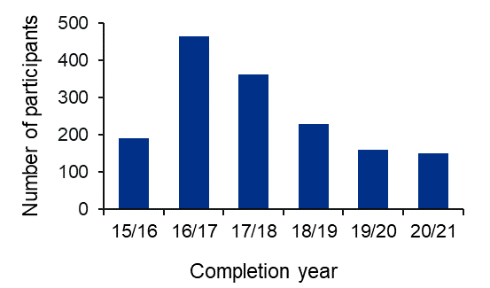

Figure 1. Participant completion data from 2015–21

Financial overview
During the period 2015–21, 1,557 participants received a total of £10,005,755 funding (Table 1). Changes in total spend across the years reflect funding availability and do not reflect a reduction in applicant interest. Funding at individual institutions reflected learner enrolment and the amount of training delivered (Table 2).

Table 1. Annual financial spend on the Master’s in Genomic Medicine programme
Financial year | Total spend
2015–16 | £2,158,340.00
2016–17 | £3,057,660.00
2017–18 | £1,547,000.00
2018–19 | £907,333.00
2019–20 | £1,196,275.00
2020–21 | £1,139,147.00

Table 2. Geographical distribution of funding for participant training by HEE region
Region | Total spend
East of England | £755,000.00
South East | £790,000.00
Midlands | £1,496,000.00
North East and Yorkshire | £1,224,000.00
North West | £916,000.00
London | £3,099,000.00
South West | £2,615,000.00
Not Provided | £92,000.00

Curriculum and module descriptions
The MGMF offers several qualification options:

- CPPD modules: individual modules of 15 credits
- Postgraduate certificate (PGCert): four modules, 60 credits
- Postgraduate diploma (PGDip): eight modules, 120 credits
- Master’s (MSc): eight modules, 120 credits plus 60-credit research project, or 10 modules, 150 credits plus 30-credit research project (total of 180 credits)
The duration of each module is four to six weeks (part time), where each module is accredited as a Level 7 or Master’s level CPPD module worth 15 credits (150 hours of learning). The MSc curriculum is comprised of the following modules:

Mandatory modules (All three modules to be completed for MSc qualification)
• Fundamentals in Human Genetics and Genomics
• Omics Techniques and Technologies and their Application to Genomic Medicine
• Bioinformatics, Interpretation and Data Quality Assurance in Genomic Analysis

Elective modules (Minimum of three to be completed for MSc qualification)
• Genomics of Common and Rare Inherited Diseases
• Molecular Pathology of Cancer and Application in Cancer Diagnosis, Treatment and Monitoring
• Pharmacogenomics and Stratified Healthcare
• Application of Genomics in Infectious Disease

Optional modules (To be completed as required to obtain the required number of credits)*
• Ethical, Legal and Social Issues in Applied Genomics
• Introduction to the Counselling Skills used in Genomic Medicine
• Health Economic Evaluation in Genomics
• Professional and Research Skills

*Not all optional modules are delivered by all HEIs. Individual HEIs can provide additional optional modules to reflect the expertise available within the institution to further enhance and expand the MGMF. For example, St George's, University of London, offers a cardiovascular genetics and genomics module and the University of Cambridge offers an epigenetics module. Students may take optional modules delivered at different HEIs.

A full list of available modules and mapped learning outcomes can be found on the Genomics Education Programme website.

National distribution of learners
Individuals who apply to the programme can attend one of seven geographically distributed training providers, all of which are established HEIs with international expertise in genomic research and postgraduate education (Figure 2). The Universities of Newcastle, Sheffield and Southampton, all of which were initially involved in programme delivery during the period 2015–18 (Figure 2), did not continue after this point, as a strategic decision was taken to reduce the number of training providers.

The distribution of participants across HEE and Genomic Medicine Service Alliance (GMSA) regions indicates that participants are drawn from a broad geographical spread (Figure 3).

Distribution of learners
*
Universities have discontinued delivery of programme
n=1,557
*

Figure 2. National distribution of learners by their choice of training provider. Learners were able to choose from a range of HEIs across England. The chart indicates the number and percentage of learners registered at individual HEIs, including three institutions that were involved in delivery only in the first three years of the programme (Universities of Newcastle, Sheffield and Southampton, 2015–18).

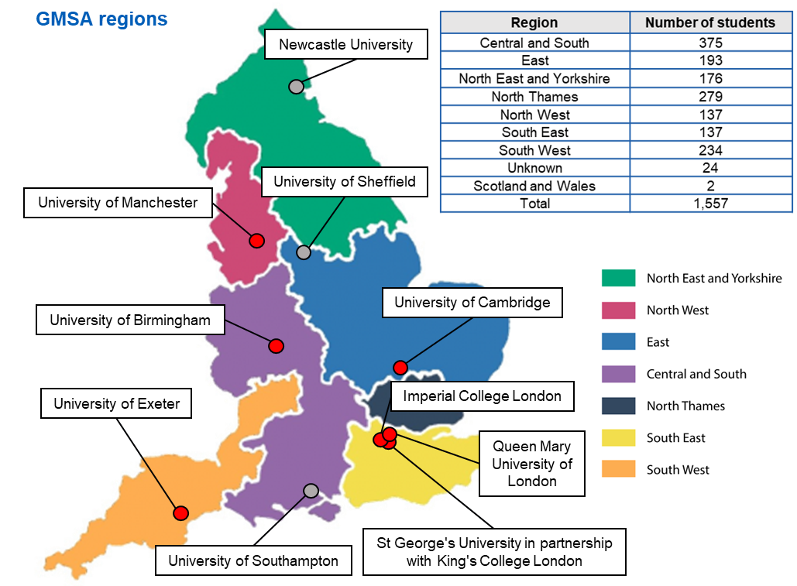
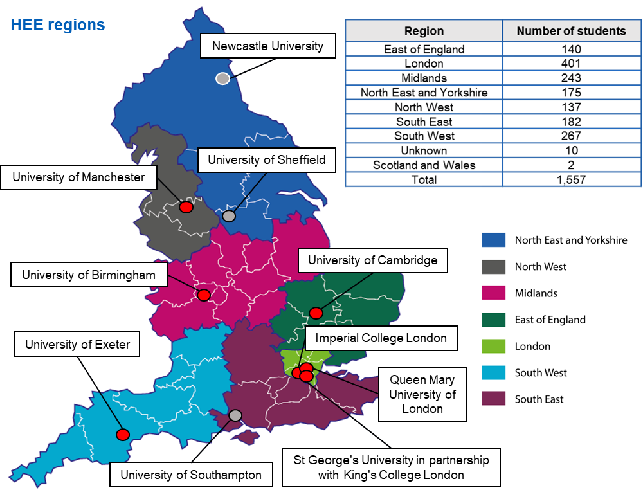
Figure 3. National distribution of learners by geographical region. The geographical distribution of learners by HEE regions (bottom panel) or GMSA regions (top panel), are indicated, as are the location of training providers (red dots show active providers, grey dots show historical providers).

Professional background of learners and training delivered
Learners were drawn from a broad spectrum of the NHS workforce, with medical professionals, healthcare scientists and nursing and midwifery professionals representing over 80% of the cohort (Figure 4, top chart). The full range of possible types of training were delivered from CPPD modules to the full MSc degree (Figure 4, bottom chart). However, the proportion obtaining an MSc varied by professional group, with a higher proportion of healthcare scientists completing the full MSc (48%) compared with nurses and midwives (30%), who mostly used the pathway for CPPD (Figure 5).

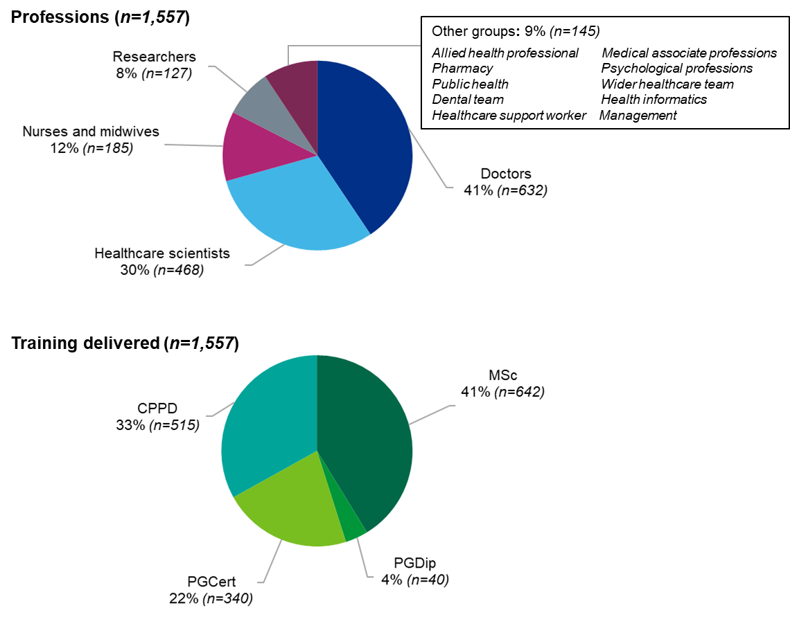
Figure 4. Analysis of learners’ professions and their study choices (training delivered). A breakdown of learners by professional background (top chart) and the training they received, including formal qualifications (bottom chart). All learners n=1,557.

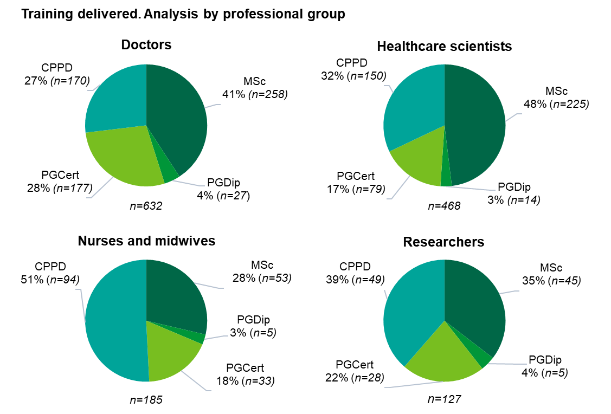
Figure 5. Analysis of training delivered subdivided by profession. Learners’ study choices differed by professional background. Doctors (n=632); nurses and midwives (n=185); healthcare scientists (n=468); researchers (n=127).

Evaluation of the Master’s in Genomic Medicine programme (2015–21)

Study aims
The aims of this study were to evaluate the programme, specifically:

- To identify the extent to which the programme is achieving its stated purpose to develop learners’ knowledge of genomic medicine and its application to their practice.

- To identify learners’, NHS managers’ and educators’ perceptions of the benefits and challenges of the Master’s framework for learners and the NHS workforce.

- To review the alignment between what employers and educators anticipate learners should be able to achieve from the programme and how this meets intended HEE outcomes.

- To inform the redesign of the Master’s framework, ensuring that it meets future workforce requirements and learner needs.

- To recommend ways of enhancing the value and impact of the framework on workforce capacity and fitness for purpose.

Study design and methodology
This mixed methods evaluation was carried out over a five-month period (November 2021 to March 2022) by a research team from the University of Birmingham.

Two online surveys were developed to evaluate the programme based on an established theoretical approach (Kirkpatrick & Kirkpatrick, 2006), which has been developed for assessing the impact of healthcare professional training (Moore et al., 2009). One was designed for learners – individuals who had taken, or were currently taking, any element of the framework – whereas the second was designed for NHS managers who approved their employees’ participation in the programme. This approval is a mandatory part of each learner’s application.

Recruitment for study participants was via targeted emails, where addresses were available, to all past and current learners and NHS line managers (Figure 6: learners n=1,229; managers n=881). These emails requested that recipients complete the appropriate online survey. The surveys opened on 25 November 2021 and closed on 4 February 2022, with 212 learners (17.2% response rate) and 55 managers (6.2% response rate) completing each survey (Figure 6). Participants were also given the opportunity to take part in an interview to provide feedback on their perception of the programme and its impact on their practice. Learners and managers who agreed to be interviewed were offered a £10 voucher for participating.

Programme teams at the seven higher education institutions who currently deliver the MGMF were contacted to establish whether they would be willing to provide feedback via focus groups. All current training providers participated in focus groups, as did one participant involved in programme management from a discontinued HEI.

Interviews and focus groups were completed by March 2022 with learners (28 interviews), NHS managers (three interviews) and members of the programme management teams at HEIs (eight HEIs, 17 individuals). Transcripts from interviews and focus groups were analysed via NVivo for emergent themes (Braun & Clarke, 2006).

The study received ethical approval from the University of Birmingham (STEM) Ethics Committee (Ref. ERN_21-1180).

Results

Results (I): Study response
Responses to online surveys and recruitment to interviews were encouraging given the Covid-19 pandemic at the time of the study. Responses to the surveys, at approximately 17% of the potential recruits for learners and 6% for managers (Figure 6) is in line with comparable large-scale online surveys of NHS healthcare professionals (for example, ~8% Jones et al., 2017; approximately 14% Bailey et al., 2020). Survey respondents were broadly representative of funded learners in terms of their professional background (Appendix A) and the HEI they attended (Appendix B). We recruited 48 individuals from across the three groups to interviews or focus groups, which allowed us to achieve saturation in thematic analysis.
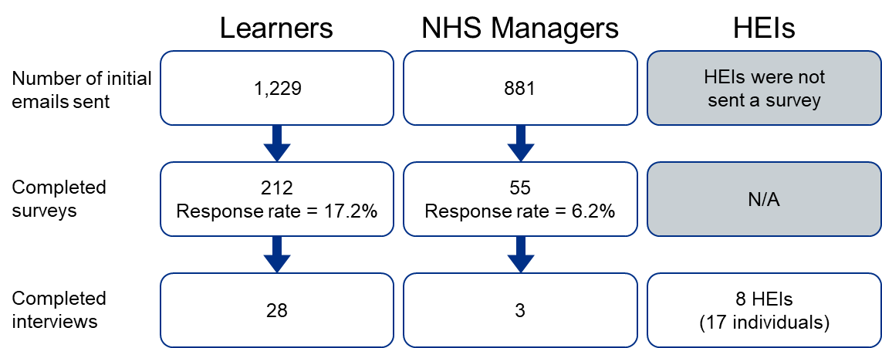

Figure 6. Overview of participant numbers at each stage of data collection. Recruitment emails were sent to all funded learners for whom HEE had contact details (n=1,229), of whom 212 (response rate 17.2%) completed the learners’ online survey. Separate recruitment emails were also sent to NHS managers who approved learners’ funding (n=881), of whom 55 completed a managers’ survey (response rate 6.2%). Learners and managers who indicated that they were willing to participate in interviews were contacted; 28 learners, and three managers were interviewed. Focus groups were also held with individuals involved in programme management at all current HEIs, and one involved in programme delivery at the onset of the framework (17 individuals at eight HEIs).

Results (II): Survey data and thematic analysis
This report presents data from learners’ and NHS managers’ surveys and combines it with the detailed insight we drew from semi-structured interviews and focus groups. These are discussed in three broad categories that map onto the learners’ journeys through the programme, the impact this had in the workplace and whether there is still a need for genomics training within the NHS.

Participant recruitment and application to the programme
A survey question focused on how participants became aware of the programme and registered interest with their managers. Results showed that the majority of learners (86%) ‘self-selected’, with only a minority being recommended to apply by their manager (Figure 7, top chart). Interviews with learners suggested they learnt about the programme via a range of routes, with most hearing via targeted marketing (for example, emails, discussions with training advisors), through informal word of mouth (for example, being encouraged by colleagues) or via non-targeted approaches (for example, posters on stairwells).

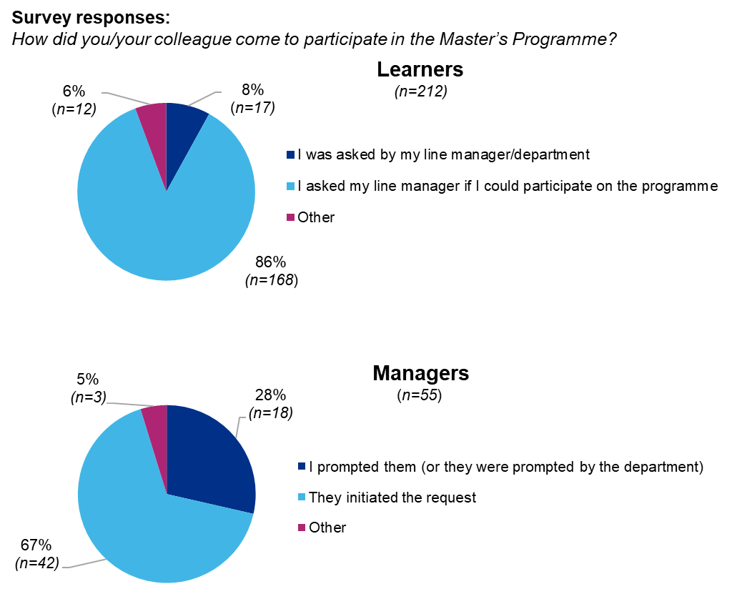
Figure 7. Learners’ (top chart) and NHS managers’ (bottom chart) perceptions about who was responsible for initiating applications to the programme. Most learners reported that they were responsible for prompting discussions, whereas line managers reported playing a larger role (learners n=212; NHS managers n=55).
Interestingly, NHS managers reported playing a larger role in recommending the programme (Figure 7, bottom chart). This may reflect sample bias, since only a small proportion of managers responded to our survey and those who did may be more invested in the programme.

NHS manager: “We advertised it internally and promoted it internally, because we felt it would be hugely valuable for our staff.”
Doctor in training (neurology): “It was just serendipitously… I was on an academic clinical fellowship research block, and I was working with a clinician who was involved with the 100,000 Genomes Project… It was one of his research nurses who told me about it [the programme].”

Programme application: Drivers and challenges
Interviews with learners identified a variety of factors that stimulated their interest in the programme. Many expressed a personal interest in genomic medicine, stated that they were keen to develop their research in the area or recognised the increased role that genomics will play in clinical delivery. Others expected that the training (and associated qualification) could lead to progression within their current role or facilitate a career change into the field of genomics. This was particularly the case for healthcare scientists, several of whom completed the full MSc to strengthen subsequent applications to the Scientist Training Programme, the NHS training programme for clinical scientists. Importantly, many participants stated that they applied because there was funding available, and that they would not have applied if the programme was self-funded.

These initial drivers influenced the length of time that participants were prepared to commit to the programme. Given the majority had busy professional workloads, many adopted a ‘stepwise’ approach – for example, by initially using the programme to complete individual CPPD modules and only subsequently deciding to build towards a qualification. In contrast, some learners reported that they focused on achieving an academic qualification from the outset (typically the full MSc), often reflecting research or career goals.

Doctor in training (clinical genetics): “Initially I started it with the thought that I’ll do some modules and see how it goes, and see if I can get a certificate and if it goes OK, I’ll do a diploma.”
We also discussed whether there were barriers that might dissuade potential participants from applying to the programme. Many applicants identified the challenge of studying part time while continuing in their professional role(s). Several learners stated that they applied because their workload was lighter than normal (for example, they were on research leave), and that colleagues with a typical workload could not make a similar commitment. This suggests that managing workloads is a key challenge for many potential learners and may dissuade some from engaging with the programme. A similar issue emerged when learners initially discussed applying to the programme with their line manager. Most learners reported being encouraged by managers, however several stated that their managers expressed concern about time and workload issues, and questioned the usefulness and relevance of the programme. This suggests that potential applicants may be dissuaded by managers from applying to the programme, but the extent of this is unclear.

Clinical scientist: “When I spoke to my manager about it, she was very much, ‘This is going to be very difficult for you – you know it's going to be a lot of time.’”
Nurse: “Asking your line manager to take up postgraduate studies when you are fully clinical is an uphill battle.”
A related issue associated with programme applications was the significant variability in the amount of study leave that learners were allocated, and how this was often inadequate for the demands of the programme. For example, many learners reported using a significant amount of their annual leave to study. This was recognised by some line managers, but many stated they were constrained in the amount of study leave they could offer.

Clinical scientist: “I had to balance my annual leave across two years to fit in all the study and all the assignments around working full time. I basically planned every single day.”
NHS manager: “If we as a department are recommending people to start this course, I feel that the amount of study leave that is offered at the moment is not sufficient for working a full-time role.”
These discussions suggest that a number of workload-related barriers may dissuade individuals and/or groups of professionals from participating in the programme. As such, current recruitment approaches will result in highly motivated individuals registering, particularly from supportive work environments. However, whether these are the ‘ideal’ recruits to contribute to the development of genomics in the NHS is less clear. A more strategic approach that identifies these ‘optimal’ learners and supports them through the programme may be needed.

Programme design and delivery

Programme design (I): Learning environments and modes of delivery
Several survey and focus group questions concentrated on learners’ perceptions of the learning environment used on the programme. These varied across training providers, but typically used face-to-face formats (for example, lectures, seminars, workshops) to cover the majority of the material, with subsequent online activities and assessment. Most learners highlighted the importance of in-person teaching for their learning and emphasised the networking opportunities and peer-to-peer learning that were a by-product of this approach.

Midwife (screening midwife): “I find it easier to interrupt a lecture and just put up my hand and say, ‘Oh excuse me, can you just re-explain that?’ I don’t have a problem with doing that in a room. So, I found it hard to ask questions when I was doing the online training.”
Doctor in training (neurology): “For me personally, I really like being in the room and having that discussion with people, I just think you just can't recreate that virtually.”
The benefits of face-to-face sessions were recognised by HEI faculty; however, faculty members also commented on the work pressures placed on learners and noted that as a result, many opted for online delivery when given the choice. This approach took a step change in response to the Covid-19 pandemic and subsequent lockdowns, when the programme was delivered wholly online (for example, using pre-recorded lectures and online seminars). Many of these approaches have been retained, with some institutions offering online-only programmes to a subset of learners.

Programme lead (HEI): “It is absolutely essential we do have some days on campus because of the tremendous peer-to-peer learning. So I would be a bit worried about doing a fully distance-based course.”
Programme lead (HEI): “Post-Covid, almost all [learners] have opted for online, even the students based in [the same city] have opted for online because of the flexibility of it.”
Given the advantages of both face-to-face and online delivery, most institutions have adopted a blended learning approach, typically using an in-person, five-day teaching block at the start of each module, with subsequent online learning activities and support. This approach mostly received positive feedback: learners noted logistical benefits, such as being able to take leave as a block, and highlighted the immersive learning experience that was created due to reduced work-related distractions. However, others felt that it was not conducive to learning due to the high volume of content presented in a short space of time, or noted that it excluded some groups of healthcare professionals due to their schedules.

Doctor (consultant, genetics): “I like the fact that the modules were definite one-week blocks, where you could go away. It was actually really important to be able to stop clinical work at the end of one week, go to [the HEI] for a whole week, stay there and just focus totally on the module. It was exhausting but good to do, and not have any distractions.”
Programme lead (HEI): “Some modules were Monday to Friday. Some modules were one day a week for five consecutive weeks. Whatever we did, we always had some students that liked one way over another way, so we can never please everybody all the time.”
Given the diversity of learners’ professions and roles, it seems unlikely that there is a single optimal format for all learners. This suggests that blended learning approaches should be retained by most providers. One consequence of this is that online learning resources are critical, and learners commented on the range of materials available online and how this supported their learning. For example, many valued the ability to access and immerse themselves in the research literature, or the availability of supplementary lecture recordings if they could not attend lectures, which could also be used as a revision tool. However, some learners implied that the programme was over-reliant on the use of pre-sessional support materials to allow some learners to catch up, reporting that these materials were essential and that modules were overwhelming without them. The use of supplementary materials to support learners is appropriate given the diversity of the cohort; however, it also highlights the fact that the expectations of learners’ prior knowledge are not always appropriate, and that this is an additional barrier for those from some professional backgrounds.

Data analyst: “Having the ability to watch lectures, watch them back if I’ve missed something or not understood something, because I am dyspraxic so sometimes it takes me a while as I have problems with my working memory. So being able to go back and re-watch a section or a lecture is really useful.”
Midwife: “If you hadn't done the pre-reading you did not have a clue what was going on in those first few sessions. There was a nurse I remember being in with me who hadn't done the pre-reading and she sort of walked out feeling really overwhelmed.”

Programme design (II): Barriers to learning
A key focus of the evaluation was whether learners experienced challenges while studying on the programme, and what the nature of these challenges were. Surveys identified that the majority of learners did face challenges while on the programme (73%, Figure 8), with word cloud analysis of respondents’ comments suggesting that they centred on balancing work and study (key words: time, work, studying). Interestingly, there were no disparities in the proportion of those experiencing challenges in different professional groups (data not shown), but this did vary between institutions (Appendix C, bottom panel), suggesting there may be scope to review curricula or assessment loads at some training providers.

Interviews highlighted the pressures many learners experienced, particularly in balancing the demands of module assessment and their professional roles. Importantly, survey data showed that only around 30% of managers were aware of these challenges (Figure 8), highlighting a potential lack of communication, understanding or support for learners in some workplaces.

Nurse (research matron): “My issue really is that my workload was increasingly stressful.”
NHS manager: “I think the problem lies with them just being overworked. So managing a full-time role, maybe having a little bit of time here and there during the nine to five to do the coursework but most, the vast majority of study and reading and coursework all has to be done in their own personal time.”
NHS manager: “I'm not aware that we've ever had an issue with somebody feeling that they were overworked clinically and unable to complete.”
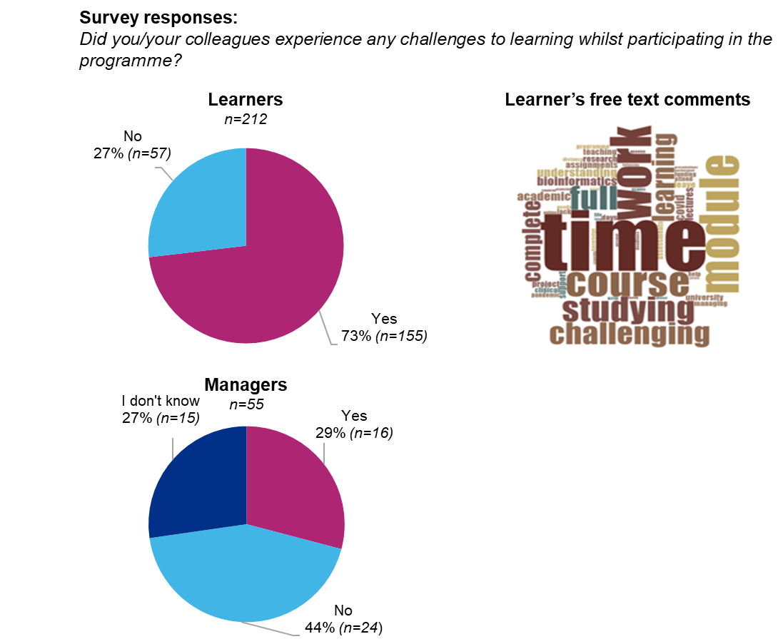
Figure 8. Survey responses from learners (top left chart), and line managers (bottom left chart), indicating the proportion that faced challenges on the programme. A word cloud image (top right) summarises the open text comments made by learners when describing the challenges they faced (learners n=212; NHS managers n=55).

Programme design (III): Learning as a multi-professional cohort
A key element of the programme is its multi-professional cohort, with participants drawn from a range of healthcare professions. A survey question focused on whether participants felt that there were benefits to this approach (Figure 9), either while on the programme or subsequently in the workplace. Responses were analysed by professional background and confirmed that all professions felt the diverse cohort reinforced their learning (more than 78% valued the approach – Figure 9). Likewise, the majority of participants reported that multi-professional learning benefitted their professional practice (more than 60% of responses – Figure 9). Interviews confirmed that learners from a variety of specialities valued the multi-professional cohort, with some stating that it was the best part of the programme. Participants commented that being taught alongside different healthcare professionals allowed them to benefit from discussions that drew on different perspectives and expertise, as well as a supportive peer-to-peer learning environment – all of which facilitated learning.

Nurse (cardiac genetics): “It was good because we got to experience and see how other people use genomics in their practice, and their perspective and what is their take on it. Also, we all use genomics in different stages – some work in the lab, I am more patient facing, so it was quite interesting to share that and learn from each other.”
Medical technical officer: “It was a good chance to network with other people from different departments and sort of put your face out there a bit more and get to actually see and meet and work with other people.”
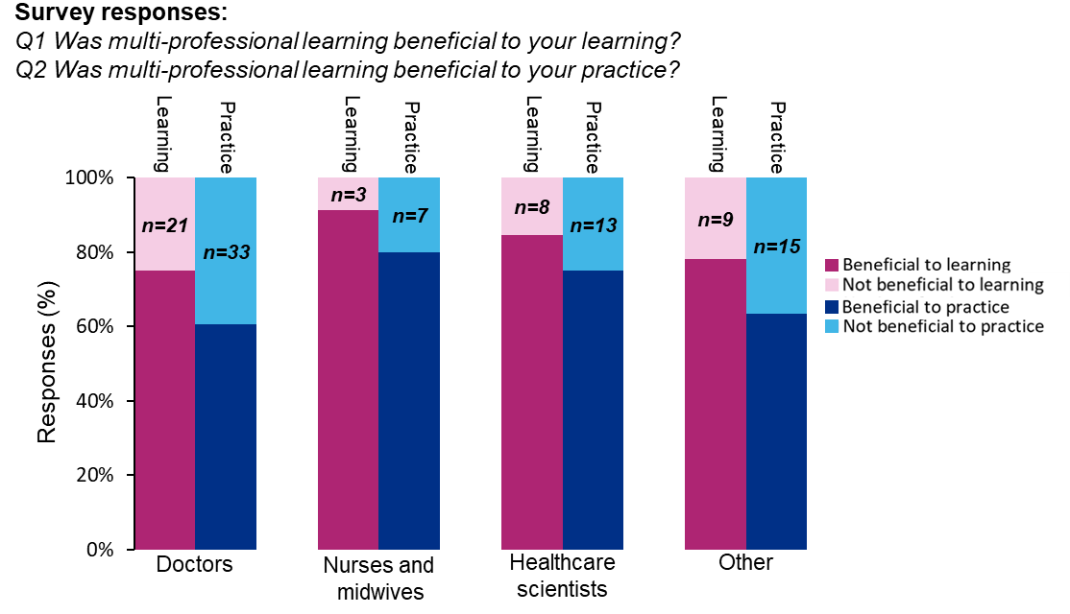
Figure 9. Survey responses to learners’ perceptions of multi-professional learning and whether it was beneficial to their learning (left-hand columns) or professional practice (right-hand columns). Responses are presented by professional group, where lower sections indicate ‘Yes’ and upper sections indicate ‘No’. The professional groups are: doctors n=84; nurses and midwives n=35; healthcare scientists n=52; and other professions n=41. A chi-squared test was performed and showed that there are no significant differences between doctors, nurses and midwives and healthcare scientists, indicating that multi-professional learning was beneficial to all professional groups (beneficial to learning p=.085, beneficial to practice p=.062).
Negative comments on the multi-professional approach largely focused on curricular issues, with some participants feeling that they needed to catch up with students from other professions, while others felt intimidated by more experienced colleagues. This highlighted the need for the programme to accommodate the diversity in learners’ educational backgrounds and training.

Nurse: “I was in a cohort with a lot of biomedical scientists, they were just breezing through – it was all easy to them. I think it was more pitched to them than it was to a nurse.”
Programme director (HEI): “We've heard from some students, they find it quite intimidating when there's people with a lot of clinical expertise contributing to the discussion when others are real beginners.”
These comments highlight the challenges posed by the diverse learner cohort to curricular design, but they also confirm that multi-professional learning is beneficial both for participants’ learning and in subsequent workplace practice (for example, via increased networking and multi-disciplinary communication). This creates an argument that the diverse learner cohort is a crucial element of the programme and contributes to its long-term outcome(s).

Programme design (IV): Programme structure and curricula

Overall balance of the curriculum
Designing a Master’s-level training programme with a balance of (i) fundamental and ‘cutting edge' genomic science, and (ii) clinical application(s) that engages healthcare professionals is challenging, so this was the focus of a survey question (‘Did the topics on the programme provide an appropriate balance between the science, ethical and practical applications needed in the NHS?’). Responses indicated that the majority of learners felt that the programme was pitched correctly, with 96% of participants ‘Somewhat’ or ‘Completely’ satisfied with the balance of the curriculum (Figure 10 pie chart). This varied between professional groups, with the highest satisfaction being reported by healthcare scientists and a more mixed response from those with nursing or midwifery backgrounds (Figure 10 bar chart). Interview responses were consistent with this: there was broad support for the curriculum, but the learners who valued exposure to cutting-edge research tended to have scientific or research backgrounds, while other learners did not anticipate the extent of scientific material that underpinned the majority of the programme.

Clinical scientist: “I think it does do a good job of doing all those things [science, ethics, practical application] – having real people, real scientists, real clinicians, counsellors who are bringing cases that are current.”
Medical technical officer: “It was good to be able to have that content delivered by someone who was at the top of their game in that field.”
NHS manager: “I don't think they [the learners] expected them [the modules] to be quite so ‘science-y’ and technical. The courses were very academic in nature, and in some ways not always directly applicable to someone doing genomics in their clinical practice.”

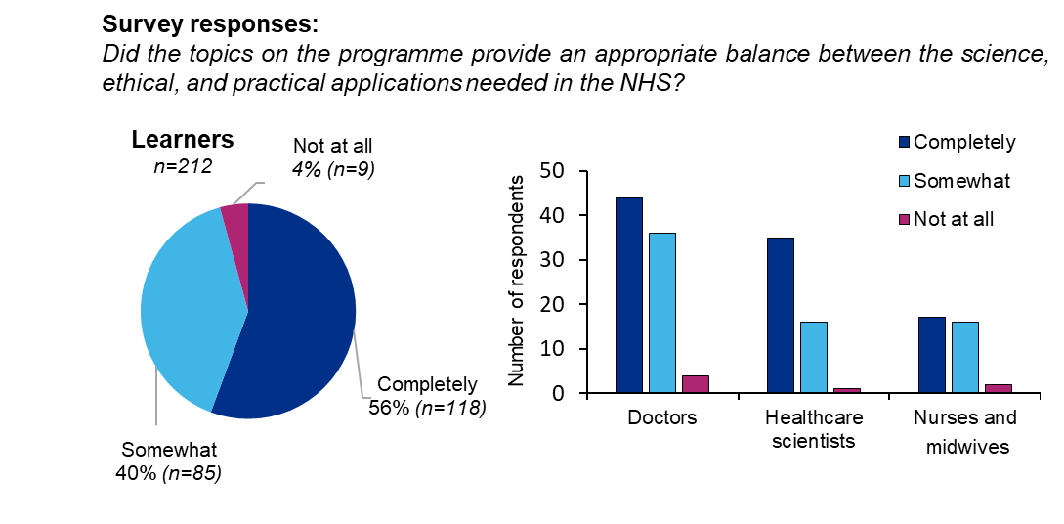
Figure 10. Learners’ perceptions of the balance of the curriculum. Responses for all learners (pie chart), and by the respondents’ professional backgrounds (bar chart) which show marked differences between the different professional groups (learners (overall) n=212; doctors n=84; healthcare scientists n=52; nurses and midwives n=35).

Overall programme difficulty
Interviews revealed that many learners found the material on individual modules challenging, but appreciated that they were taught at Master’s level and that the science underpinning genomic medicine is extensive and complex. Most felt that these difficulties reflected their professional background – for example, many healthcare scientists will have received professional training in molecular biology and are likely to keep up to date with developments in genomics as part of their role. In contrast, for many healthcare professions with a focus on clinical skills, genetics and genomics is a much smaller component of their training and practice. However, even learners who had completed training in this area often recognised that their understanding was outdated or incomplete.

This placed an onus on the programme to familiarise learners with underpinning material, either
by providing pre-sessional reading lists or via the introductory ‘Fundamentals’ module. However, comments from learners stating that they needed more academic support, or that lecturers assumed that learners were from scientific backgrounds, suggested that this was not always effective.

Pharmacist (consultant, genomics): “I wouldn't say it's easy because I did have to work hard on it, and I mean it is complex, but I enjoyed the complexity of it. I don't think making it easier is necessarily the right thing. There were clearly things that I didn't quite get, but I think that's not a reason to take content out if it is perceived as being hard.”
Doctor in training (neurology): “It's such a fast-moving field. In a way we're all starting from scratch really. What I learned at university 20 years ago… some of it's wrong now.”
Midwife (screening midwife): “They [the modules] varied considerably. The first module I did was the introduction, and oh God on day three I was asking to leave. I’m not joking.”

Topic and/or module usefulness and relevance
In a related survey question, learners were asked to identify the most and least useful topics covered by the programme, where the topics given mapped onto individual modules. See Appendix D for details about which topics map to which modules (and note that some topics map to multiple modules). The results revealed a wide variation in learners’ perceptions, with the topics covered in the compulsory modules that formed the core of the programme being generally well received (highlighted in red, Figure 11). However, the topics ‘Bioinformatics’, mapped to a compulsory module, and ‘Health economic evaluation’ and ‘Communication and counselling skills’, both mapped to optional modules, were identified as less useful by many learners.

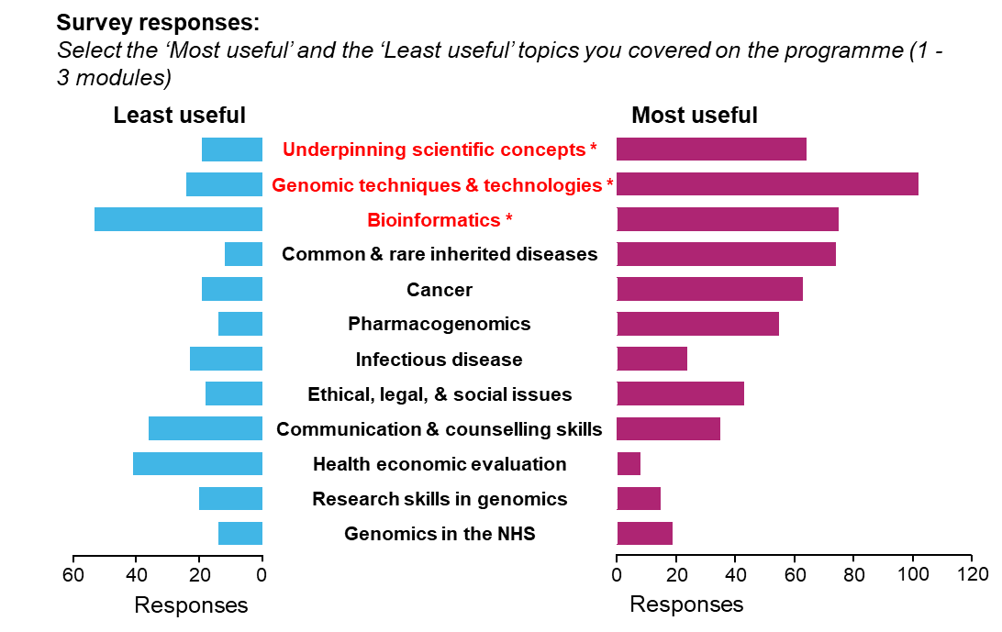
Figure 11. Learners’ perceptions of the most and least useful topics on the programme. Learners were asked to identify between one and three topics that were the most useful (right-hand column) and the least useful (left-hand column), where the topics mapped to modules in Appendix D. Topics that mapped to compulsory modules are marked with an asterisk (*). Topics covered by modules that were delivered at individual institutions are not presented, because they would not be comparable. The chart indicates the number of responses for each topic (870 responses from 212 learners). Note that these data combine responses on a national scale, and variation between providers will influence the responses.
Learners’ perceptions of topics appeared to reflect their relevance to professional practice – something highlighted by their open text comments. Word cloud analysis of these comments (Figure 12) frequently identified the words relevant, practice, working and applicable, whereas the words understanding, knowledge and interest emerged less often. This is consistent with learners’ expectations of the programme (Figure 14), which also focused on application in the workplace.

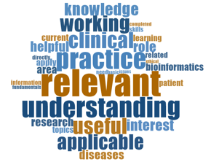
Figure 12. Word cloud analysis of comments learners used to describe the usefulness of programme topics. In this analysis, the size of individual words reflects the frequency with which they were used by learners. Comments associated with the most useful and least useful topics were combined to identify the words that justified their choices (n=200).

The focus on the application of learning was highlighted by the marked differences in learners’ perceptions of topics when analysed by professional group. For example, nurses and midwives (Figure 13, central panel) particularly valued the topics Communication and Counselling Skills and Ethical, Legal and Social Issues, which interviews confirmed could be readily applied to their practice. Similarly, doctors (Figure 13, top panel) and healthcare scientists (Figure 13, bottom panel) particularly valued the topics Genomics Techniques and Technologies and Bioinformatics, as these specialities are more likely to use these approaches to inform diagnosis or research. However, interviews suggested that workplace applicability did not wholly explain the disparities observed between healthcare professions, and that aspects of module curricula and/or delivery also contributed. This was clear for two topics: Bioinformatics and Ethical, Legal and Social Issues.

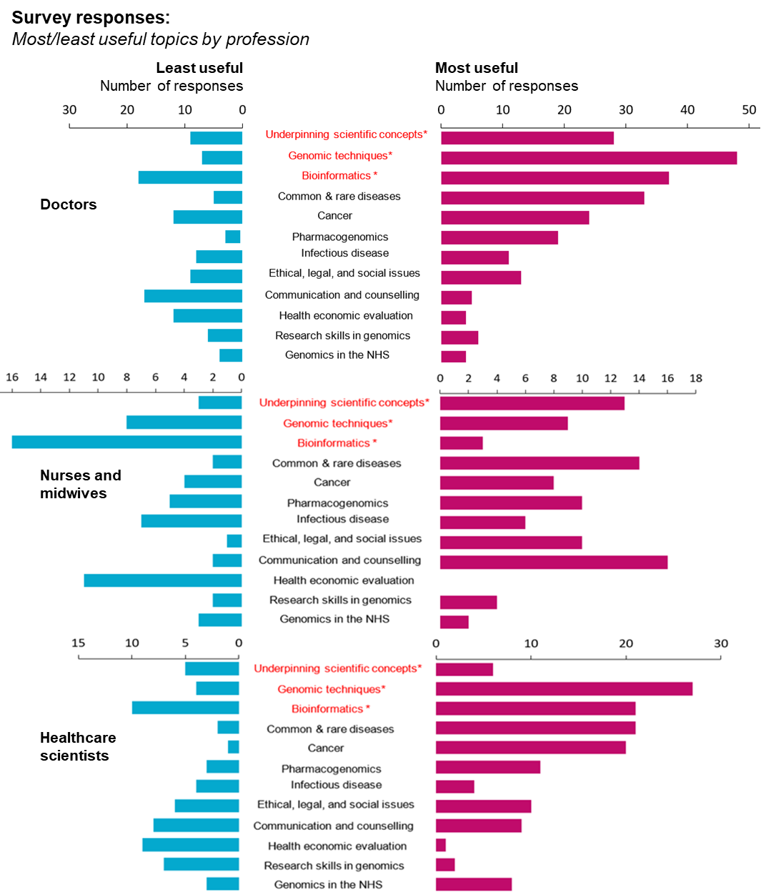
Figure 13. Learners’ perceptions of the most and least useful topics when analysed by professional background. Learners were asked to identify between one and three topics that were the most useful (right-hand chart) and least useful (left-hand chart). Compulsory topics are marked with an asterisk (*).

(i) Bioinformatics
Feedback on the Bioinformatics module was the most mixed of the compulsory modules, with a significant proportion of learners identifying the topic as less useful. Many either felt aspects of the module were unnecessarily challenging (for example, the requirement for computer programming in some sessions) or questioned the module’s relevance or whether their educational background had been considered when developing the curriculum. This issue was reinforced because bioinformatics is a mandatory module, which learners must complete for the MSc qualification. Sharing best practice between training providers may resolve some of these issues as many learners valued the module, however, it was noticeable that positive comments often came from those with research or lab-based backgrounds. This suggests that the curriculum for this module (including expectations of learners’ prior knowledge and skills) should be reviewed.

Nurse: “Bioinformatics was a really tough one. Sometimes we really felt like we had no idea what was going on.”
Doctor (consultant, genetics): “Students were being taught almost to become mini-bioinformatics experts, which wasn't the point at all. The point was to give people the understanding and the knowledge to just know what's out there – how to apply the skills very broadly, but not to become experts in the field.”
Medical technical officer: “I absolutely loved bioinformatics from start to finish, I thought it was brilliant.”

(ii) Ethics, legal and social issues in applied genomics
Learners also gave mixed responses regarding the optional ethics module. Positive comments focused on how ethical issues underpin many applications of genomics, and learners from clinical roles in particular valued how they could readily apply the topic when communicating with patients. This led a number of participants and HEI faculty members to suggest that the module should be mandatory, or that aspects of ethics should be incorporated into all modules. However, as with the bioinformatics module, there was some evidence of disappointing teaching practice, suggesting sharing curricula may be useful.

Pharmacist (consultant, genomics): “The ethics module was really useful to me and I've used it actually at work in this role.”
Data analyst: “I found the content of the ethics course a bit trivial. It was almost like it was led by scientists that had already made up their mind. I was kind of hoping for some sort of discussion around ‘Is that right? Can we do something better?’ It wasn't really explored.”

Implications for programme structure
A broad theme that emerged from discussions with learners was the challenge of ensuring the programme engaged the whole cohort. This was reflected in the varied perceptions of topics by different professional groups, and raised the issue of whether some mandatory modules (for example, Bioinformatics) should be optional.

Clinical scientist: “There were a couple of units that when I was doing them, I was thinking, ‘This is going to be absolutely no use to me and my job.’ So maybe I was subconsciously less interested, worked less hard and struggled more.”
Midwife: “I did struggle with the omics and bioinformatics, which were actually I think core modules. So, I have to say I think I don't understand why they had to be core modules, because I don't think I’d ever really use them again.”
A related issue was whether the overall ethos of the programme was appropriate. Faculty at many HEIs had a clear vision of what the programme aimed to achieve, often describing the increased understanding, knowledge and skills learners would take into the workplace. However, this was often described in the context of research skills and disciplinary understanding, rather than clinical application. This highlighted the research focus of the Master’s programme, but raised the issue of whether more emphasis on clinical application in the workplace is needed.

Programme lead (HEI): “In terms of giving them the true conceptual background to genetics and genomics, I think they've got a good basis.”
Programme co-lead (HEI): “Our aim is to make them think and gain principles that they can apply in their own areas.”
Finally, several learners, institutional faculty and NHS managers questioned whether a full MSc degree (with the focus on research and the commitment required) is more appropriate for a subset of learners rather than the broader NHS workforce. This is an appropriate area for strategic review, and raises operational issues such as whether the threshold for funding participants studying for higher level qualifications should be reviewed.

Programme lead (HEI): “Are they being educated to be researchers? Are they being educated to be clinicians, or to be diagnosticians?”
Nurse (research matron): “The problem is I don't really know what market they're trying to address. Is this just a bioscience degree for say, the scientific world, or do you want the nurses? So that's why I’m a bit confused.”
NHS manager: “I wonder whether its value is less in getting a full MSc, and more in being able to do one-off modules and postgraduate certificates and that kind of thing. Specifically, for people that are in practice so they can really pick and choose.”

Programme outcomes
The final series of survey questions focused on programme outcomes in the context of individual learners, in particular whether it had impacted on their practice and the wider NHS workplace.

Outcomes (I). Participants’ expectations of the programme
A survey question asked learners and line managers to identify their expectations of the programme and the extent to which these were met. This offered a range of anticipated outcomes (Figure 14); however, learners and managers chose two areas above others, both of which focused on the application of genomics to either (i) healthcare provision, or (ii) professional practice. A smaller number of responses focused on developing academic or clinical skills, or increased career opportunities. Reassuringly, a majority of learners (greater than 90%, Figure 15) confirmed that their expectations were met, though this varied across the criteria, and 9% reported that their career-related expectations were not met. We received a similar pattern in managers’ responses, confirming that learners’ and managers’ expectations of the programme were broadly in line.

Interviews largely confirmed that the programme met learners’ expectations. These were often discussed in terms of the survey criteria; for example, for improved academic skills (expectation 1, Figure 14), learners commented on improved writing, editing and research skills, or being able to understand current research articles. Similarly, others described how taking the programme had resulted in promotions or new career paths (expectation 5, Figure 14), particularly for healthcare scientists entering the Scientist Training Programme. However, several learners described a lack of career opportunities and felt frustrated that they were unable to put their genomic understanding and/or skills into practice.

Doctor (consultant): “I was surprised how useful it was for me, it opened my eyes to a whole load of the way the technology works now… The other thing I suppose I should say – a load of our pathology journals actually now make sense again.”
NHS manager: “A lot of our technologists who have done this have moved then into becoming clinical scientists.”
Allied health professional: “I would have expected to have a little bit more with regards to career progression... I was really motivated to do something with it [the qualification] over the last three years... I’ve had no luck at all so far.”
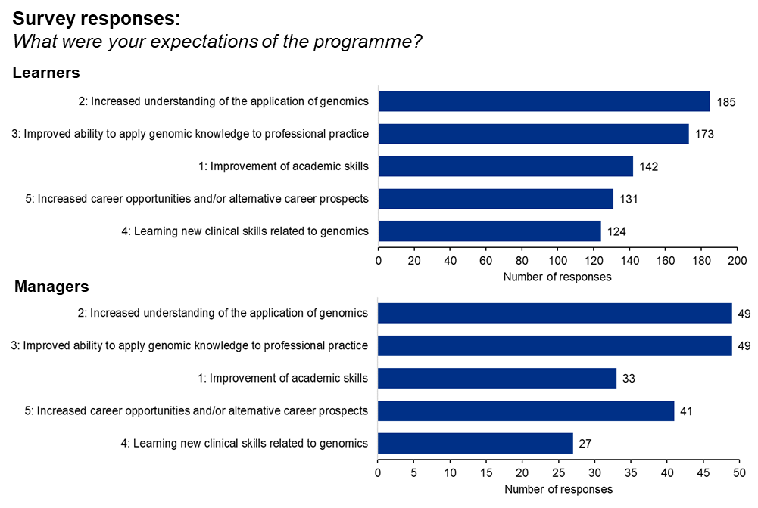
Figure 14. Learners’ and managers’ expectations of the programme and the extent to which these were met. Respondents were asked to identify one or more outcomes they anticipated from the programme (expectations 1–5). Learners n=212; NHS managers n=55.

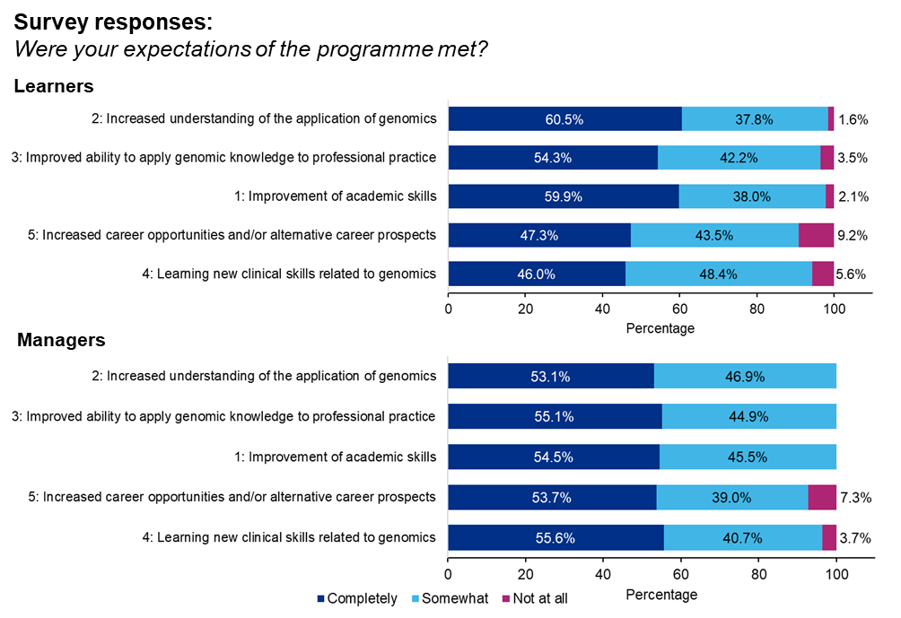
Figure 15. The extent to which learners’ and managers’ expectations of the programme were met. Respondents were asked to identify one or more outcomes they anticipated from the programme (expectations 1–5) and the extent to which these were met. Percentages indicate the proportion of responses indicating expectations were satisfied, either completely, somewhat or not at all. Learners n=212; NHS managers n=55.

Outcomes (II). Impact in the workplace
A common thread in learners’ and managers’ expectations of the programme centred on the application of genomics in the workplace (expectations 2, 3 and 4, Figure 14). A survey question therefore focused on whether the programme enhanced professional practice. Responses provided an encouraging picture, with 86% of learners reporting positive change (Figure 16, top left chart). Similar patterns of enhanced practice were reported in all professional groups, though healthcare scientists were particularly positive about the impact of the programme (96% reported enhanced practice, Figure 16). Importantly, 69% of managers also recognised learners’ enhanced practice in the workplace (Figure 16, bottom left chart).

Likewise, a majority of learners (64%, Figure 17) reported that the programme contributed to enhanced departmental practice, with similar levels of enhancement in all professional groups (data not shown). A similar proportion of managers (58%, Figure 17) confirmed that the programme had positive impact(s) on departmental delivery.

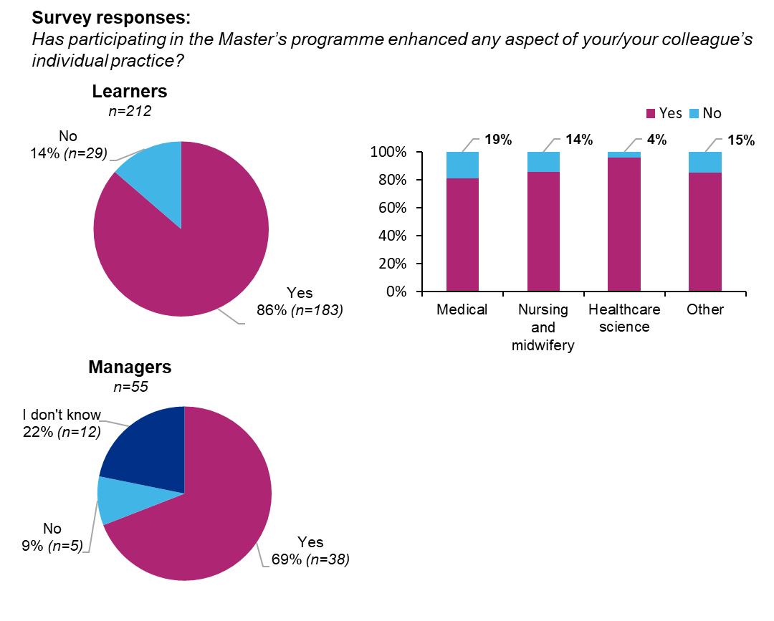
Figure 16. Did the programme enhance participants’ individual practice? Learners (top left chart) and managers (bottom left chart) were asked whether the programme enhanced professional practice, with the percentage responding yes or no indicated. Learners’ responses were analysed by professional background, and the percentage of participants responding no and yes are indicated (top right chart). Learners (overall) n=212; doctors n=84; nurses and midwives n=35; healthcare scientists n=52; other professions n=41; managers n=55.

Learners and managers reinforced the survey findings in interviews, reporting that the programme resulted in improved practice in a number of areas. For example, learners in a variety of clinical roles reported having increased confidence in interpreting patients’ genetic and genomic data, whereas others valued how their increased understanding improved their communication of genomic data to patients. Others reported that the programme benefitted their wider department as they informally passed on knowledge or were involved in training colleagues.

Nurse (cardiac genetics): “I think just building up my confidence to discuss genetic concepts with my patients and being able to provide more in-depth advice. I feel like I’m more confident when I engage with my peers and with my colleagues in genetics discussions, I can add more to the discussion.”
NHS manager: “They [learners] have greater confidence and competence [in their] ability to answer patient’s questions if they had that sort of science knowledge.”
Nurse: “It's benefited me phenomenally in my background knowledge of genomics which I now teach to other people... I have used my learning to upskill others in the NHS.”
NHS manager: “I think it gives them a really wide context of the work they’re doing, and they understand more of the patient aspect as well. It gives them a wider scope to their role, and they just understand their work a lot more.”
Participants also commented on the outcomes that flowed from the multi-professional nature of the programme, which allowed learners to make connections that extended into the workplace. This applied across both clinical and non-clinical contexts, with learners commenting on improved communication in multi-disciplinary team (MDT) meetings and reporting that networking on the programme had led to them contributing to genomic research.

NHS manager: “I think it improves the quality of our MDT meetings, our multidisciplinary team meetings that we had.”
Clinical scientist: “I think the ways it exceeded my expectations is the networking with other clinical colleagues and how useful that's been in my job.”
Pharmacist (consultant, genomics): [On the multi-professional cohort] “I always say it is one of the best bits about this course and the way it's run, because you are problem-solving with people that you will be problem-solving with if you're working in a service.”
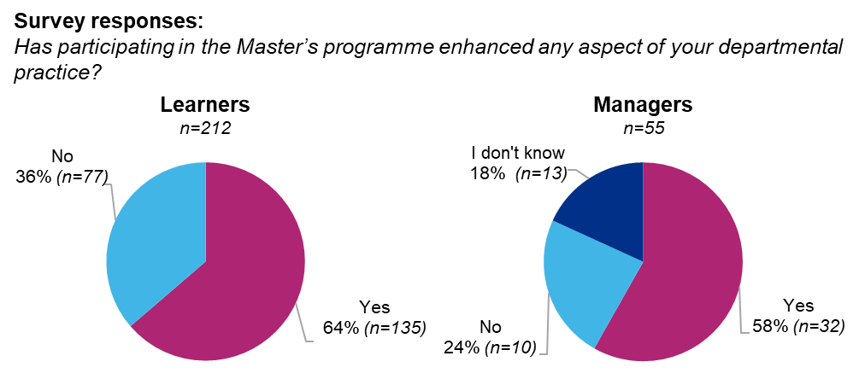
Figure 17. Did the programme enhance departmental practice? Learners (left-hand chart) and managers (right-hand chart) were asked whether the programme enhanced any aspect of departmental practice. The number of responses and the percentage responding yes or no is indicated (learners n=212, managers n=55).

Outcomes (III). Would you recommend the programme?
A set of survey questions focused on whether learners and managers would recommend the programme to colleagues. Encouragingly, 86% of learners would do so (Figure 18, top chart), with high levels of satisfaction across all professions. Healthcare scientists were particularly positive about their experience (96% would recommend the programme: Figure 18, top right chart).
Importantly, managers were equally positive, suggesting they also recognised the value of the programme (85% would recommend the programme: Figure 18, bottom left chart). However, responses did show marked disparities between training providers, suggesting some institutions met the needs of learners more than others (Appendix E).

Doctor (consultant): “I've been a massive advocate for the MSc and the modules ever since I did them, because I think they're really good. I’d recommend lots of people to go and do it and I'm very, very positive about it.”
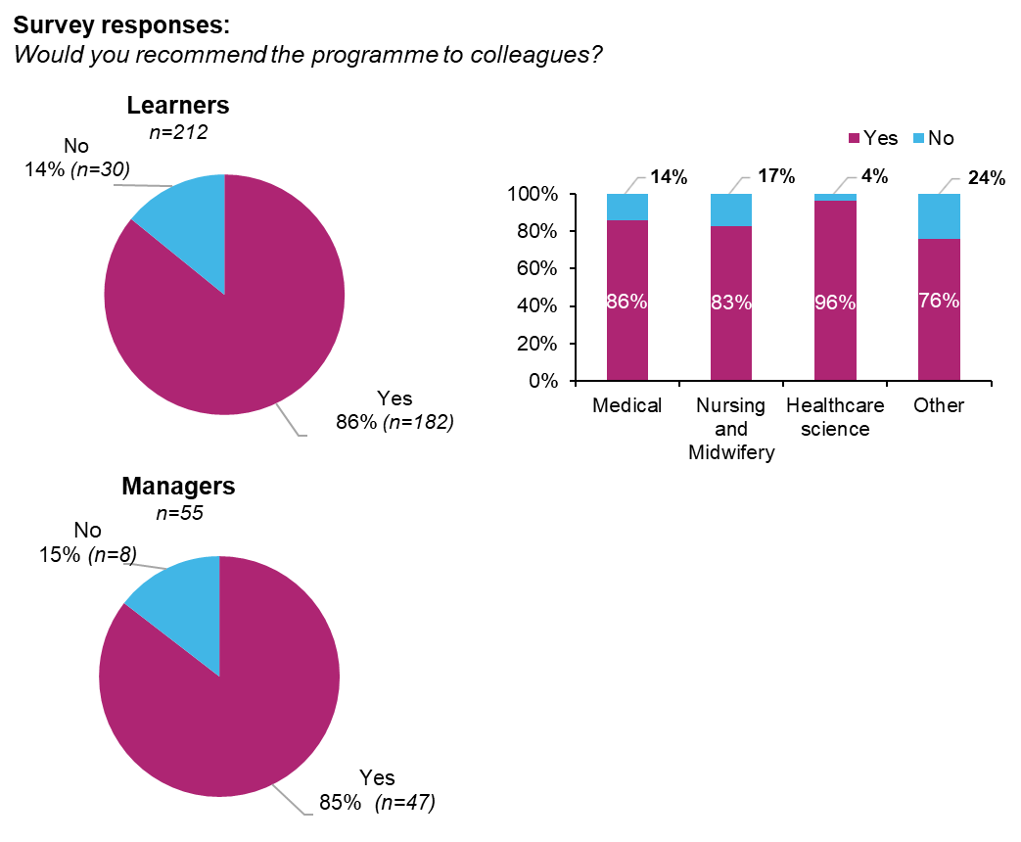
Figure 18. Learners’ and managers’ willingness to recommend the programme. A high proportion of learners (top left chart) and managers (bottom left chart) indicated that they would recommend the programme to colleagues. This was similar for all groups of healthcare professionals. The percentage of participants responding no and yes are indicated (top right chart). Learners (overall) n=212, doctors n=84, nurses and midwives n=35, healthcare scientists n=52, other professions n=41, managers n=55.

Outcomes (IV). Is there a continuing need for the programme?
A related series of survey questions focused on whether learners and managers felt there was a continued need for the programme. One aspect addressed individual learners and whether they were interested in continuing with or returning to the programme if they were no longer registered. Encouragingly, a majority were interested in continuing to study, although this was markedly higher for current learners (87%, Figure 19) than for those no longer registered on the programme (62% of completed learners, Figure 19). Likewise, the level of qualification they aspired to differed: 95% of current learners intended to study to full MSc level, whereas only 56% of those who had taken a pause showed interest in completing the full MSc.

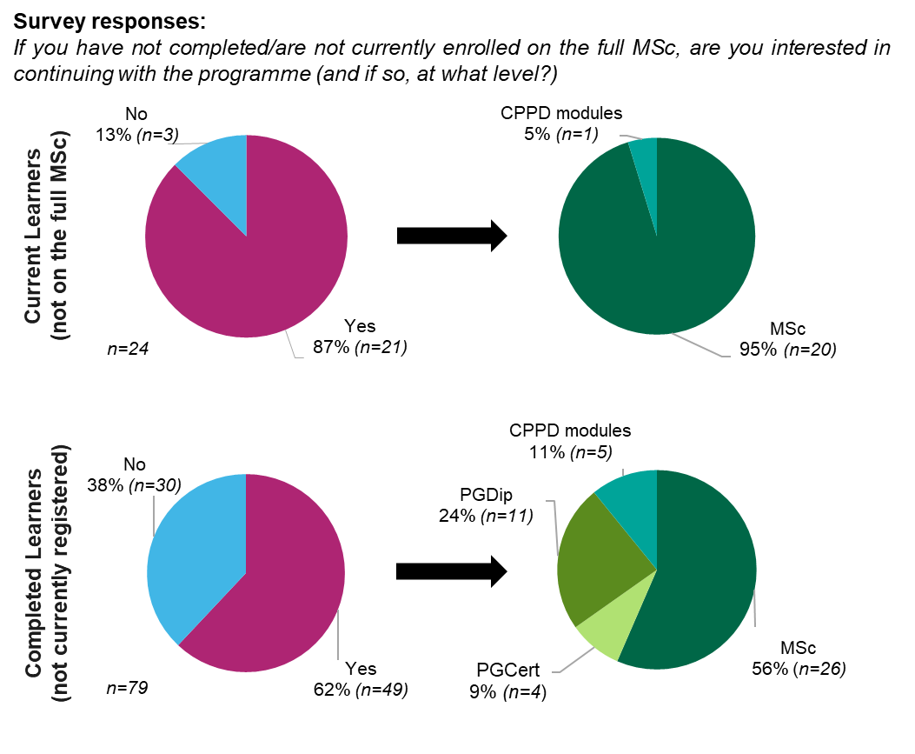
Figure 19. Learners’ interest in further study on the programme. We surveyed current learners on the programme (top charts) and completed learners (those no longer registered (bottom charts)) to find out whether they were interested in further study and, if so, at what level of training and/or qualification. Learners’ responses regarding further study are indicated (left-hand charts), as is the level of training they are interested in (right-hand charts) (current learners n=24, completed learners n=79).

Discussions highlighted a continuing need for the programme. Comments often centred on the insufficient coverage of genetics and genomics in professional training, and how the rapid pace of research meant that what coverage did exist quickly became outdated. A number of participants expected an increased role for genomic medicine within the NHS, and commented that upskilling the workforce was essential for this development. Given the ongoing change in genomic research and clinical application, discussions also focused on ensuring that programme alumni maintained a current understanding of the topic. Several participants suggested establishing an online forum to address the ongoing development needs of programme alumni, facilitate networking and disseminate job opportunities.

Doctor (consultant, genetics): “It has been helpful to keep me current in an environment that is changing so rapidly.”
Doctor in training (neurology): “Genomics is just kind of shooting up exponentially in terms of knowledge. All the research is growing at such a fast pace, the NHS workforce needs to keep up with it.”
Pharmacist (consultant, genomics): “I'm under no illusions, my knowledge is five years out of date.”

Discussion
Study aims and methodology
This mixed methods study represents the first detailed evaluation of the Master’s in Genomic Medicine, a nationwide programme of genomics training aimed at healthcare professionals in the NHS. The programme’s purpose is to develop participants’ knowledge of genomics so that they can communicate effectively about the topic with colleagues and patients or be involved in genomics education, policy or research; ultimately, the programme aims to address the key barriers to implementing genomics in healthcare (Johnson et al., 2020). We therefore focused on whether the programme is designed appropriately to deliver these outcomes in the NHS workplace, and on identifying factors that facilitate or act as barriers to this.

Given that participants are drawn from a variety of healthcare professions, the extent to which learners can incorporate genomic knowledge into their practice and the impact this has on patients will depend on participants’ speciality, role(s) and work environment (for example, their ‘proximity’ to genomics; McClaren et al., 2020). This determined the conceptual frameworks that informed the evaluation (Kirkpatrick and Kirkpatrick, 2006; Moore et al., 2009), which used a structured process to describe the characteristics of the learners (level 1), their satisfaction with key aspects of the programme (level 2), assessment of knowledge gained (level 3), ability to deliver change in the workplace (levels 4 and 5), and whether it impacts on patients (level 6). This approach has advantages, including its logical structure and ability to identify issues that impact on the implementation of training. Semi-structured interviews with key stakeholders (learners, managers, academics involved in delivery) allowed us to triangulate and generate rich data on these issues.

Study findings: Study response rates and respondent profile
Our approach, using a combination of online surveys and follow-on interviews, is consistent with other evaluations of CPPD training for healthcare professionals (Curry et al, 2013; Lawler et al., 2020). We anticipated that there would be challenges to participant recruitment, given the extended period of delivery evaluated (seven years: 2015–22) and the increased workload on the NHS workforce associated with the Covid-19 pandemic. Given this background, survey responses were encouraging and are comparable with previous surveys of NHS healthcare professionals (for example, ~8%, Jones et al., 2017; ~14%, Bailey et al., 2020). The profiles of survey respondents were similar to those of funded learners in terms of professional background and training providers attended (Appendices A and B), though we had a larger response from learners that studied for the full MSc, suggesting that those who committed more to the programme were more likely to respond.

Study findings: Learner characteristics and training completed
Data on learner characteristics was drawn from the HEE database of participants and showed that applicants came from a range of healthcare professions with a broad geographical distribution (Figures 3 and 4). With approximately 1,500 participants on the programme from an eligible NHS England workforce of ~558,000 (doctors, nurses, midwives and scientific, therapeutic and technical staff; NHS Workforce statistics, June 2021), the scope of the programme remains limited; however, this is just one part of a web of genomics education and training available, and it may reflect an appropriate amount of high-level training within this large and diverse workforce (Slade et al., 2016). Understanding the extent of preparedness and/or need for professional training in genomics (for example, using surveys: Simpson et al., 2019; McClaren et al., 2020) in a range of healthcare specialities (Crellin et al., 2019) would be useful to assess the ongoing level of workforce demand in the NHS.

While this study shows that approximately 41% of learners completed a full MSc during this period, whether that is an optimal outcome for the development of genomic medicine in the NHS is unclear. Disparities in the qualifications obtained by learners in different professional groups (Figure 4) may reflect differential training needs (for example, there is lower perceived need for genomic education and training for nurses and midwives than for medical professionals and healthcare scientists: Simpson et al., 2019), but could also reflect barriers in the programme or workplace that mean that some learners do not extend their study. We found some evidence of this (for example, workload issues and curricular challenges), and it is an appropriate area for further research.

Study findings: Learner and manager satisfaction with the programme
We used a combination of online questionnaires and semi-structured interviews to survey learners’ perceptions of key aspects of the programme, including the programme application process (Figure 7), curriculum design and delivery (Figures 8 to 12) and whether the programme met learners’ expectations (Figure 14). Learner responses were triangulated with the views of managers and academics involved in programme management to give several broad findings, outlined below.

1. Learners were broadly supportive of the structure and balance of the programme curriculum, and valued the modules that comprised the Master’s programme. Interviews with learners suggested that many found Master’s level curricula challenging, but valued their detailed understanding of current genomics and the implications it had for patient care. This focus on the application of training is known to motivate healthcare professionals (Simpson et al., 2019) and suggests that it may be under-represented in some modules and/or at some institutions.

2. Learners were highly supportive of the blended learning environments used, valuing the inter-personal aspects of face-to-face learning and the flexibility of online learning activities and resources (Nortvig et al., 2018). Given the challenge(s) of balancing part-time study and professional jobs, the blended approach was a key strength of the programme.

3. The multi-professional learning approach was highly valued across all professional groups and was central to the delivery of programme outcomes in the workplace. Learners valued the ‘real world’ understanding that came from discussions with colleagues from other disciplines, the strong ethos of peer support and the ability to form connections that often extended into the workplace (Thistlethwaite, 2012).

4. Learners’ and managers’ expectations of the programme were strongly aligned, and a high proportion of both groups stated that they would recommend the programme to colleagues.

5. Learners were highly supportive of programme management teams, but there were disparities in perceptions of the programme at individual institutions (Appendices C and E). This may reflect differences in the cohorts they recruit, but could also suggest that there is a need to review curricula and/or delivery at some HEIs.

Study findings: Impact of the programme on learners’ knowledge of genomics
Several elements of the evaluation mapped onto the impact of the programme on learners’ knowledge of genomics. This was superficially straightforward, because learners had to pass assessments to complete modules and, as a Master’s level programme, these assessments required critical evaluation of current genomic research, a sophisticated understanding of its application in healthcare and/or the application of associated skills. These map onto the learning elements of Moore’s framework (for example, ‘knows’, ‘knows how’ and ‘shows how’: Moore et al., 2009). As most learners had minimal experience in genomics, this is consistent with comments that assessment was one of the most challenging aspects of the programme.

These assessments cannot assess learners’ knowledge gain (for example, we did not use a pre- and post-test design: Jackson et al., 2019), and we did not collect data from HEIs on the proportion of learners who successfully passed modules. However, learners (self-) reported an increased understanding of genomics and its application(s) and a development of academic skills in surveys (Figure 15) and interviews.

Study findings: Impact of the programme on practice in the workplace
Learners’ increased genomic knowledge and understanding was accompanied by enhanced practice in the workplace (Figures 16 and 17). Importantly, this self-reported enhancement was confirmed by NHS managers and often mapped onto the intended outcomes of the programme. Learners from a range of backgrounds reported that their understanding of genomics contributed directly to patient care, either due to increased confidence in contributing to multi-disciplinary diagnostic teams or to communicating about genomics with patients. These are areas in which advances in genomics have highlighted development needs (for example, teamwork: Best et al., 2021; patient communication: Haga, 2019; Patch and Middleton, 2018). Other programme outcomes were also found to enhance clinical practice, albeit indirectly, with learners contributing to the NHS processes that manage bioinformatic/DNA sequencing data, training colleagues or contributing to genomic research.

Summary and study limitations
In summary, our evaluation of the Master’s in Genomic Medicine establishes that the programme meets its intended outcomes and is an effective approach to addressing some of the training needs of the NHS workforce. We demonstrate a high level of learner satisfaction, evidence of long-term engagement, increased knowledge and skills, and outcomes in the workplace consistent with improved patient care. Importantly, we also show a high degree of alignment between learners’ (self-reported) responses and NHS managers’ perceptions of the programme’s impact.

This evaluation approach has disadvantages common to other methodologies (Frye and Hemmer, 2012), in that we do not assess individuals’ learning gain (for example, comparing pre-training and post-training tests; Jackson et al., 2019), or have a ‘control group’ to determine learners’ knowledge and skills when they enter the programme. Likewise, we are largely reliant on self-reporting to assess changes in learners’ behaviour, though we do survey manager perceptions to address this. This highlights the limitations of the Kirkpatrick model (Bates, 2004), which only collates a subset of learner data and assumes that there is a causal link between trainee satisfaction, learning and outcomes.

Similarly, given the diversity of learners’ professions and the extended time scale(s) required to deliver measurable changes in patient outcomes, we have not developed metrics to assess the impact in the workplace and/or on patient health (for example, ‘Level 5–7’, Moore et al., 2009; intermediate and long term outcomes, Nisselle et al., 2019). This partially reflects the nature of genomic medicine, which underpins many aspects of diagnosis and treatment. However, other studies have evaluated outcomes with defined learner groups (for example, GPs’ referral of patients to clinical genetics centres; Houwink et al., 2015), something that should be explored in future evaluations given its importance (Nisselle et al. 2021).

Recommendations
Our study establishes that the programme has considerable strengths, and that it achieves its purpose in training a wide range of healthcare professionals to a Master’s level with evidence of subsequent impact in the workplace. However, we also revealed a number of issues that influence the effectiveness of the programme and/or bring focus to the question of whether the programme is a cost-efficient and appropriate means of upskilling the NHS workforce. These issues are discussed below, as are some potential areas for review.

Strategic review: Learner recruitment and support
The programme’s current approach to learner recruitment depends on participants responding to targeted marketing; this has been effective in recruiting motivated learners who can integrate increased genomic understanding into their practice. However, it is clear that marketing is not comprehensive, and the level of support given in many workplaces (for example, study leave, ongoing workload expectations) is widely perceived as being inadequate. This acts as a disincentive for potential candidates and may lead to patchy uptake, with some specialities, roles or institutions being under-prepared for developments in genomic medicine.

HEE should consider:

- Commissioning studies to: (i) understand the time commitment associated with studying on the programme (for example, learner diaries); and (ii) evaluate the level of workplace support for learners (for example, survey study leave and/or ongoing workload expectations). This will generate an evidence base for reviewing the programme and/or workplace policy on study leave.

- Extending previous surveys of key NHS workplaces and/or professional groups to evaluate workforce preparedness and/or the extent of training need(s) (for example, Simpson et al., 2019; McClaren et al., 2020). This could be extended to understand barriers to programme uptake as necessary.

- Adopting a more strategic approach if areas of low workforce preparedness are identified, by: (i) targeting candidates using managers’ recommendation(s); and (ii) supporting these candidates by funding the partial backfilling of their role in the workplace.
Review the programme curriculum to optimise training for all healthcare professions
The model underpinning the Master’s in Genomic Medicine is that of a common curriculum, delivered by geographically distributed training providers; however, this will accommodate disparate practice across HEIs as curricula will often reflect the clinical and/or research interests of faculty. While this is engaging, it will result in different balances of curricular content and/or place different expectations on learners. This may explain the disparities in learner perceptions of the programme at different training providers. A related issue is that learners from some specialities find the programme more challenging due to the nature of their professional training, and these learners are less likely to progress to a qualification.

- Overall, the curriculum is well received by learners; however, training providers should take the opportunity to review whether it is appropriate for all learners and whether to increase emphasis on the application of genomic medicine in healthcare. Strengthening the input of clinicians (particularly from nursing and midwifery) in curriculum design may help to increase those learners’ engagement and progression.

- HEE and HEIs should review module assessment and whether it strikes an appropriate balance between demonstrating the achievement of learning objectives and recognising the work pressures on full-time professionals.

- The bioinformatics module received mixed reviews from learners, suggesting that it should be reviewed in the context of the diverse range of learners taking it. Given the central role that bioinformatic approaches play in genomic medicine, it should remain a core topic in the Master’s programme; however, the level of the material should be reviewed and some aspects may be better addressed in a non-mandatory advanced bioinformatics module. An alternative approach is to consider whether the bioinformatics module should be mandatory and required only for the full MSc.

- HEE should explore the possibility of establishing a wider range of specialist modules, particularly on topics that are readily applicable in clinical contexts. These could be delivered by individual institutions wholly online or using a residential or blended learning approach to maximise uptake.
Review whether an MSc qualification is an ideal outcome for NHS workplace development
A key element of this programme is that learners can study for a full MSc qualification – and a substantial proportion of learners complete it. This has benefits for the NHS as it takes learners’ understanding to the cutting edge of genomic practice and develops high-level academic and research skills; however, it carries a higher cost than other approaches to training. Our study suggests that learners value the opportunity to complete a MSc and that there are tangible benefits for patients; however, it is not clear whether the full MSc is necessary for these outcomes. This is a good opportunity for a strategic review of the programme.

HEE should:

- Review whether the full MSc qualification adds value for all learners and whether individual modules, or a PGCert or PGDip, may be more appropriate for some.

- Review the process of extending funding from the initial CPPD to full MSc level, such that students have to justify progression to the MSc in terms of the added value it creates for workplace practice. An element of this review should consider whether increasing the career development of learners in the absence of immediate impact on workplace practice is sufficient justification for funding.

References
Bailey O, Vernazza CR, Stone S, Ternent L, Roche AG and Lynch C. Amalgam phase-down part 1: UK-based posterior restorative material and technique use. J. Dental Research Clinical & Translational Research 2020: volume 7, issue 1. doi: 10.1177/2380084420978653

Bates R. A critical analysis of evaluation practice: the Kirkpatrick model and the principle of beneficence. Evaluation and Program Planning 2004, volume 27, issue 3, pages 341–347. doi: 10.1016/j.evalprogplan.2004.04.011

Best S, Brown H, Stark Z, Long JC, Ng L, Braithwaite J and Taylor N. (2021). Teamwork in clinical genomics: A dynamic sociotechnical healthcare setting. Journal of Evaluation in Clinical Practice 2021: volume 27, pages 1369–1380. doi: 10.1111/jep.13573

Braun V, Clarke V. ‘Using thematic analysis in psychology’. Qualitative Research in Psychology 2006: volume 3, issue 2, pages 77–101.

Crellin E, McClaren B, Nisselle A, Best S, Gaff C and Metcalfe S. Preparing medical specialists to practice genomic medicine: education an essential part of a broader strategy. Frontiers in Genetics 2019. doi: 10.3389/fgene.2019.00789

Frye AW and Hemmer PA. Program evaluation models and related theories: AMEE guide no. 67. Medical Teacher 2012: volume 34, issue 5, e288-e299. doi: 10.3109/0142159X.2012.668637

Haga SB (2019). First responder to genomic information: a guide for primary care providers. Molecular Dignosis and Therapy 2019: volume 23, issue 4, pages 459–466. doi: 10.1007/s40291-019-00407-z

Houwink EJ, Muijtjens AM, van Teeffelen SR, Henneman L, Rethans JJ, Jacobi F and Dinant GJ (2015). Effect of comprehensive oncogenetics training interventions for general practitioners, evaluated at multiple performance levels. PLOS One 2015: volume 10, issue 4, e0122648. doi: 10.1371/journal.pone.0122648

Jackson L, O’Connor A, Paneque M, Curtisova V, Lunt PW, Pourova RK and Cornel MC. The Gen-Equip Project: Evaluation and impact of genetics e-learning resources for primary care in six European languages. Genetics in Medicine 2019: volume 21, issue 3, pages 718–726. doi: 10.1038/s41436-018-0132-3

Johnson K, Clayton E, Starren J and Peterson J. The implementation chasm hindering genome-informed health care. Journal of Law, Medicine and Ethics 2020: volume 48, issue 1, pages 119–125. doi: 10.1177/1073110520916999

Jones J, Rayner S, Logue S, Imray E, Stewart D and Leslie SJ. National Health Service healthcare staff experience and practices regarding complementary and alternative medicine: an online survey. International Journal of Complementary and Alternative Medicine 2017: volume 5, issue 4. doi: 10.15406/ijcam.2017.05.00159

Kirkpatrick D. L, Kirkpatrick J. D. ‘Evaluating training programs: The four levels’ (third edition) 2006. San Francisco: Berrett-Koehler Publishers.

McClaren B J, King EA, Crellin E, Gaff C, Metcalfe SA and Nisselle A (2020). Development of an evidence-based, theory-informed national survey of physician preparedness for genomic medicine and preferences for genomics continuing education. Frontiers in Genetics 2020: volume 11, issue 59. doi: doi.org/10.3389/fgene.2020.00059

Moore Jr DE, Green JS and Gallis HA. Achieving desired results and improved outcomes: integrating planning and assessment throughout learning activities. Journal of Continuing Education in the Health Professions 2009: volume 29, issue 1, pages 1–15. doi: 10.1002/chp.20001

Nisselle A, Martyn M, Jordan H, Kaunein N, McEwen A, Patel C and Gaff C. Ensuring best practice in genomic education and evaluation: a program logic approach. Frontiers in Genetics 2019. doi: 10.3389/fgene.2019.01057

Nisselle A, Janinski M, Martyn M, McClaren B, Kaunein N, Maguire J and Gaff C. Ensuring best practice in genomics education and evaluation: reporting item standards for education and its evaluation in genomics (RISE2 Genomics). Genetics in Medicine 2021: volume 23, issue 7, pages 1356–1365. doi: 10.1038/s41436-021-01140-x

Nortvig AM, Petersen AK and Balle SH. ‘A literature review of the factors Influencing e‑learning and blended learning in relation to learning outcome, student satisfaction and engagement’. Electronic Journal of E-learning 2018: volume 16, issue 1, pages 46–55.

Patch C and Middleton A. Genetic counselling in the era of genomic medicine. British Medical Bulletin 2018: volume 126, issue 1, pages 27–36. doi: 10.1093/bmb/ldy008

Simpson S, Seller A and Bishop M. Using the findings of a national survey to inform the work of England’s Genomics Education Programme. Frontiers in Genetics 2019: volume 10, 1265. doi: 10.3389/fgene.2019.01265

Slade I, Subramanian DN and Burton H. Genomics education for medical professionals – the current UK landscape. Clinical Medicine 2016: volume 16, issue 4, pages 347–352. doi: 10.7861/clinmedicine.16-4-347

Thistlethwaite J. Interprofessional education: a review of context, learning and the research agenda. Medical Education 2012: volume 46, issue 1, pages 58–70. doi: 10.1111/j.1365-2923.2011.04143.x

Appendices
Appendix A: Are study respondents a representative sample of learners?
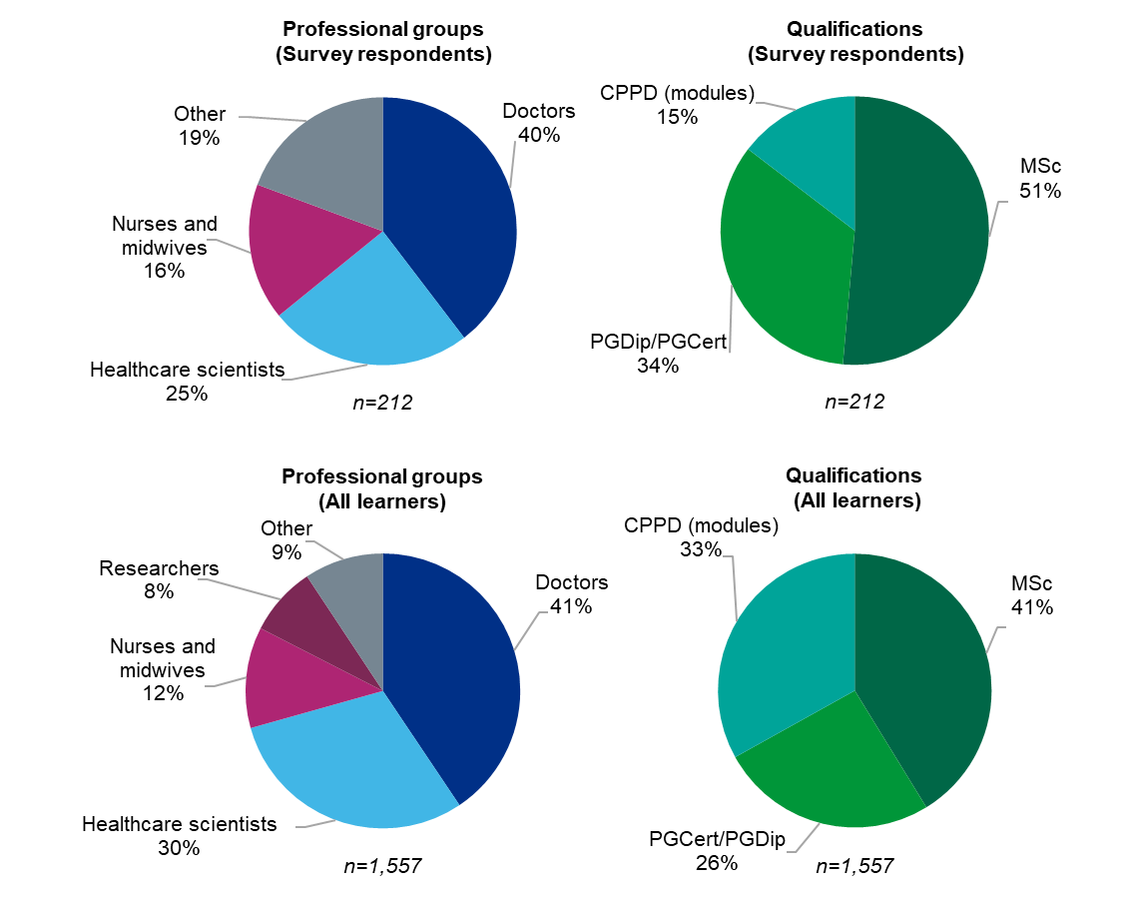
Appendix A. Professional backgrounds of survey respondents and all learners on the Master’s programme. Survey respondents (top charts) had a similar profile of professional backgrounds to programme learners (bottom charts), but respondents were more likely to have completed the full MSc than the national cohort (respondents 51% vs all participants 41%). (All learners n=1,557, survey respondents n=212).

Appendix B: Are study respondents a representative sample of learners?

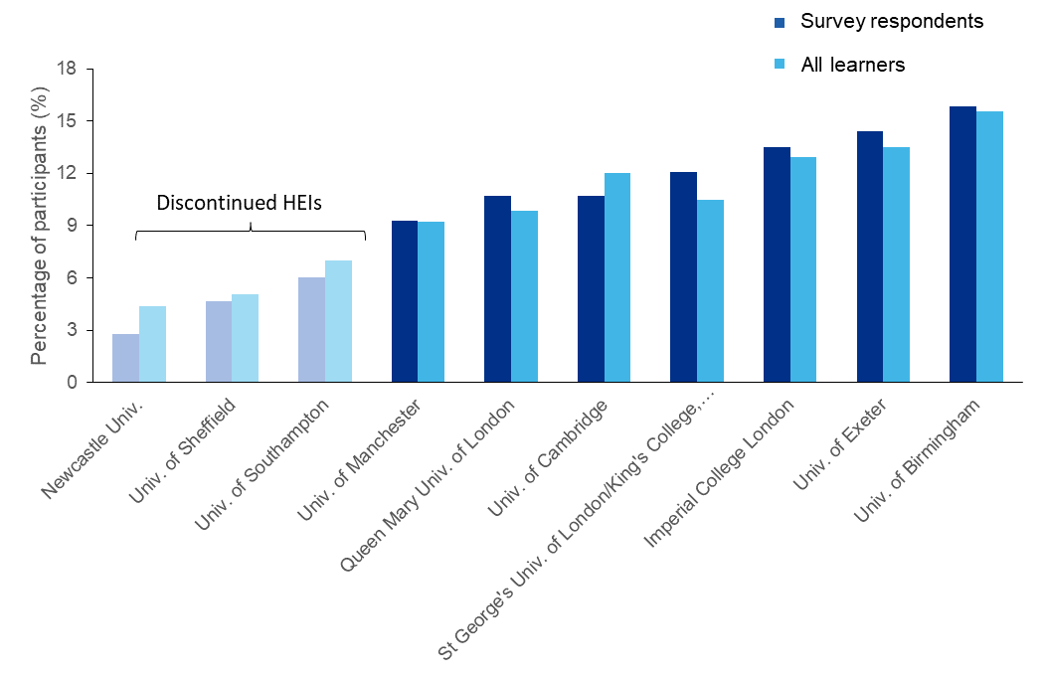
Appendix B. Proportion of survey respondents and all learners attending training providers. Survey respondents attended the full range of training providers and closely reflected the national distribution of learners. Institutions in paler colours were training providers only during 2015–18.

Appendix C. Learners’ perceptions: Analysis by HEI
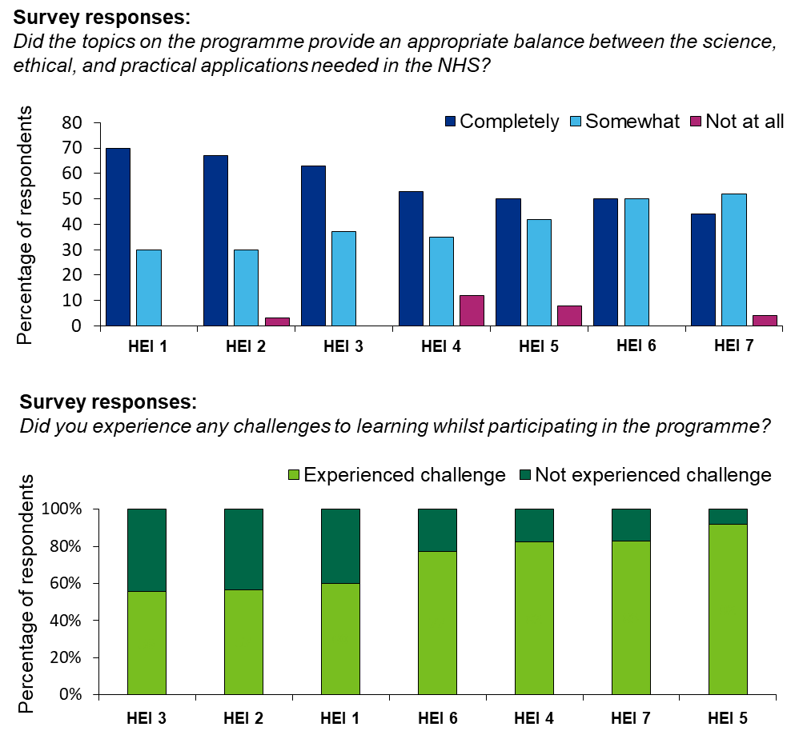

Appendix C. Learners’ perceptions of the programme analysed by the training provider they attended. Responses to questions about (i) whether the balance was appropriate (‘completely’, ‘somewhat’ or ‘not at all’, top panel), and (ii) whether they experienced challenges on the programme (bottom panel) are presented by higher education institution (HEI) attended.

Appendix D. Topic-to-module mapping
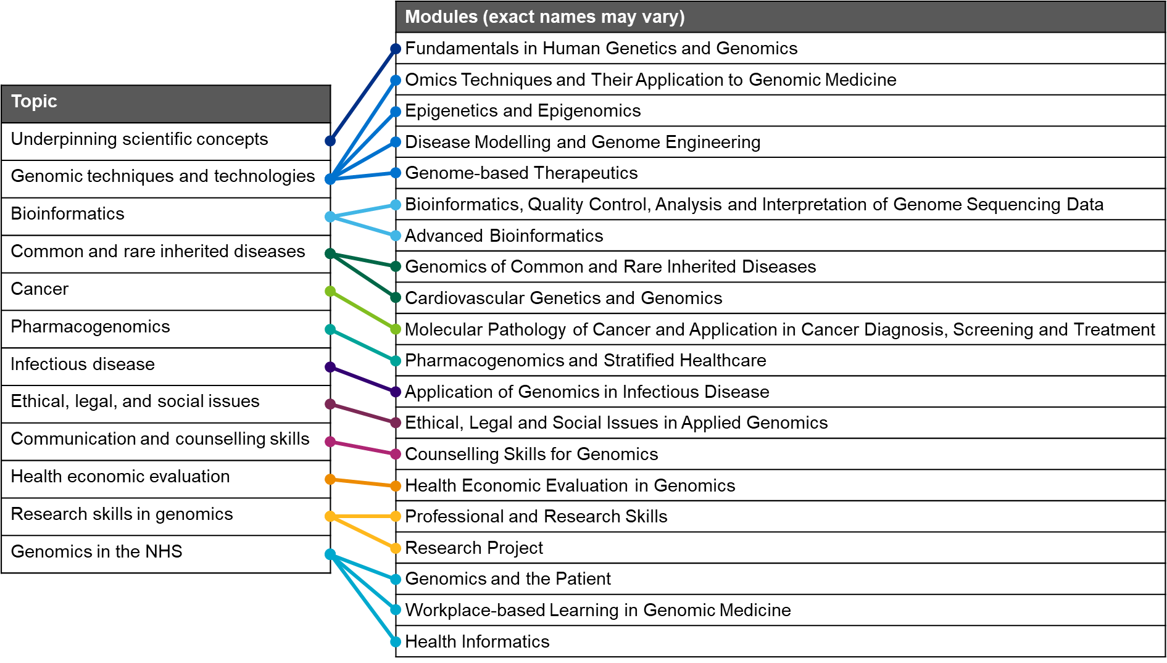
Appendix D. Topics asked about in the survey broadly mapped to modules delivered by the HEIs. Some topics, such as ‘Underpinning scientific concepts’ and ‘Ethical, legal and social issues’ are likely to be covered across multiple other modules.

Appendix E. Learners’ perceptions: Analysis by HEI
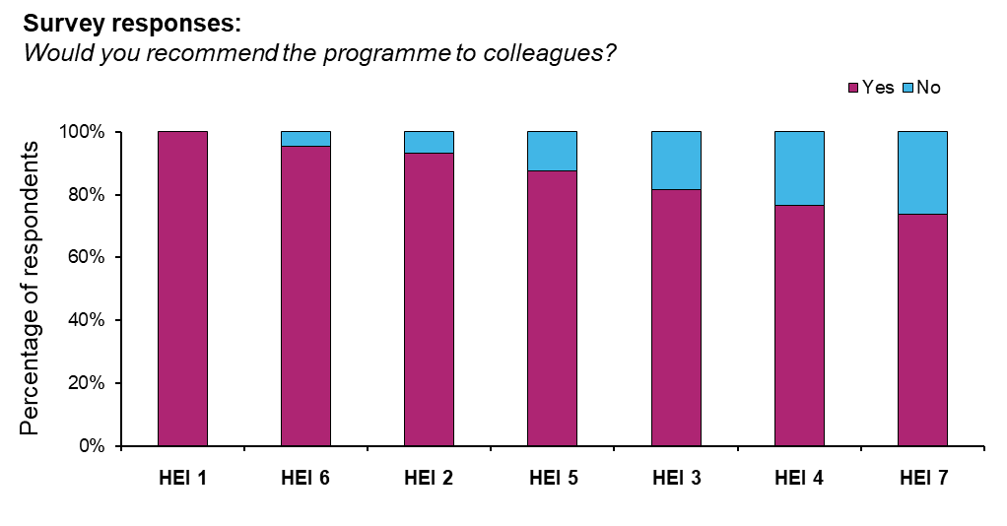
Appendix E. Learners’ willingness to recommend the programme to colleagues, analysed by training provider attended. Results showed marked disparities between institutions.

