The Clinical Pathway Initiative
Quick jump to:
1. Introduction
2. Creating a Clinical Pathway Initiative project
3. Exemplar of a pathway project
4. Developing the education to support the pathway project delivery
5. Any queries?

1. Introduction
Thank you for contributing to the Clinical Pathway Initiative. This document will provide further detail of the steps taken to write a pathway project.
The primary aim of the CPI is to identify the competencies required by healthcare professionals in each step of a clinical pathway where genomics is required for delivery. Many are likely to be smaller sections of larger pathways or networks. A flow diagram representing the steps to developing a pathway project is shown overleaf

2. Creating a Clinical Pathway Initiative project (flowchart)
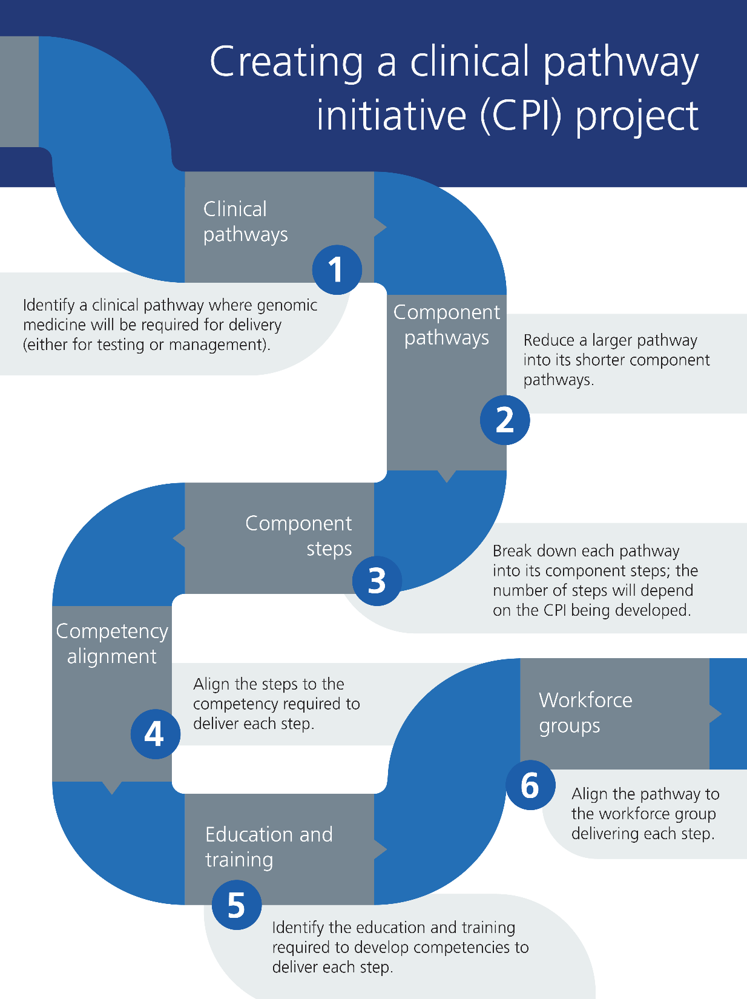
Figure 1 - Creating a clinical pathway initiative (CPI) project flowchart
* In consideration of Step 2, a larger pathway (for example, a CPI project to investigate an intellectual disability), might be divided into one pathway to request genomic and testing and several pathways to return results.
** You may wish to consult with the National Genomics Education competency frameworks when considering appropriate competencies

3. Exemplar of a pathway project

(Please note, this is not a completed project but is shown for illustration.)

- Clinical pathway: Identify a clinical pathway where genomic medicine will be required for delivery (either for testing or management).
In this example, you identify a clinical pathway for genomic testing to investigate a child with hypotonia.
- Component pathways: Reduce a larger pathway to its shorter component pathways.
For instance, a pathway investigating a child with hypotonia might be divided into two: a) requesting genomic testing and b) interpreting and feeding back results, the latter of which could then be divided further. As such, the CPI would have the following component pathways:
- Requesting testing
- Feeding back results: causative result
- Feeding back results: non causative result
- Feeding back results: uncertain result
- For the remainder of this exemplar, we will focus on a) Requesting testing.
- Component steps: Break down each pathway into its component steps;
It is helpful to use a spreadsheet to start the mapping process, and you may find our spreadsheet template helpful for this. Below you will see that we have divided the component pathway into five main steps. The fifth step collates 3 smaller sub-steps which involved the process of obtaining the patient sample for testing.

Case finding/patient identification |  | Identifying relevant information to facilitate clinical diagnosis |  | Decide what tests to undertake |  | Ensure specific gene/s of interest are tested |  | Provide information on test | Consent for testing | Collection of sample, recording and requesting genomic testing

- Competency alignment: Identify the genomic competencies required to deliver each of these steps.

- Determine which competencies your workforce will require to deliver each of the steps. You may find it helpful to refer to the competency frameworks developed by NHS National Genomics Education and the genomic syllabus developed by the Academy of Medical Royal Colleges. The template has also identified common generic competencies that may be applicable to your pathway.
- Number each learning need.
- Code each competency using the following*:
  - G: Generic competency, that is those that are shared by all healthcare professionals, such as: Recognises and acts within professional/role specific boundaries
  - P: Pathway specific; those that are specific to the CPI, such as: Demonstrates knowledge of genomic conditions that include hypotonia as a characteristic feature
  - St: Step specific: those that are specific to the step, such as: Understands how to access and use the National Genomic Test Directory
  - K: Knowledge competency; such as: Understands, Describes
  - S: Skills competency; such as: Demonstrates, Applies
  - A: Attitude competency; such as: Appreciates, Recognises
This coding system is intended to aid both authors and end-users to identify competencies that may be unique to the CPI, and, secondly, the types of competencies that need to be met.
Note: You may identify competencies that are required across every step of your chosen pathway. A separate column at the end of your pathway can be made for these to indicate their significance across all steps.

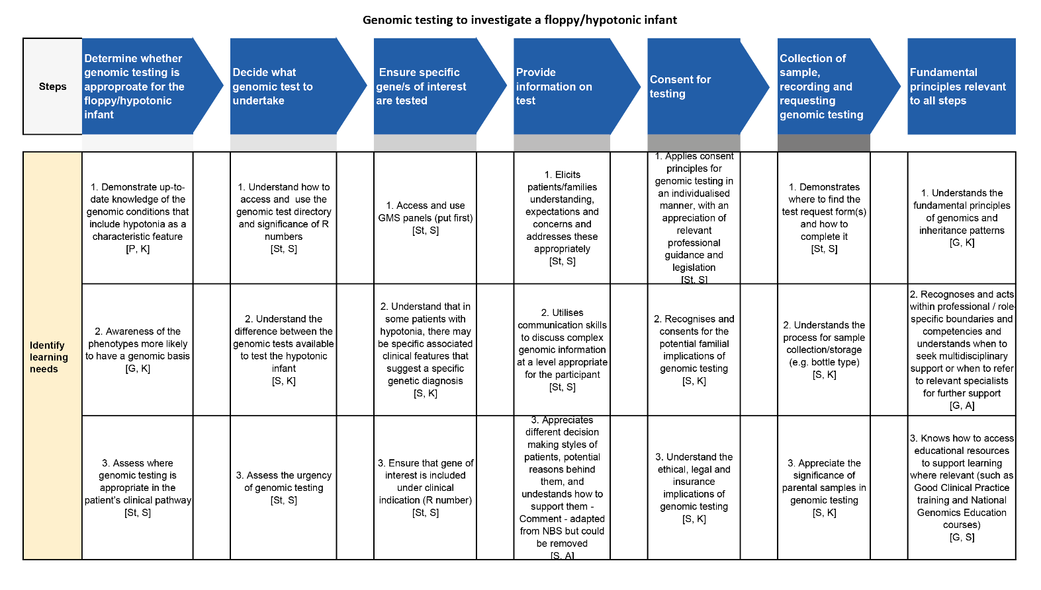
Figure 2 - Example CPI project (genomic testing to investigate a floppy hypotonic infant): Identifying learning needs

- Education and training: Identify education and training resources that are available to develop each competency.
Identify educational resources and align them to their respective numbered competencies. For example, educational resource 1 will contribute to the development of competency 1, educational resource 2 will contribute to the development of competency 2, etc. Educational resources can be mapped to more than one competency where relevant. Please provide a link or the resource itself where possible.
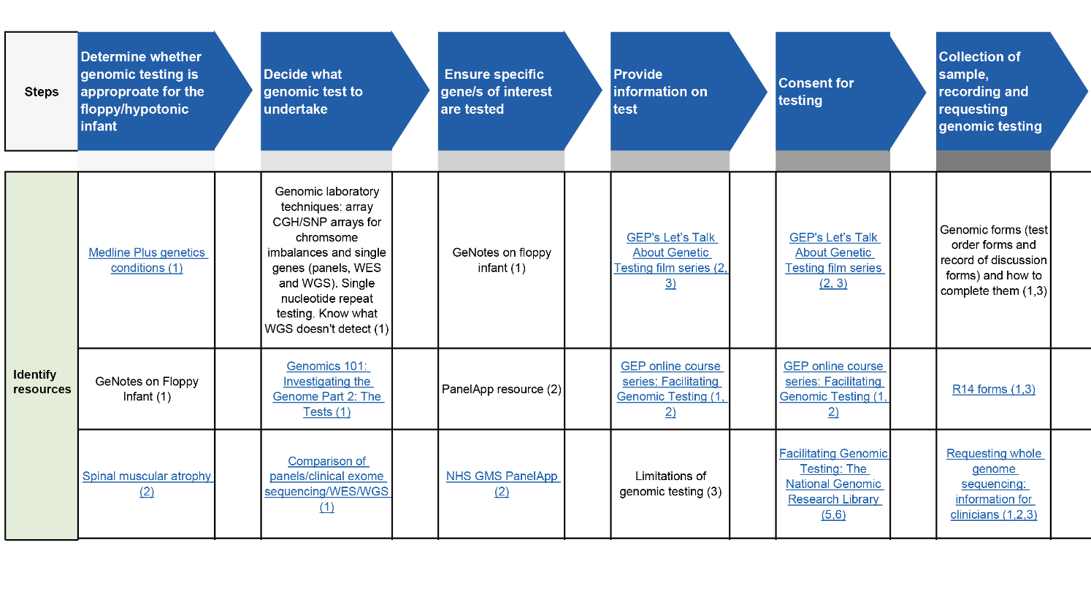
Figure 3 - Example CPI project (genomic testing to investigate a floppy hypotonic infant): Identifying resources

- Workforce group: Align the pathway to the workforce group(s) who will be delivering each step of the pathway.
Identify the workforce group(s) who, in your region, are likely to be delivering each of the steps. You can colour-code the icons to easily differentiate between different professional groups.
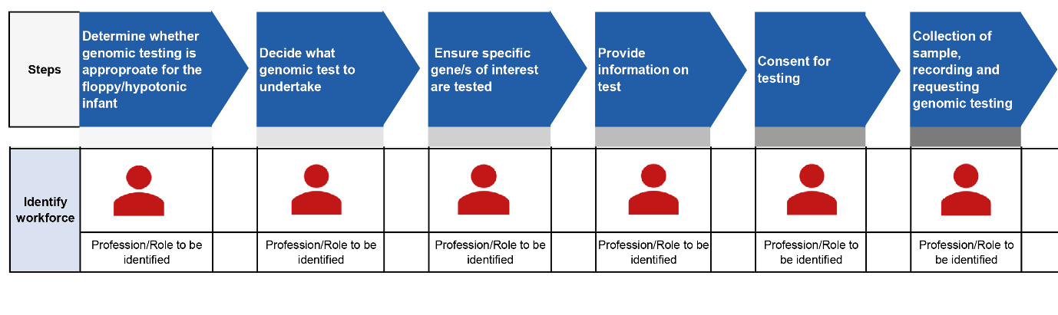
Figure 4 - Example CPI project (genomic testing to investigate a floppy hypotonic infant): Identifying workforce
Once your pathway project is complete, please email the spreadsheet to the National Genomics Education team. You can also email us with your questions or suggestions to improve the template or process.

4. Developing the education to support the pathway project delivery
A considerable education and training package will be required to deliver each of the pathway structures that are developed. Ideally, these resources would be 1) developed in line with a template/guide and 2) hosted/signposted on the National Genomics Education website so that they can be easily accessed and nationally shared.
If you identify any gaps in educational content, please inform the National Genomics Education team, who may be able to use this information to target future projects.

5. Any queries?
If you are interested in developing a pathway project but have questions, please see our FAQs, or contact the National Genomics Education team.

